[Event Invitation]

HelpMeSee X A New Vision
“ Snap the Vision” Charity Photo Exhibition

Cataract has caused more than 20 million people losing their vision worldwide.

In order to enhance the public awareness of cataract-blindness globally, HelpMeSee is going to launch the FIRST charity photo exhibition in Hong Kong to showcase the work of HelpMeSee as an International Charity Organisation fighting against cataract and share the joy of the cataract patients who could see again.

During the exhibition, one of the many 2016 Indonesian programmes will be exhibited. It was a collaboration with a Singapore Charity Organisation, A New Vision, a partner of HelpMeSee for Indonesia programme since 2015 which focuses their work on eye health awareness. All photos were taken by a passionate volunteer Singaporean photographer, Ms. Lee Siew Yian, who has dedicated herself to humanitarian work.

HelpMeSee Ambassador - Hong Kong Triathlon Athletes, Ms. Leanne Szeto, Mark Cheung, Managing Director of HelpMeSee and Effi Jono, founder of A New Vision will join together as special guests to launch the exhibition. We are honoured to have the energetic Busking Team Endless and talented students from Chemical Music to perform for us. They share their enthusiasm and positivity through their music.

HelpMeSee cordially invite you to join the opening ceremony of

“Snap the Vision” Charity Photo Exhibition

DATE: | 4TH AUGUST, 2017 (FRIDAY)
TIME: | 12:45-13:45
VENUE: | Covered Piazza, Ground Floor, Times Square, Causeway Bay
GUEST: | Ms. Leanne Szeto, Mr. Mark Cheung, Ms. Effi Jono

RSVP
Flora Ip | Tel: +852 3792 0774 | Email: floraip@helpmesee.org
Ricky Ho | Tel: +852 3792 0776 | Email: ricky@helpmesee.org

The photographer--- Lee Siew Yian
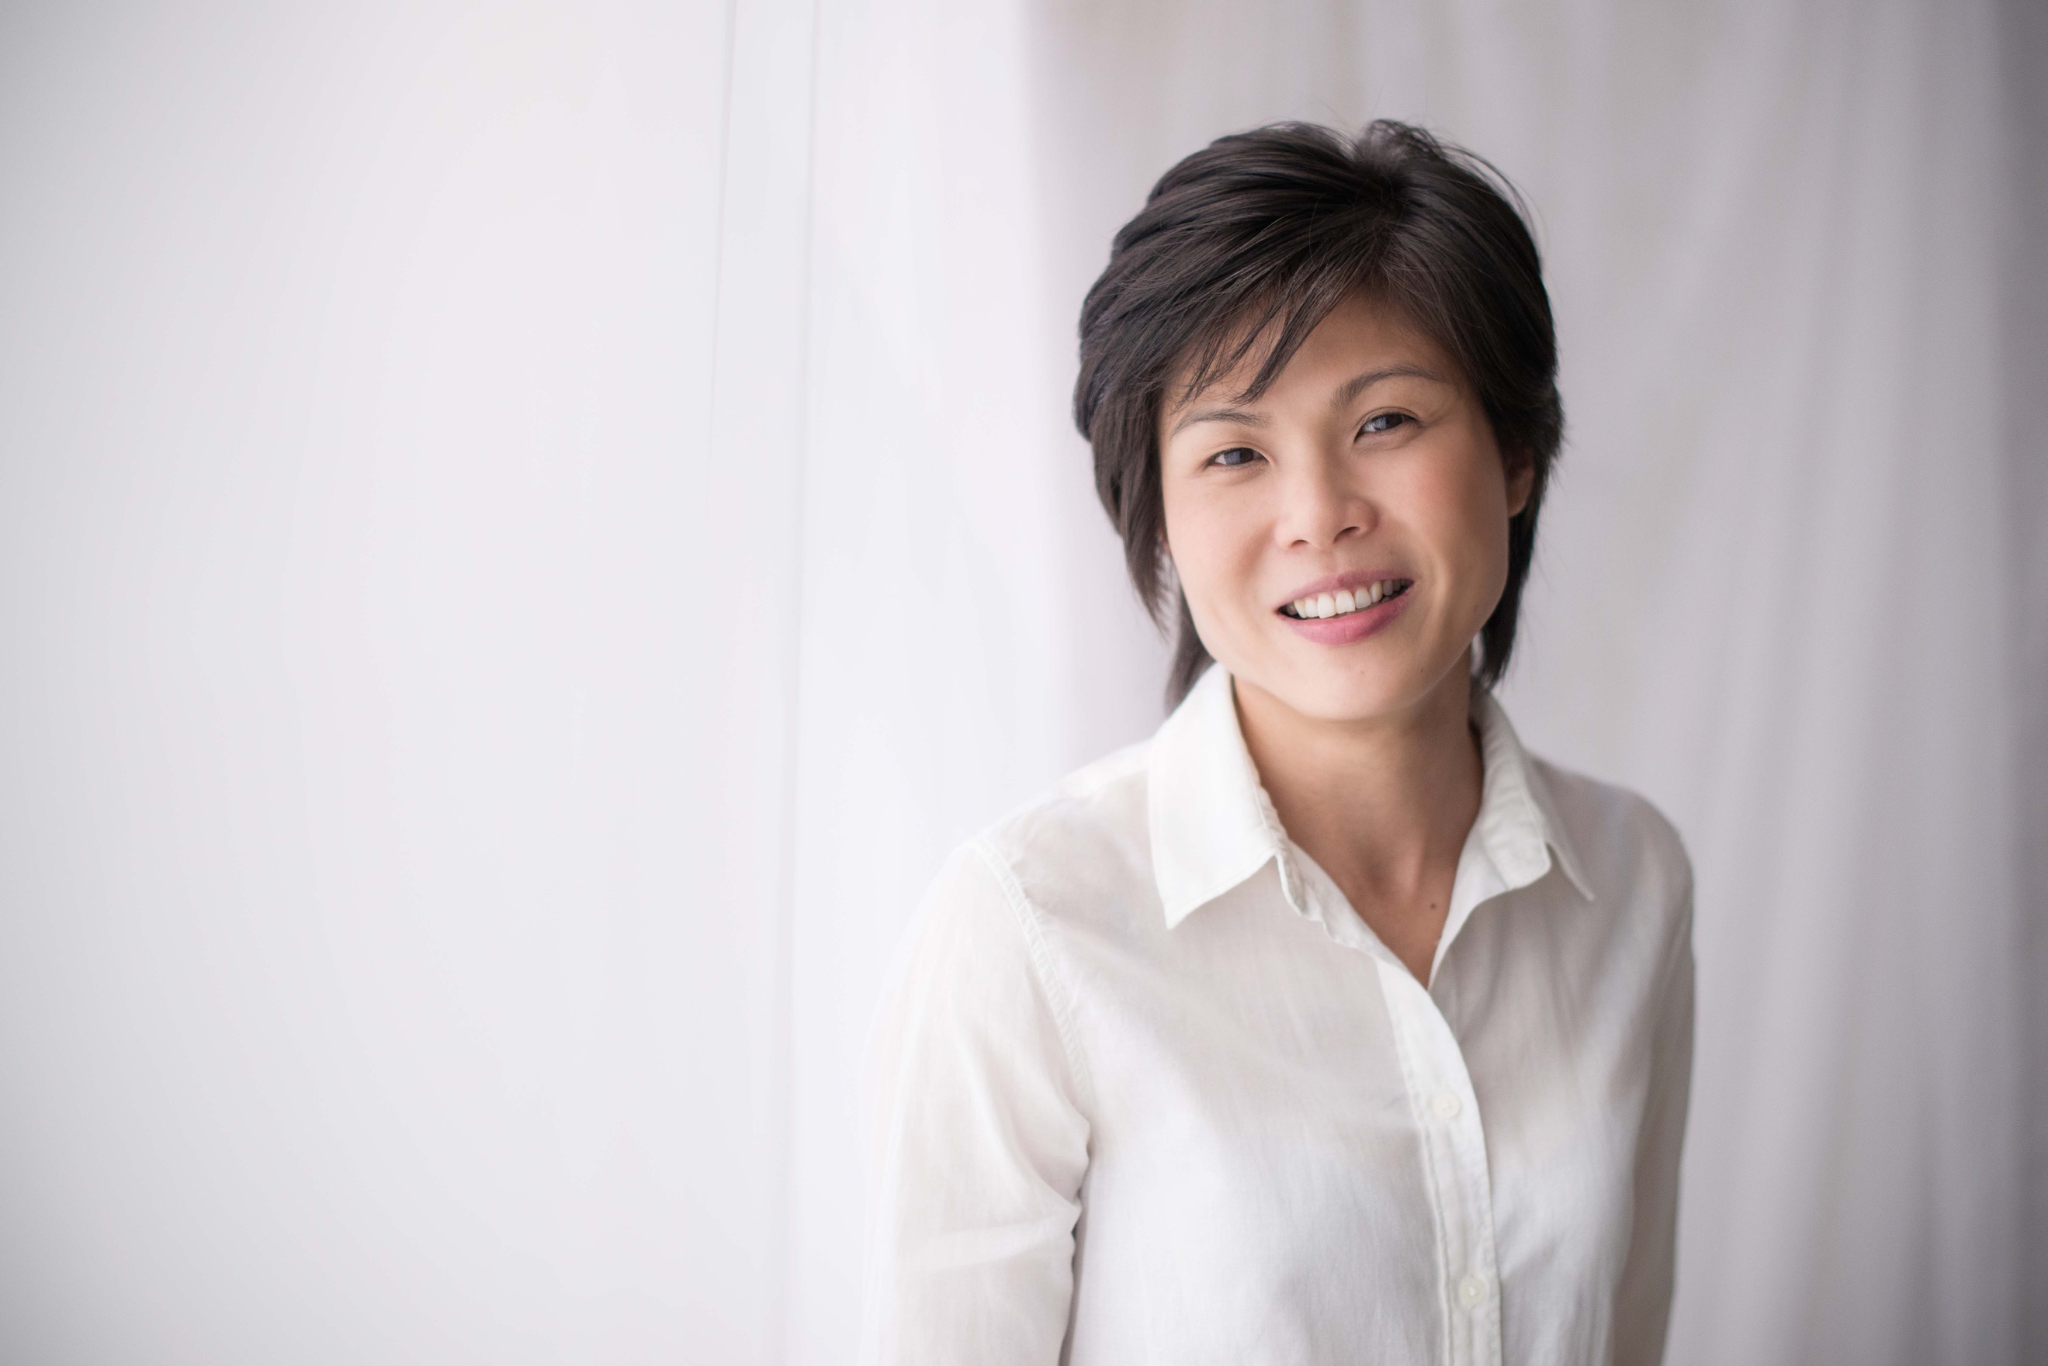
has been working in a telecommunication company as a Global Account Manager for 14 years. She decided to quit her successful career and use her photography skills as a channel to give back to the community and to speak for the marginalised.

She started as a volunteer for A New Vision to take photos for its website after she quitted her job. She made good use of her photography skills to help create public awareness. She did not expect her documentary style photos and true stories would attract so much attention. Her friends were interested to find out more. They also became aware of cataract disease and curable blindness. Donations begin to pour in to support the cause, to help the poor and blind to see again.

Beyond taking photos, Siew Yian has initiated various humanitarian projects in Asia, including an emergency food distribution after a major earthquake in Nepal. She photographed the priceless moments of the beneficiaries’ expressions when they regained their visions, and deployed social media to create awareness on curable blindness in hope to inspire more to contribute to the cause.

HelpMeSee Ambassador --- Leanne Szeto
is a Triathlon Athletes since she was 14. She joined Hong Kong Junior Triathlon Squad and came at 8th place in The 2014 Incheon Asian Games. She was also the Female Winner in The TNF100 2017 earlier this year, as well as the first runner-up of Female Half Marathon Challenge in The Hong Kong Standard Chartered Marathon. In recent years, she participated in different sports events around the world, including different charity runs. She is also a running instructor. Being a big lover of the colour pink, she is called “Pink Big Brother” by her friends.

HelpMeSee appointed Leanne as the Ambassador in April 2017, aiming to raise the public awareness of ending cataract blindness worldwide together. Leanne wishes to help more cataract patients receive proper treatment, so that they can restore their vision and be able to pursue their own dreams. She is also keen to inspire more people to be aware of the cataract blindness problem and encourage them to join HelpMeSee to ignite hopes to the beneficiaries.

About HelpMeSee
HelpMeSee, headquartered in New York, USA, is an international charitable organisation which is committed to ending cataract blindness, the leading cause of blindness worldwide. Established in June 2016, HelpMeSee Hong Kong is served as the liaison office in the Asia Pacific region, aiming at raising public awareness on the mission and vision of the organisation, through corporate partnership, street fundraising and educational events.
With a focus on surgical training, we are determined to make sure those with greatest need can get the help. Since 2012, HelpMeSee has partnered with 303 surgeons and provided over 256,000 sight-restoring surgeries across over 10 countries, including India, China, Madagascar, Nepal, Peru, Indonesia and Vietnam etc. HelpMeSee restored the sight for a cataract patient every 11 minutes.
For details, please visit: http://www.helpmesee.org.hk / www.facebook.com/helpmeseehongkong/

About A New Vision
A New Vision is a young non-profit organisation which is formed and run by a band of volunteers. 100% of the donation goes towards sight restoring projects in Indonesia. A New Vision has been a partner of HelpMeSee for Indonesia programme since 2015 and completed over 2,800 vision recovery surgeries to alleviate the problem of local surgery backlog.

[活動邀請]
助視會x A New Vision
「照出光明」慈善攝影展 開幕禮
白內障已造成全球超過2千萬人失去視力。
為了提高公眾對全球白內障失明的認識，助視會將在香港舉行首次慈善攝影展，展示助視會作為國際慈善機構，致力杜絕白內障致盲的工作，並分享白內障患者重見光明的喜悅。
助視會與關注眼睛健康的新加坡慈善組織 – A New Vision合作，展出2016年在印尼的慈善項目。A New Vision自2015年以來，一直都是助視會在印尼助視項目的合作夥伴。印尼慈善項目的照片均由新加坡志願攝影師 ，致力於人道主義工作的Lee Siew Yian 女士所拍攝。
助視大使 – 香港三項鐵人運動員司徒兆殷小姐、助視會總幹事張梓楓先生、A New Vision創辦人Effi Jono女士，將以主禮嘉賓身份出席開幕典禮。我們亦有幸邀請到音樂學校- 化樂作用學員為我們表演，以音樂表達對助視會的熱心支持。

助視會誠意邀請您參加開幕禮

「照出光明」慈善攝影展
日期: | 8月4日，星期五
時間: | 中午12:45-13:45
地點: | 銅鑼灣時代廣場地下有蓋廣場
嘉賓: | 司徒兆殷小姐，張梓楓先生， Effi Jono女士

傳媒查詢 :
葉斯琴小姐 電話: +852 3792 0774 電郵: floraip@helpmesee.org
何瑋祺先生 電話: +852 3792 0776 電郵: ricky@helpmesee.org

志願攝影師--- Lee Siew Yian女士
Siew Yian在電訊公司擔任全球客戶經理14年，毅然放棄自己建立的職業生涯，以攝影技巧作渠道，回饋社會，為弱勢社群發聲。
離職後她開始在 A New Vision擔任志願者，透過攝影技巧提高公眾關注，並把照片用於A New Vision網站上。紀錄片風格的相片，配合真實故事，使其反饋及迴響遠超想像。Siew身邊朋友都更想了解這些重見光明的故事，亦提高了對白內障的認識。憑藉她的努力，捐款亦隨之而來，讓更多患者可以受惠。
除攝影外，Siew Yian也曾在亞洲發起各種人道主義項目，包括尼泊爾大地震後的緊急食品派發。她的攝影作品，不但紀錄了受助者重獲視力後的感動之情，亦讓更多人對可治癒失明有深入了解。

助視大使--- 司徒兆殷小姐
司徒兆殷小姐14歲加入香港三項鐵人青少年代表隊，2014年在仁川亞運會三鐵比賽取得第八名。今年初在泰國越野跑贏得女子組全場冠軍，亦在香港渣打馬拉松獲得女子半馬全場亞軍。近年，她經常於世界各地參加不同比賽，包括慈善賽事。兆殷亦是一名跑步教練，由於酷愛粉紅色，朋友都稱她為「粉紅大佬」。
助視會在本年4月委任司徒兆殷小姐為助視大使，致力向本港公眾倡導 【杜絕全球白內障致盲】的訊息，與助視會攜手締造無視障世界。兆殷希望日後幫助更多白內障患者接受治療，讓他們重拾健康、清晰的視力，勇敢追求自己的夢想。她亦期待加入助視會行列，啟發更多人關注白內障致盲問題，為更多受助者燃點光明希望。
關於助視會
助視會是一間國際慈善機構，總部設於美國紐約，致力於消除全球白內障致盲的健康危機。香港分會於2016年6月成立，作為亞太區聯絡辦事處，主要透過在亞洲區內進行企業伙伴合作，街頭募捐及教育宣傳活動等，傳揚助視會使命及理念。
助視會以手術培訓為重點，確保最需要救治的社群得到幫助。自2012年起，助視會與303名醫生合作，在10多個國家，包括印度、中國、馬達加斯加、尼泊爾、秘鲁、印尼和越南等，支援超過25萬6千次視力回復手術，每11分鐘拯救一名白內障患者的視力。
了解更多，請瀏覽︰http://www.helpmesee.org.hk/
www.facebook.com/helpmeseehongkong/

關於A New Vision
A New Vision是一個年輕的非牟利組織，由一群志願者組成和營運，所接受的捐款，全數用於印尼的治盲項目。自2015年， A New Vision一直是助視會在印尼的合作夥伴，共同完成了超過2,800次視力恢復手術， 紓緩當地手術積壓問題。

