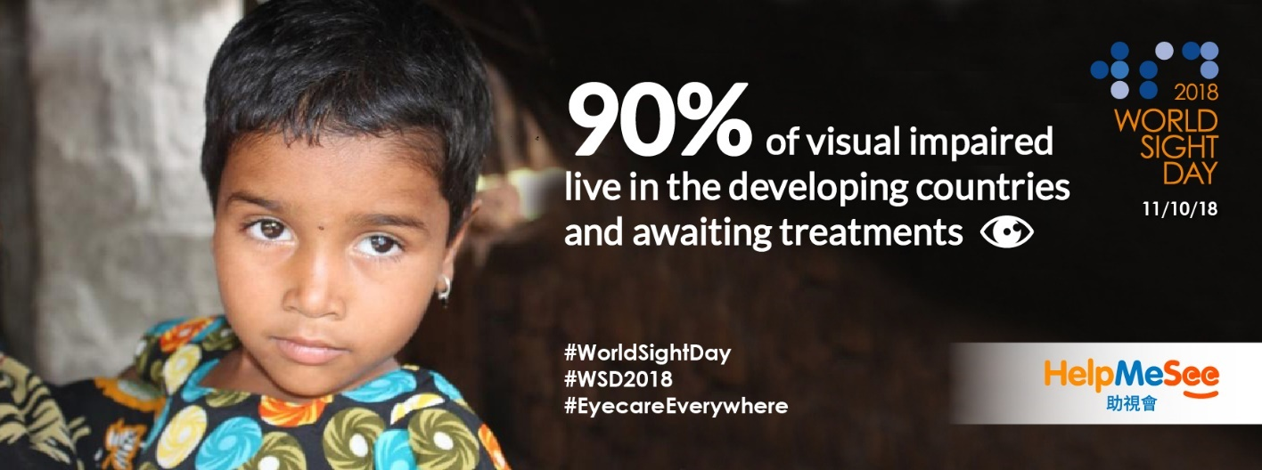

To support this year's World Sight Day and respond to our slogan "Save more Sight", HelpMeSee will hold a series of activities to raise funds for our eye surgery simulators project and simulation-based training programmes. Our goal is to train more medical professionals in developing countries and restore sight to millions of blinds through a sustainable solution! We hope more people could understand the importance of eye vision and the urgency of global cataract blindness crisis by participating in these activities.

HelpMeSee Hong Kong will join with Naturally Good for the charity event, titled 2018 Carnival - New Zealand and Australia Cultural Tour x HelpMeSee Charity collaboration from October 20th to November 4th in the Atrium of Miramar Shopping Centre to help raise fund for HelpMeSee. The opening ceremony will be held on October 20th. There will be a group of Maori performance Haka Dance on the stage and our fundraising development director will present appreciation certificates to the sponsors and speak at the stage to call for attention to the global blindness and raise fund for HelpMeSee’s eye simulator and training programmes.

This event will bring you an unique flavour of New Zealand artisan handcraft beer, experience how’s the coffee goes with meat pie culture, taste the milky smooth chocolate and the exclusive New Zealand ice cream. You can even have an opportunity to taste a first time in Hong Kong, a prestigious century brand their range of honey products. For ginger lovers, you shouldn’t miss a popular drink - organic ginger honey tonic specially made by New Zealand native Maori.

In addition, HelpMeSee has invited a famous color pencil artist – Steven Tang (Peterpancil Art 小飛俠) to demonstrate his new art piece <Three Stuffed Treasures > at the charity booth on opening day and raise fund for HelpMeSee. There are also a number of charity activities, including cataract and eye health test, one minute dark challenge game (suitable for adult and children), free gifts giving from HelpMeSee ambassadors, a free public eye-care talk jointly organised with the charity partner Eyeglass Vision Friendly Foundation, and cookie/cupcake workshop with the event partner Lam C9 and handmade wool felt workshop… etc., all of them will raise fund for HelpMeSee global campaign!

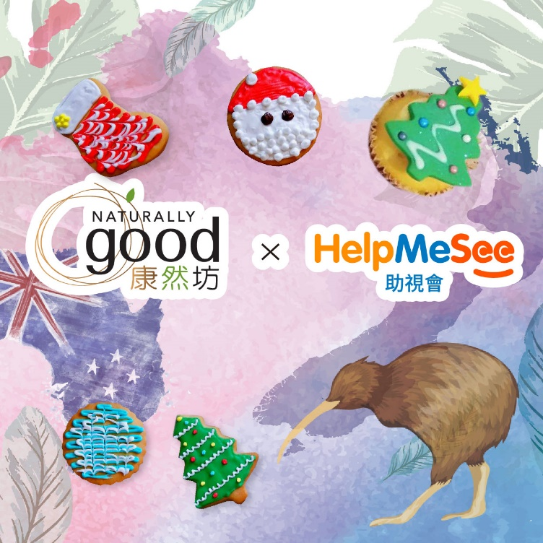

Details of the charity workshops:

Lam C9 : I love cooking since I was young. I believe that food is a bridge to connect people.

A. Introduction of Holiday Theme Cookies DIY: The cookies are made with high-quality ingredients, and each participant can make 6 pcs cookies. There will be souvenirs given to each participant to acknowledge their support.

B. Introduction of Holiday Theme Cupcake DIY: The cupcakes are made with high-quality ingredients, and each participant can make 4 pcs cupcakes. There will be souvenirs given to each participant to acknowledge their support.

Eyeglass Vision Friendly Foundation: Established in December 2010 with a registered charity organisation number of 91/11154. The mission of Eyeglass Vision Friendly Foundation is to promote eye care and public awareness, co-organise eye health talks with charitable partners, provide visual inspections and high-quality eyewear.

Introduction of HelpMeSee Eyecare Talk (Free admission):
Mr. Dick Lo, the co-founder of Eyeglass Vision Friendly Foundation, and representatives of HelpMeSee Hong Kong, will talk about common causes of blindness – cataracts and the latest hot topic - Myopia Control. Mr. Lo will also demonstrate the eye health exercises to the participants.

To register the talk and workshops, please click HERE or download the enrollment form HERE

HelpMeSee cordially invite you to join the opening ceremony of

2018 Carnival - New Zealand and Australia Cultural Tour x HelpMeSee Charity collaboration

DATE: 20th October 2018 (Saturday)

TIME: 12:00-13:00

VENUE: The Atrium of MiraPlace 1, 132 Nathan Road, Tsim Sha Tsui, Kowloon

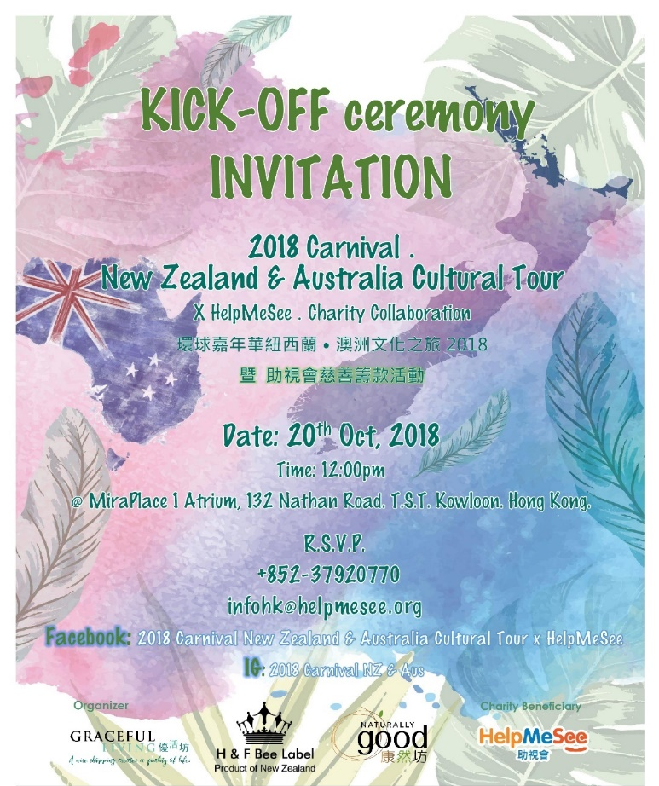

About HelpMeSee

HelpMeSee is a US-based, international nonprofit organisation making great strides every year toward our goal of eliminating cataract-caused vision loss and blindness. Established in June 2016, HelpMeSee Hong Kong is served as the liaison office in the Asia Pacific region, aiming at raising public awareness on the mission and vision of the organisation, through corporate partnership, street fundraising and educational events.
Since 2012, HelpMeSee has partnered with over 300 surgeons and developed readiness standards and tools for surgery practice including patient safety and quality outcome. This resulted in sight-restoring surgeries for more than 250,000 people across over 10 countries, including India, China, Madagascar, Nepal, Peru, Indonesia and Vietnam etc.
At present, HelpMeSee is well on our way to introducing the leading edge, virtual-reality surgery simulator to train 30,000 cataract specialists, while simultaneously reducing the risks of surgery, and providing access to sight-saving cataract surgeries at a most affordable cost.”

For details, please visit:
https://www.helpmesee.org.hk/
https://www.facebook.com/helpmeseehongkong/
https://www.instagram.com/helpmesee_hongkong/

Media Enquiries:

Ms. Flora Ip
Marketing and Communication Manager, HelpMeSee Hong Kong
Direct Line：（852）3792 0774
E-mail：Floraip@helpmesee.org

