NORWEGIAN JEWEL TO SPEND SECOND SEASON IN
AUSTRALIA AND NEW ZEALAND IN FALL 2018/2019

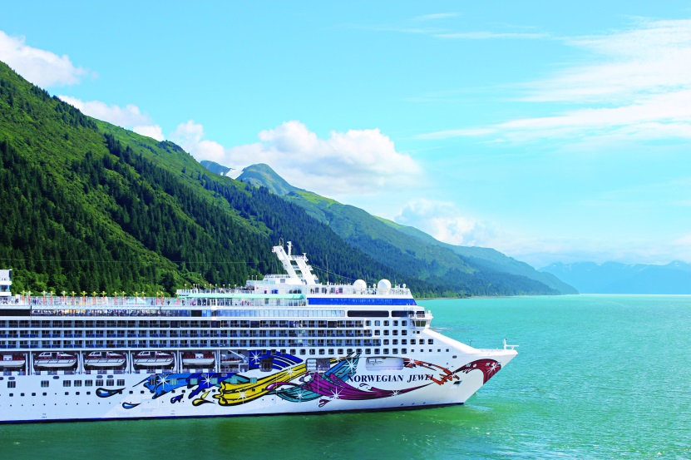

Hong Kong – October 26, 2017 – Norwegian Cruise Line opened for sale the line’s 2018/2019 Australia and New Zealand cruises aboard Norwegian Jewel. Following an expansive refurbishment, Norwegian Jewel will spend a second season down under cruising an action-packed series of itineraries taking in the best of Australia including Melbourne, Cairns, Hobart; and New Zealand including Milford Sound, Wellington and Tauranga, as well as itineraries to the South Pacific, Southeast Asia, and a transpacific voyage from Vancouver to Tokyo (Yokohama).

In late October 2018, Norwegian Jewel will undergo a three-week dry-dock enhancement in Singapore, as part of the Norwegian Edge multi-million-dollar revitalization program. She’ll emerge a nearly new ship for her Australian season with bow to stern refreshments and a new look across many of the ship’s public spaces.

“Norwegian Jewel’s Australia and New Zealand sailings have received a great deal of anticipation and excitement from guests both locally and internationally,” said Andy Stuart president and chief executive officer for Norwegian Cruise Line. “The region is a bucket-list destination for many of our guests with a warm culture, lush lands, sandy beaches, action-packed adventure and more. We are thrilled to be returning to this dream destination with the iconic Norwegian Jewel looking as if she were a brand new ship.”

Highlights for the new 2018/2019 season include a spectacular 19-day transpacific journey from Vancouver to Tokyo (Yokohama) via Alaska and Russia; a 19 day journey to Australia from Singapore with stops in Bali and Komodo Island; a new 13-day South Pacific itinerary and – back by popular demand – a series of sailings in and around Australia and New Zealand home-porting from Sydney, including a seven-day round-trip itinerary featuring calls in Tasmania just before the holidays in mid-December.

Norwegian Jewel boasts 15 dining options including the line’s signature specialty restaurants including Cagney’s Steakhouse serving up the finest cuts of Premium Black Angus Beef, Le Bistro, an intimate upscale French bistro and Teppanyaki, the home of sizzle and surprises with authentic Japanese Hibachi. The ship also boasts 15 bars and lounges featuring Norwegian favorites such as Sugarcane Mojito Bar, Maltings Beer & Whiskey Bar, a poolside bar for afternoon cocktails at sea and many more.

Renowned for her remarkable repertoire of entertainment at sea, Norwegian Jewel guests can enjoy world-class entertainment including acrobatics and artistry in Le Cirque Bijou, variety entertainment and more. The sports complex will get the heart started with a range of activities including basketball, dodgeball, tennis and volleyball, and kids won’t want to leave the designated kid’s pool or Splash Academy, Norwegian’s award-winning youth program. Health enthusiasts can choose from classes ranging from Zumba to yoga, while those keen to dial down the pace may want to book in to be pampered at the Mandara Spa and Thermal Suite, home to a myriad treatments designed to relax and rejuvenate weary travelers.

Accommodation options aboard Norwegian Jewel range from inside staterooms to balcony staterooms boasting superb views and private outdoor areas. Interconnecting rooms and multiple-bedroom suites are also available for families. For an unforgettably indulgent experience, Norwegian Jewel’s ultra-exclusive The Haven by Norwegian® is home to the ship’s most luxurious suites and villas, a private courtyard, whirlpools and dedicated private deck exclusively for Haven guests, as well as dedicated concierge services.

About Norwegian Cruise Line
Norwegian Cruise Line is the innovator in cruise travel with a 50-year history of breaking the boundaries of traditional cruising. Most notably, Norwegian revolutionized the cruise industry by offering guests the freedom and flexibility to design their ideal cruise vacation on their schedule. Today, Norwegian invites guests to enjoy a relaxed, resort style cruise vacation on some of the newest and most contemporary ships at sea with a wide variety of accommodation options, including The Haven by Norwegian®, a luxury enclave with suites, private pools and dining, concierge service and personal butlers.

Recently, the line was named “Europe’s Leading Cruise Line” for the ninth consecutive year, as well as “Caribbean’s Leading Cruise Line” for the fourth time and “World’s Leading Large Ship Cruise Line” for the fifth straight year by the World Travel Awards. Norwegian will introduce two new “Breakaway Plus” class cruise ships through 2019 and has four additional ships on order for delivery beginning in 2022, with an option to introduce two more ships in 2026 and 2027.

To book a cruise, contact +852 2165 6000 (English, Cantonese and Mandarin assistance) contact your preferred travel professional or visit ncl.com.

# # #

For more information please contact:

Brittany Eubanks / Alisa Chen | Wendy Wang / Kathy Mueller
GHC Asia Hong Kong | GHC Asia Singapore
Phone: +852 2810 0532 | +65 6438 4024
Email:Brittany.eubanks@ghcasia.com  Alias.chen@ghcasia.com | wendy.wang@ghcasia.com kathy.mueller@ghcasia.com

