

Seven Seas Voyager – One of the Most Luxurious Ships in the World –
Offering Asian Itineraries in December and January
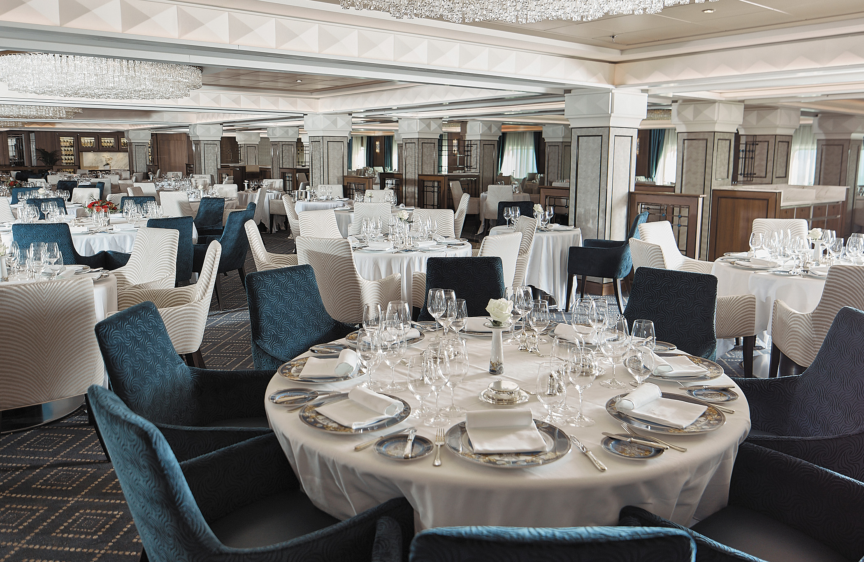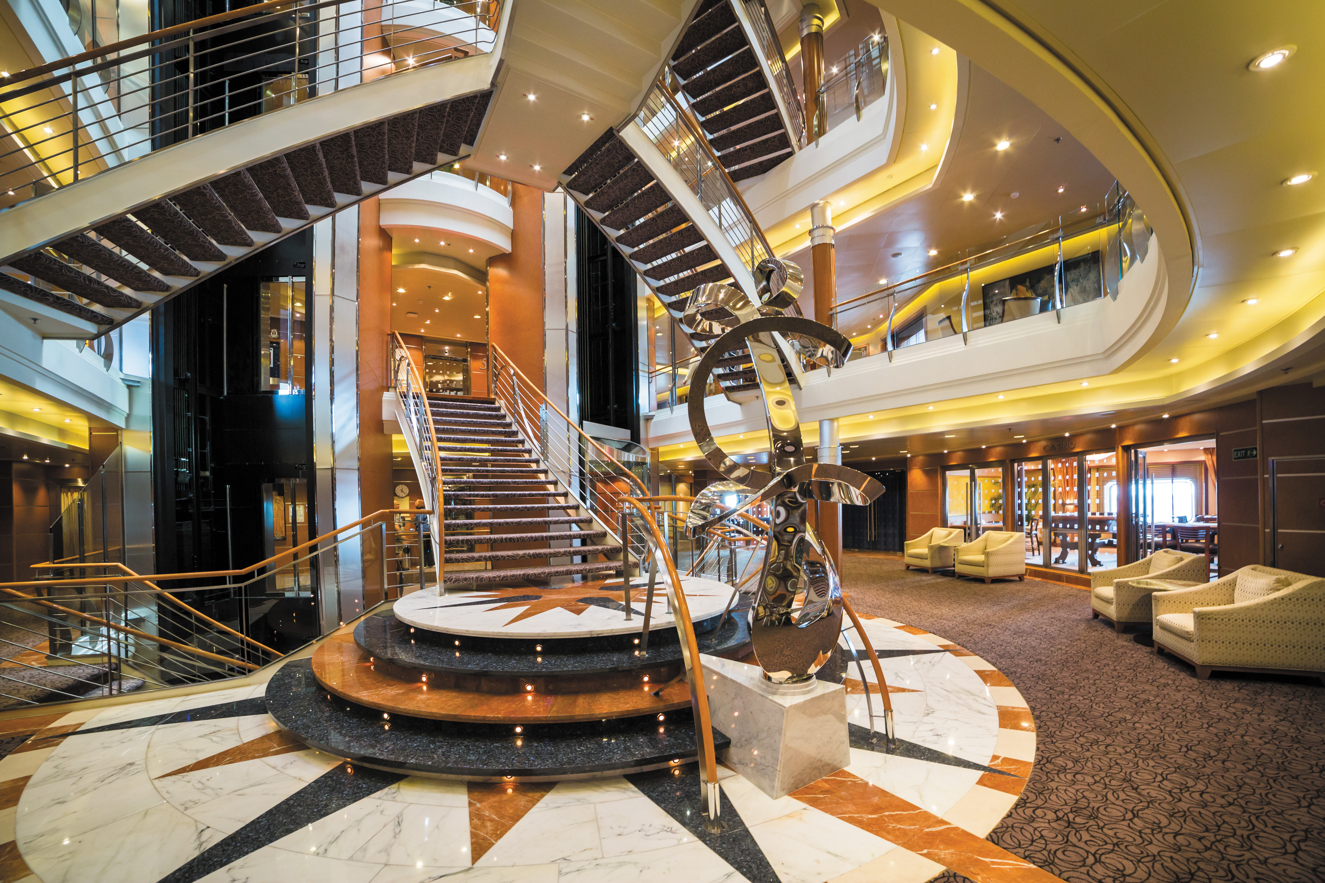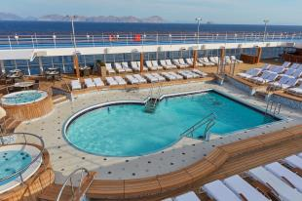

Rare opportunity to enjoy the ultimate luxury cruise straight in or out of Asia

Singapore, November 1, 2017 –Seven Seas Voyager, one of the most luxurious cruise ships in the world, arrives in Singapore on December 5th and will sail to Hong Kong via Thailand and Vietnam, then north to Shanghai and Beijing (Tianjin), before heading back to Hong Kong and around South East Asia for the whole of January and early February 2018. This creates rare opportunities for Hong Kong and Singapore residents to conveniently sail straight into or out of their own home ports and enjoy the most inclusive luxury experience, for which Regent Seven Seas Cruises is world-renowned. Seven Seas Voyager boasts a 1-to-1.5, guest-to-staff ratio, so guests will enjoy highly personalized service from every member of the exceptional staff and crew.

About The Newly Refurbished Regent Seven Seas Voyager
The all-suite, all-balcony Seven Seas Voyager recently completed a bow-to-stern refurbishment in November 2016 as part of Regent Seven Seas Cruises’ $125 million ongoing fleet-wide refurbishment program. The ship now matches the same elegant style and indisputable attention to detail of Seven Seas Explorer, which entered service on July 2016 and has since been recognized as the most luxurious ship ever built.
The new refined décor of Seven Seas Voyager’s Penthouse, Concierge and Deluxe Suites accentuate their spaciousness, while flagship restaurant Compass Rose, is resplendent with stunning grand crystal chandeliers, new décor, and features a revolutionary menu that offers guests an unprecedented level of personalization and choice, making it essentially the largest specialty restaurant at sea. Guests also enjoy unlimited free specialty dining in Prime 7 Steakhouse, and the new Chartreuse French restaurant.
Public spaces also renewed aboard Seven Seas Voyager include the La Veranda buffet restaurant, Pool Bar & Grill, Voyager Lounge, Reception Area, Coffee Connection, Connoisseur Lounge, Card Room, boutiques, casino and the Canyon Ranch SpaClub. In addition to the physical enhancements, the ship headlines four new captivating production shows: Lights, Camera, Music!, Broadway in Concert, Vegas The Show, and Dancin’ Fool.
The Most All-Inclusive Experience at Sea
Regent Seven Seas Cruises offers the most inclusive luxury experience in the industry. From the moment guests get on board, they can enjoy high-quality food and beverages in any of the ship’s luxurious specialty restaurants, bars and lounges - as much as they want.
Nearly all other onboard activities are also complimentary. These ranges from unwinding with a cold beverage pool side, to enrichment lectures hosted by former ambassadors, politicians and other notables. Additional activities include practicing the perfect swing at the golf cages, going for a jog on the upper deck or enjoying an evening watching professional cabaret or full-scale musical productions.
With Regent Seven Seas even the shore excursions are complimentary too, allowing access to a wide range of highly curated experiences on the ground in the destinations visited without any additional cost.
Upcoming Asian Itineraries on Seven Seas Voyager
14 November 2017: Dubai to Singapore (21 days)
14 November 2017: Dubai to Hong Kong (33 days)
5 December 2017: Singapore to Hong Kong (12 days)
17 December 2017: Hong Kong to Beijing (Tianjin) (12 days)
29 December 2017: Tianjin to Singapore (19 days)
17 January 2018: Singapore to Singapore (16 days)
-ENDS-
About Regent Seven Seas Cruises
Celebrating its 25th anniversary in 2017, Regent Seven Seas Cruises is the world's most inclusive luxury cruise line with a four-ship fleet that visits more than 425 destinations around the world. Regent Seven Seas Cruises is currently undergoing a $125 million fleet wide refurbishment that will elevate the level of elegance found throughout the fleet to the standard set by Seven Seas Explorer, which entered service on July 20, 2016, and has since been recognized as the most luxurious ship ever built.

A leader in luxury cruising, the line's fares include all-suite accommodations, highly personalized service, exquisite cuisine, fine wines and spirits, unlimited internet access, sightseeing excursions in every port, gratuities, ground transfers and a pre-cruise hotel package for guests staying in concierge-level suites and higher. For the latest news about Regent Seven Seas Cruises, please visit www.rssc.com/news.

For more information please contact:

Alisa Chen | Lynn Koh
GHC Asia Hong Kong | GHC Asia Singapore
+852 3163 0180 | +65 6723 8161
Alisa.chen@ghcasia.com | Lynn.koh@ghcasia.com

