Press Release
Festive Celebrations Made Memorable at Morton’s
Morton’s brings festive cheer with special treats
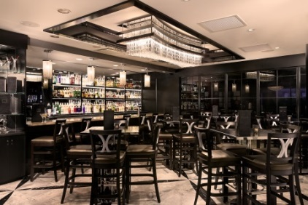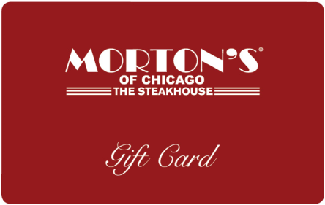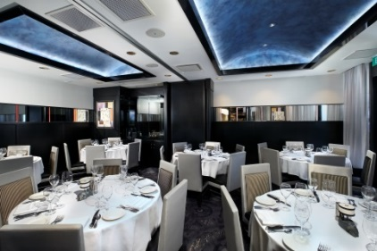

(Singapore, November 24 2017) – Morton’s Singapore is gearing-up for the holiday season and to help spread festive cheer the famed steakhouse is offering special incentives for the purchasing of gift cards and party bookings.

For this holiday season, guests purchasing gift cards from Morton’s worth S$500 will receive a bonus S$100 gift card as a treat from the steakhouse. During the same period of time, guests who book a dinner party held between 1st December 2017 and 15 January 2018 for a group of 8 or more people in the Private Dining Room(s) will receive Morton’s limited edition giveaways.

From the succulent steaks and seafood and vast wine selections to the seamless service, Morton’s has all the elements to make for a memorable festive experience. Diners can enjoy the best available aged grain-fed beef, as well as the freshest seafood, lamb chops, chicken entrees, and Morton’s brand-new fall menu. Renowned for its hallmark steaks, meat-lovers will be spoiled for choice when they have to choose amongst the substantial 14oz Bone-in Filet Mignons, Porterhouse Steaks, Centre-Cut Prime Ribeye’s, Five Peppercorn Rubbed Prime Strip Steaks just to name a few.

Seafood enthusiasts will be able to savour the freshest produce Morton’s has to offer. From the famed Lobster Bisque and generous Ocean Platters to the signature Jumbo Lump Crab Cakes and Whole Baked Maine Lobsters; there is something to please every taste.

What better way to end a festive party than with a little sweetness. Guests can choose from a wide selection of oh-so-tempting deserts including Morton’s Legendary Hot Chocolate Cake, the tangy Key Lime Pie or indulge in a decadent slice of New York Cheesecake.

With a fully- stocked bar offering top-shelf spirits, domestic and imported beers and creative cocktails, Morton’s can facilitate all palates when it comes to a tipple. Wine enthusiasts can also rejoice with Morton’s extensive wine list which includes more than 200 international labels.

Morton’s of Chicago is located at The Mandarin Oriental Hotel Singapore, 4th Storey, 5 Raffles Avenue, Singapore. Reservations can be made at tel. (65) 6339-3740 or via www.mortons.com

* S$500 gift cards will be valid for 1 (One) year from the next day of purchase. Bonus gift card(s) can be redeemed from 16/2/2018 through 15/5/2018 (excluding Mother’s Day). Terms and conditions apply. For more information, please call Morton’s at (65) 6339 3740.
** Giveaways are only available for party bookings of a group of 8 or more people in a Private Dining Room with a minimum spend of S$150++ and above per person. Not valid in conjunction with other discounts, membership privileges, promotions or vouchers. Morton’s of Chicago The Steakhouse Management reserve the right to modify or replace any part of the terms and conditions without prior notice.

- Ends –

Issued by GHC Asia on behalf of Morton’s of Chicago, The Steakhouse
For media enquiries, please contact:
Kathy Mueller
GHC Asia – Singapore
Tel: (65) 6723 8152
Email: kathy.mueller@ghcasia.com

About Landry’s, Inc./ Morton’s The Steakhouse
Landry’s, Inc., wholly owned by Tilman J. Fertitta, is a multinational, diversified restaurant, hospitality, gaming and entertainment company based in Houston, Texas. The company operates more than 500 high-end and casual dining establishments around the world, including well-known concepts such as Landry’s Seafood, Bubba Gump Shrimp Co., Rainforest Cafe, Mitchell’s Fish Market Restaurants, Morton’s The Steakhouse, The Oceanaire, McCormick & Schmick’s Seafood, Chart House, Saltgrass Steak House, Claim Jumper and Mastro’s Restaurants.
Landry’s also operates a group of signature restaurants, including Vic & Anthony's, Grotto, Willie G's and others. Landry’s gaming division includes the renowned Golden Nugget Hotel and Casino concept, with locations in Las Vegas and Laughlin, Nev.; Atlantic City, N.J.; Biloxi, Miss.; and Lake Charles, La. Landry’s entertainment and hospitality divisions encompass popular destinations including the Galveston Island Historic Pleasure Pier, Kemah Boardwalk, Aquarium Restaurants and other exciting attractions, coupled with deluxe accommodations throughout the Houston and Galveston area, including the luxurious San Luis Resort, Spa & Conference Centre on Galveston Island.

