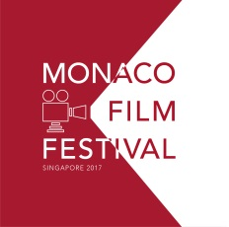
Glitz and Glamour Takes Centre Stage at Asia’s First Ever Monaco Film Festival
The 9-day Film Festival reached over 60,000 people
(Singapore – 27 November 2017) – Asia’s first ever Monaco Film Festival, hosted by the Monaco Government Tourist and Convention Authority, concluded after 9 days of cinematic grandeur from 14 to 22 October. Taking centre stage at the festival at the Alliance Française of Singapore was the presentation of 13 classic movies, an exclusive film and photo exhibition featuring vintage movie posters and Asian superstar Lin Chi-ling for the August issue of Vogue Taiwan.

The festival kicked-off with an exclusive cocktail gala reception at the Capitol Theatre that attracted Singapore’s local & regional media, cultural and business elites. Attendees were dressed to the nines and encouraged to wear their best 50’s glamour fashion, alluding to Grace Kelly’s style in the iconic “To Catch a Thief” which was screened on the gala night alongside “Monaco: Back to the Future”. The festival was graced by Christine Oberdorff – the film’s producer and director – and Monaco Tourist Authority’s Press and Communications Director Corinne Kiabski, who flew specially from France and Monaco for this occasion.

Guests were also treated to two mesmerising performances from Jazz guitarist Leopoldo Giannola and Zhang Zhang – founder of Zhangomusiq and violinist of the Monte-Carlo Philharmonic Orchestra. Zhang Zhang turned out to be a very vivacious host when she led the guests through the evening, interviewing Ms. Christine Oberdorff on-stage.

When talking about her experience attending the first ever Monaco Film Festival, celebrated French journalist, Christine Oberdorff was excited to return to Singapore after 22 years to screen her documentary and exhibit Monaco’s rich culture. “Cinema is the easiest way to reach people and educate them on issues of the world. I am very honoured to be invited here to share my views of Monaco’s technological and ecological advancements,” enthused Ms. Oberdorff.

“We are very pleased with this year’s turnout and how we reached out to the audience. We introduced Monaco through so many mediums, from classic films, exhibits of the original movie posters to musical performances. We are already in talks with neighbouring countries to host next year’s edition to build on our success,” said Benoit Badufle, Managing Director of Monaco Government Tourism Bureau Asia Office. “As food and music are universal languages, we will be adding concerts and gastronomy to future festivals for an all-round experience. Local fans of Monaco can rest assured that the film festival will return to our shores on alternate years. For 2018 they can look forward to the Prince Albert II of Monaco Foundation’s fundraising gala dinner on 9th November at Marina Bay Sands“.

With the wrap-up of 2017’s Monaco Film Festival, the Monaco Tourism Office in Singapore is gearing up for next year’s much-anticipated Prince Albert II of Monaco Foundation’s biannual charity dinner. 600VIP guests and philanthropes are expected at this event which will be the 4th in Singapore graced by the Presence of H.S.H. Prince Albert II of Monaco. 2018 will also be the foundation’s twelfth year of championing environmental protection and promoting sustainable development on a global scale, supporting initiatives of public and private organisations in the fields of research and studies, technological innovation and socially-aware practices.

For more information about the Prince Albert II of Monaco Foundation, visit http://www.fpa2.org/home.html

*****

Monaco Film Festival is organised by Monaco Government Tourist Bureau Asia, in partnership with Alliance Française de Singapour, Singapore Film Society, Capitol Theatre, Bomanbridge Media and Air France, with the support of Creme Simon, APM Monaco, Bottles XO, L’Orangerie Liqueur de Monaco and Capella Singapore.

For recaps and updates on Monaco Film Festival – Asia, visit https://www.facebook.com/monacofilmfestivalsg/ or http://www.horusdvcs.com/monacofilmfestivalsg

[END]

Our Partners and Sponsors
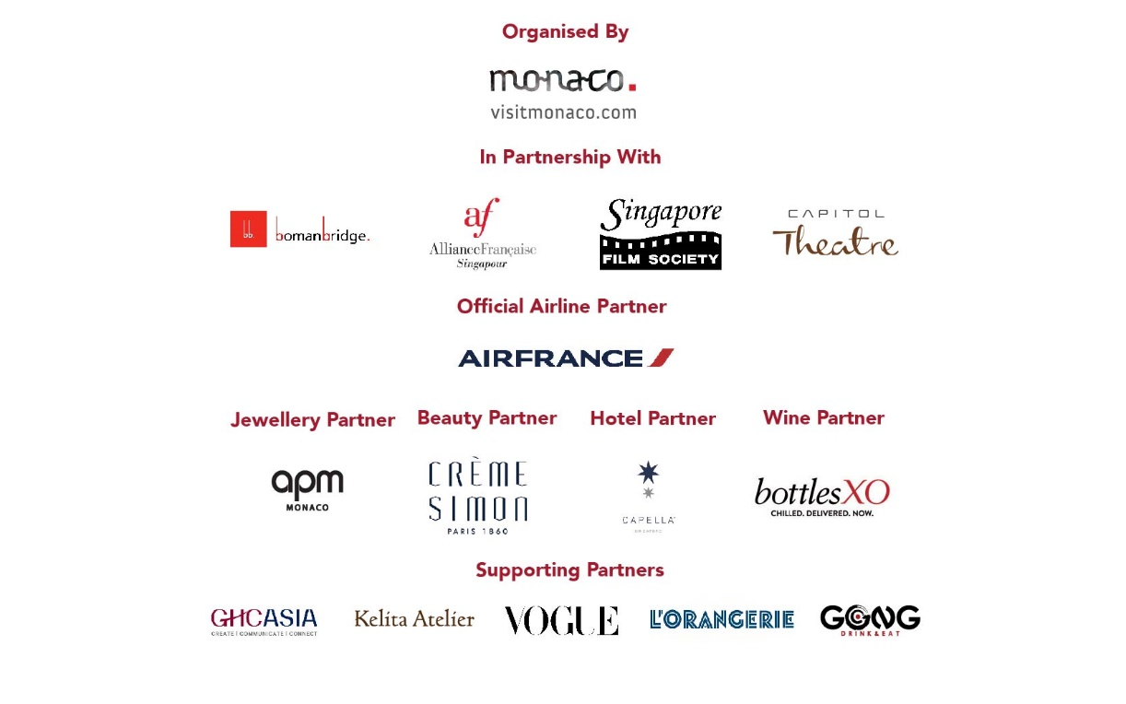

Distributed on behalf of Monaco Government Tourist Bureau Asia Office:

Ms. Lynn Koh
Senior Account Executive
GHC Asia | Singapore
Tel: +65 6723 8161
Email: lynn.koh@ghcasia.com

