Press Release

Worldhotels Suggests the “Hottest and Coolest” Ways to Spend
the Year-end Festive Season

Whether it’s escaping the winter chill, or embracing it wholeheartedly, Worldhotels has
the ideal locale to suggest for each guest this year end

(Singapore, 28 November 2017) – Worldhotels believes that when embarking on vacation, preferences for the weather tend to be either hot or cold. Some guests yearn for the cold and snow, while others prefer to bask in the golden sunshine. Be it tropical climates and balmy temperatures, or snuggling up in front of a roaring log fire after taking to the snow-capped ski slopes, Worldhotels proposes both sizzling hot, and sublimely cool destination suggestions for all to journey to during the year end festivities.

For hotel stays from 1st December 2017 to February 28th, 2018, guests can save up to 20 per cent off Best Available Rate for stays of two nights or more. This rate also includes breakfast and either 500 frequent flyer miles or loyalty points from Worldhotels’ Peakpoints programme. Guests may now book ‘Celebrate Differently’ via https://www.worldhotels.com/special-offers/celebrate-differently-promotion as well as from any other Worldhotels booking channels.

Amatara Wellness Resort, Phuket, Thailand – Experience a most relaxing, hot and cold bathing ritual
Phuket has long been heralded as one of the best tropical destinations especially if guests think the world of pristine beaches and endless sunshine. What truly makes Amatara Wellness Resort stand out from its competitors is the resort’s famed spa – which offers the only Thai Hammam in all of Phuket. The treatment involves a series of stages for cleansing, rejuvenating and relaxation of the body, and incorporates an alternation of cool and warm temperatures with water, steam, heated stone beds, and the application of ice as well. So, refresh yourselves with a hot and cold Thai Hammam this festive season, and start the new year off feeling absolutely fabulous.

Stamford Plaza Melbourne, Australia – A bird’s eye view of The 12 Apostles and The Great Ocean Road during Summer
Guests can venture into the great outdoors of Melbourne and immerse themselves into the Australian outback. Guests who have yet to traverse through The Great Ocean Road and witness the breathtaking 12 Apostles, should seize the opportunity to do so this festive season. There is even an option to marvel at the Apostles via a splendid helicopter ride! Not only will guests be able feel the sun on their face and the summer wind in their hair, temperatures may even climb to a summery 24 degrees Celsius in the afternoon. A marvelous option to reside at during your time in Aussie, is Stamford Plaza Melbourne as it is situated in the heart of the city, and provides easy access to some of Melbourne’s other top attractions as well.

Hotel Fort Canning, Singapore – An abundance of spicy street food, and searing hot weather as company
Those who adore the heat and a climate that mirrors a tropical rainforest can find solace in Singapore as the island nation is literally bathed in sunshine for 12 hours a day, all year round. The city is also home to a melting pot of races, each boasting its own signature cuisine that comes peppered with spicy goodness. There’s chili crab, a variety of curry dishes, laksa, and even Mala (which translates into numbingly spicy) Hotpots. Hotel Fort Canning can be found within the heart of the Lion City, and provides easy access to literally all the above foods, guests will be thrilled to discover that some of the spicy delicacies may even be served in the hotel itself!
Fleming’s Hotel Zürich, Switzerland – Skiing and snowboarding amongst the Swiss Alps
Adrenaline junkies and guests who can withstand sub-zero temperatures can marvel at the spectacular Swiss Alps and go skiing or snowboarding this festive season. There’s nothing quite as splendid as waking up to the view of snowcapped mountains, and December just so happens to be one of the best months to visit Switzerland for the exact reason. Fleming’s Hotel Zürich is one of the best places to set up base at as it is of close proximity to several ski slopes with varying difficulties. So, guests can rest assured that even beginners or professionals of the winter sports can find a suitable snow-sure slope to further hone their skills at. Switzerland is also one of the best places to go skiing and snowboarding as there are 57 peaks that tower over 4,000m, the most out of any country!

The Kimberly Hotel, New York, United States – Ice Skating at The Rink at Rockefeller Centre
A winter visit to the Big Apple will never be complete without first relishing in one of the city’s most celebrated traditions. Each winter, hordes of visitors and New Yorkers alike lace up their skates and glide away at The Rink at Rockefeller Centre – where the celebrated Christmas tree lights up every year. So, embrace your inner figure skater within, and twirl those troubles away for a most fantastic 2018 ahead. Guests can opt to stay at The Kimberly Hotel, which is conveniently located within a 10-minute walk to Rockefeller Centre, and the famed Times Square is also a mere stone’s throw away from the hotel.

Harbour Grand Kowloon – Experience a winter wonderland in the most magical place on Earth
Guests can revel in the magic of Hong Kong Disneyland this festive season as the entire park gets transformed into a winter wonderland. With realistic-looking snow-flecked trees, twinkling lights, and the serenade of Christmas carols everywhere, almost everyone can feel like a kid again this festive season. Guests can also get up close and personal with some of their favourite Disney characters donning their finest holiday costumes. A Christmas musical extravaganza will also be premiering in Hong Kong Disneyland this year, with the performance ending with a delightful faux snowfall moment! Guests can choose to stay at Harbour Grand Kowloon as it provides easy access to countless of other attractions in Hong Kong.

[ends]

About Worldhotels:

• Worldhotels is dedicated to empowering the true independence of hotels all around the world. The global brand brings together 350 of the world's most unique independent hotels. With 45 years of excellence in the industry, the company's mission is to provide sales & distribution solution and consultancy to upscale hotels of character and distinction. By reaching over 50 countries and six continents, the group targets savvy business and leisure travellers that seek an authentic and local experience when choosing a hotel.

• Worldhotels solutions allow hotels to keep their independency through providing the power of a global brand with a comprehensive range of products and services that include global marketing, sales, training services, quality experience measurements, hotel business consultancy, operational support, e-commerce services and state-of-the-art distribution and technology. Worldhotels loyalty programme Peakpoints, 19 frequent flyer programmes as well the high number of preferred partnerships provide competitive advantage to the independent hotel industry

• Worldhotels is part of Associated Luxury Hotels. As the owner and operator of Worldhotels and Associated Luxury Hotels International (ALHI), Associated Luxury Hotels is a significant, full-service “soft brand” solution which provides an array of Global Sales Organisation services with broad-reaching reservations connectivity solutions and a powerful sales and marketing infrastructure.

For reservations or information, visit worldhotels.com. Images are available from alow@worldhotels.com.

For most recent news, follow Worldhotels on Facebook and Twitter.
www.worldhotels.com/facebook
www.worldhotels.com/twitter

Issued on behalf of Worldhotels by Grebstad Hicks Communications.

For further information or hi-res images, please contact:

GHC Asia (Singapore) Worldhotels
Ms. Lynn Koh Mr. Ash Low
Tel: 65 6723 8161 Tel: 65 6227 5535
E-mail: lynn.koh@ghcasia.com E-mail: alow@worldhotels.com

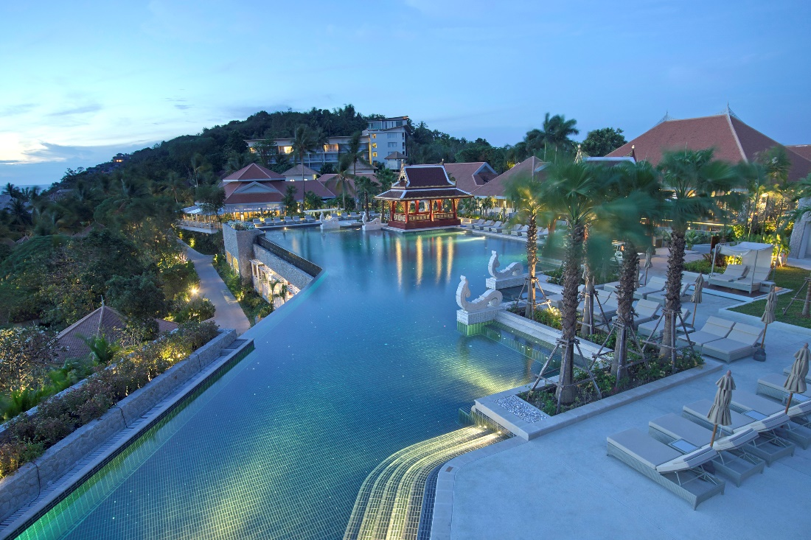
Amatara Wellness Resort, Phuket, Thailand

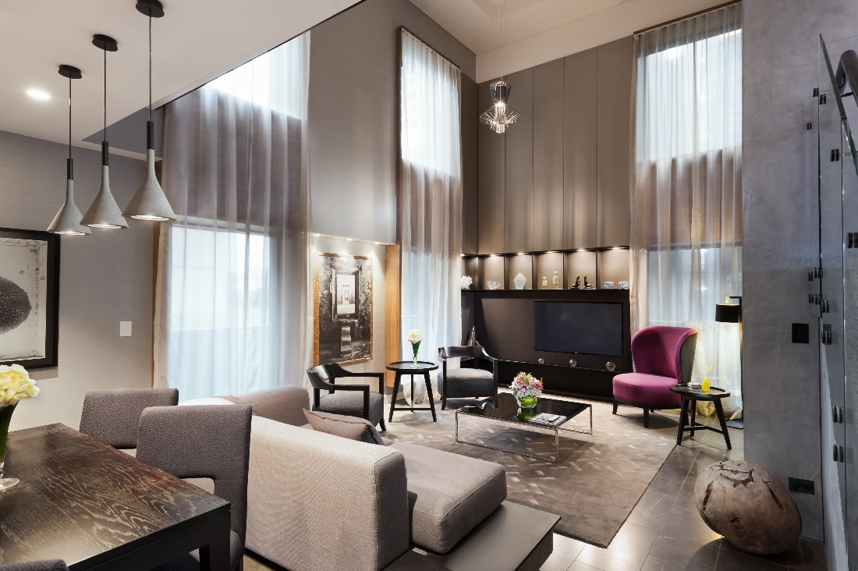
Stamford Plaza Melbourne, Australia

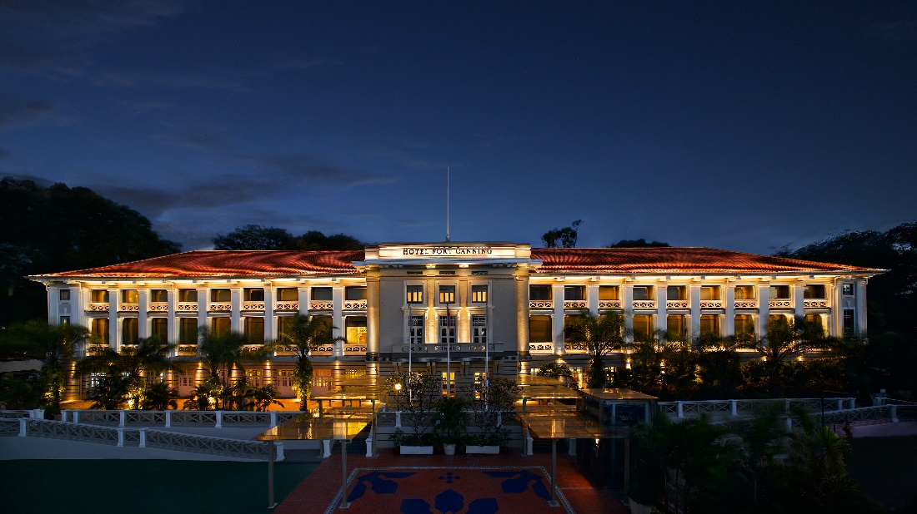
Hotel Fort Canning, Singapore

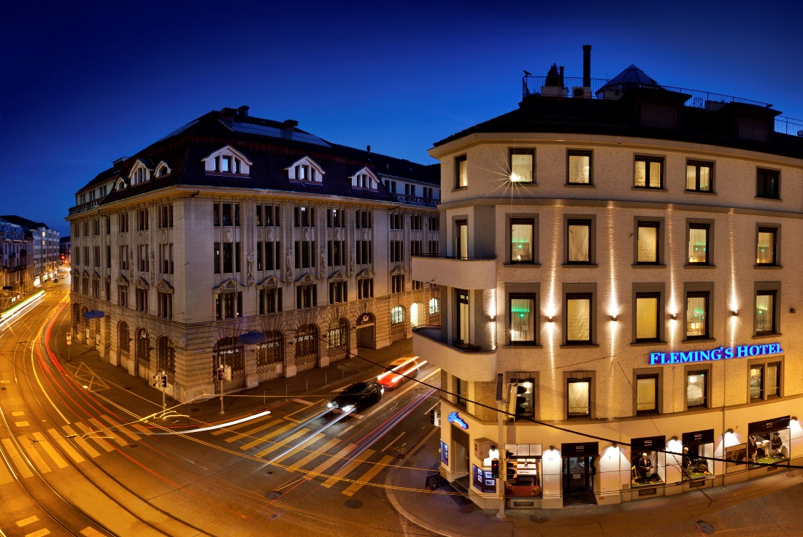
Fleming’s Hotel Zürich, Switzerland

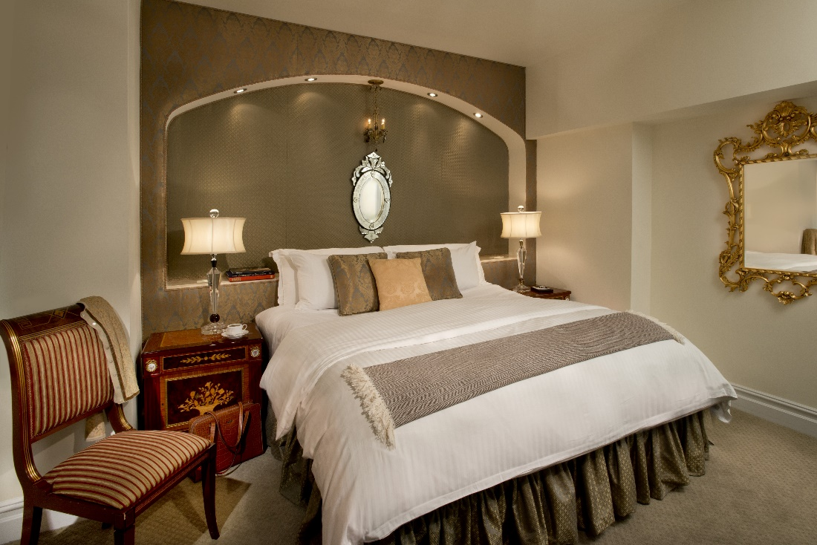
The Kimberly Hotel, New York, United States

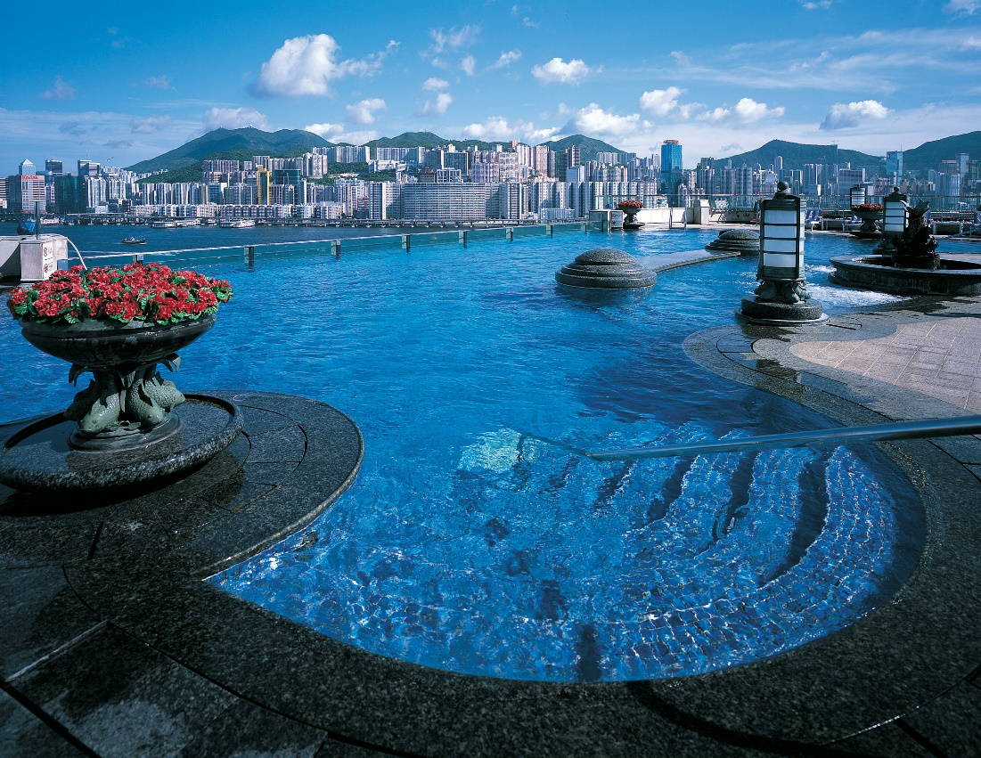
Harbour Grand Kowloon, Hong Kong

