World’s First Mobile Tourist Tax Refund Solution with New Tourego App
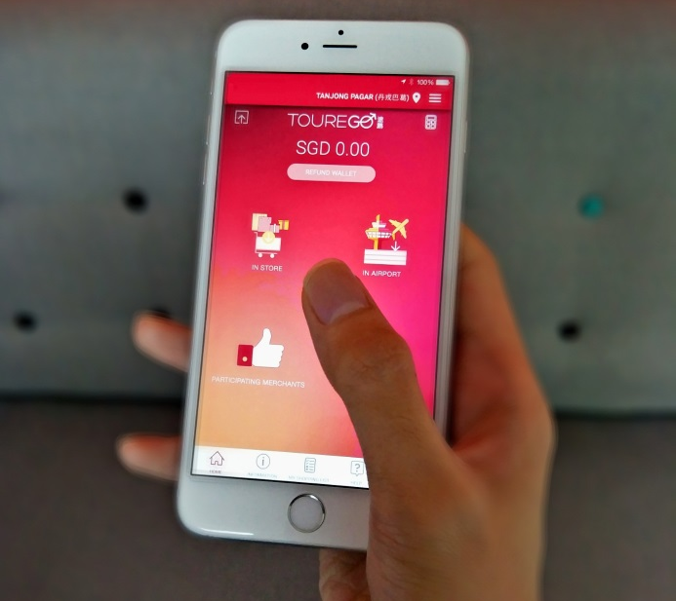
Innovative paperless tax refunds for fuss-free shopping in Singapore
(Singapore – 6 December 2017) – Approved by the Inland Revenue Authority of Singapore (IRAS), Tourego is the world’s first mobile tourist tax refund solution, and the only Singaporean tax refund company,
This innovative paperless solution migrates the current paper based tax refund process onto the Tourego app, allowing users to receive and store their refund tickets in an e-wallet.
More than a tax refund app, Tourego is also a travel companion that provides tourist users with the latest shopping, food and travel tips about Singapore. There is also a shopping list function that recommends Tourego retailers as users put together a wish list.
Already spanning more than 100 doors in Singapore, the Tourego retailer network coverage is expected to increase with more partner announcements expected in the coming months.
Singaporean entrepreneur, Tan Tie Wee, Founder and CEO of Tourego explains, “Tourego wants to be Singapore’s solution to the worldwide problem of tourists spending too much time at airports trying to get their tax refund back. Our mobile app enhances the shopping experience for tourists, helps our retail partners improve their retail operations efficiency, and gain big data insights into the consumer behaviour of their tourist customers.”
“We are grateful to the Singapore Tourism Board (STB), IMDA, SPRING Singapore, and IE Singapore for their support as Tourego contributes to Singapore’s vision to be a smart nation.”
“The Singapore Tourism Board is always on the lookout for new and innovative ways to enhance visitors’ retail experience. We are pleased to support Tourego’s mobile-friendly solution to make shopping even more seamless and hassle-free for visitors to Singapore,” said Ms Ranita Sundra, Director, Attractions, Dining & Retail, STB.
Launching in Singapore as its first market, the Tourego app is free to download, but is currently only available to non-Singaporeans (eligible tourists for tax refund) to register for an account.
For more information about Tourego, please visit https://www.tourego.com.

[End]
Distributed by GHC Asia on behalf of Tourego Singapore:
GHC Asia Singapore
Ms. Lynn Koh
Senior Account Executive
Tel: +65 6723 8161
Email: lynn.koh@ghcasia.com

Tourego
Ms. Winnie Yee
Marketing Director
Tel: +65 6909 2409
Email: Winnie@tourego.com.sg

