Gourmet Specialist Oceania Cruises Returns to Asia for 2018 Season in January
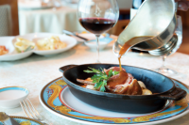

2018 Voyages To Offer Culinary Highlights of 50 of Asia’s Most Sought After Destinations

(Singapore, December 8, 2017) – Starting from January 2018, Oceania Cruises, the cruise line dedicated to epicurean enthusiasts and which is known for serving The Finest Cuisine at Sea™, is offering a season of voyages dedicated to exploring the culinary highlights of the Asian region. Oceania Cruises’ acclaimed Nautica and Insignia will be calling on more than 50 ports in the region starting next month.

With Oceania Cruises, guests can expect elegant accommodations, exceptional personalized service, as well as expertly crafted excursions to provide an immersive cultural, historic, and above all culinary experience of the local destinations.

Asian Voyages
Recommended itineraries include the 15-day Eastern Escapade cruise aboard Nautica from Hong Kong to Bangkok. Guests will cruise through picturesque Ha Long Bay in Hanoi, before stopping at the beautiful coastal city Nha Trang and the historic Ho Chi Minh City. Singapore and its rich culinary culture is the next port of call before cruising through the Gulf of Thailand for a pit stop on the island of Koh Samui, finally bringing the ship to in Bangkok.

The 15-day Pagodas and Shrines cruise aboard Nautica from Singapore to Hong Kong cruises the Gulf of Thailand, stopping at the island of Koh Samui and the Thai capital, Bangkok. Sihanoukville, with its pristine beaches on the Cambodian coast is the next port of call before cruising to the vibrant Vietnamese cities of Ho Chi Minh and Hanoi. Guests will then sail through the Hainan strait before the journey comes to an end in Hong Kong.

Intimate and Luxurious Ships

In 2014, both Nautica and Insignia underwent a multi-million dollar refurbishment to create virtually new ships that are sleek and elegantly charming. The decks are resplendent with the finest teak, custom stone and tile work, and the lounges, suites and staterooms boast luxurious, neo-classical furnishing.
Both Ships offer four open-seating restaurants, world-class fitness centers and spas, lounges and bars, a casino, 342 lavish suites and luxurious staterooms. And with just 684 guests onboard, the 400 professionally trained staff ensures all guests receive utmost attention and care.
The Finest Cuisine at Sea™

With legendary Master Chef Jacques Pépin as the line’s Executive Culinary Director, each restaurant offers guests extraordinary dining experiences. All dining; be it breakfast, lunch or dinner is inclusive and made a la minute. Gourmands can choose from authentic Italian dishes at Toscana, succulent seafood and USDA Prime steak at Polo Grill, and continental cuisine in the Grand Dining Room. Casual alfresco dining is available all day at Terrace Café and made-to-order American fare is served alongside healthy options including a newly introduced Raw Juice & Smoothie Barat Waves Grill.

2018 Asian Itineraries
Nautica: 20 January 15days Singapore to Hong Kong
Nautica: 4 February 15days Hong Kong to Bangkok
Insignia: 15 March 20 days Singapore to Beijing
Insignia: 31 March 25 days Tokyo to Singapore

To learn more about Oceania Cruises or to order a brochure, visit OceaniaCruises.com, call 800-616 -7096 for Singapore / +852 2165 6010 for Hong Kong / +612 9224 6098 for rest of Asia, or contact your preferred travel agent.

-ENDS-

About Oceania Cruises
Featuring a fleet of intimately luxurious ships, Oceania Cruises offers an unrivaled experience renowned for the finest cuisine at sea and destination-rich itineraries spanning the globe. Seasoned world travelers are drawn to Oceania Cruises’ expertly crafted voyages, which call on more than 400 ports across Europe, Asia, Africa, Australia, New Zealand, the South Pacific and the Americas. Spacious and elegant accommodations aboard the 684-guest Regatta, Insignia, Nautica, and Sirena and the 1,250-guest Marina and Riviera invite guests to explore the world in unparalleled comfort and style.

For more information please contact

Kathy Mueller / Lynn Koh
GHC Asia Singapore
+65 6438 4024
kathy.mueller@ghcasia.com
lynn.koh@ghcasia.com

Images:
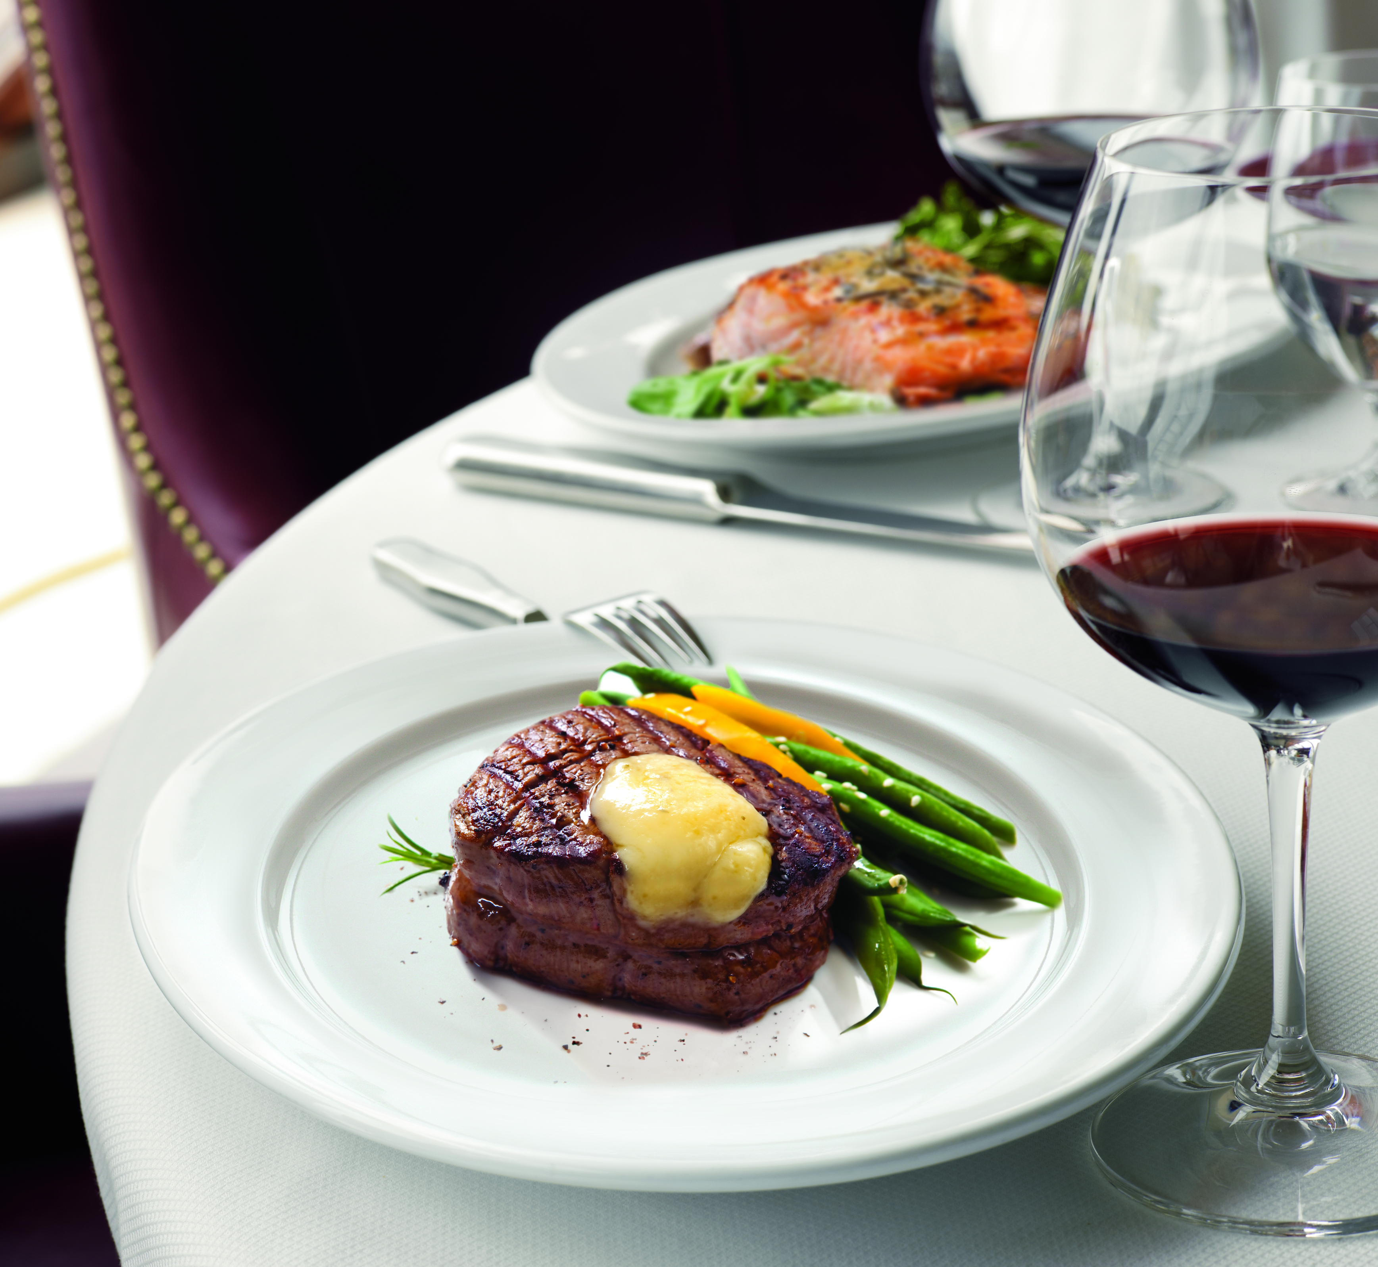 | 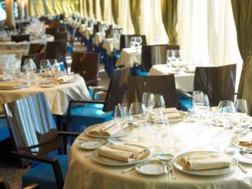
Polo Grill – A Classic Steakhouse | Toscana Restaurant – Authentic Italian Cuisine
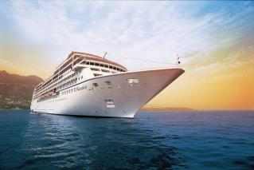 | 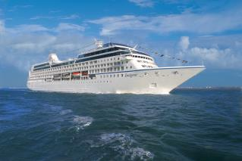
Oceania Nautica will be sailing in Asia starting from January 2018 | Oceania Insignia will be sailing in Asia starting from March 2018

