Press Release

WorldHotels Welcomes Third Jin Jiang Property –
The Kunlun Jing An
Rebranded from the former Hilton Shanghai, The Kunlun Jing An joins the ranks of WorldHotels and brings the grand total of properties in China to 26

(Singapore, 18 January 2018) WorldHotels proudly adds the newly rebranded, The Kunlun Jing An, into its portfolio of over 350 independent hotels around the world. The hotel was formerly known as The Hilton Shanghai, and was heralded as one of first international hotel brands to enter mainland China. The Kunlun Jing An now bears the distinguished Kunlun Brand managed by Jin Jiang Premier Hotels, and the hotel management team is fully committed to provide guests with outstanding services that not only matches, but exceeds those offered by its international predecessor.

Perfectly situated in the heart of iconic Shanghai’s business and entertainment district, The Kunlun Jing An is a short drive away from several of Shanghai’s top attractions such as The Bund, Nanjing Road, and Xin Tian Di. Hongqiao International Airport also is a mere 20-minute drive away from the hotel, while Pudong International Airport is a 50-minute drive away. Guests will be thrilled to discover that the hotel also boasts an indoor swimming pool, squash courts, plus a well-equipped fitness centre, spa and hair salon as well. Located on 38th Floor of the hotel, the Executive Lounge offers magnificent views of Shanghai’s cityscape.

From now till 2 March 2018, guests can enjoy 20% to 40% off Best Available Rate when booking stays at The Kunlun Jing An with the following rate codes:
- D01 - 20% off BAR for Deluxe, Grand Deluxe, Grand Premier Panorama King Room
- D03 - 30% off BAR for Executive Room
- D02 – 40% off BAR for Panorama Suite, Executive Panorama Suite, Deluxe Suite

Impeccably appointed rooms that offer panoramic views of Shanghai
Not only does the 714 rooms and suites of The Kunlun Jing An offers panoramic and incomparable views over Shanghai, each well-appointed room also comes equipped with luxury amenities, and a marble ensuite bathroom, complete with a bathtub. The presidential suite of the hotel stands at an impressive 208 square metres, and has a kitchenette attached as well.

Inviting and palatable dining options that promise to delight
With seven delectable dining options to choose from at The Kunlun Jing An, guests will truly be spoilt for choice. Guests can have their palates tantalised in Leonardo’s, which serves up some of the best Mediterranean and Italian cuisine found in Shanghai. Sichuan Court specialises in fiery and spicy Sichuan delicacies, while People on The Water offers the freshest of seafood, cooked in classic Ningbo flavours.

Dedicated conference team and state-of-the-art facilities that cater to all sorts of events
Comprising of over 2500 square metres of event space made up from 18 different meeting rooms, The Kunlun Jing An is certainly capable of hosting the most intimate to the grandest of affairs. The hotel prides itself on its conference services - which are designed to ensure that each event is a complete success. Some of these services include, delivering professional conference solutions, excellent catering and preparing of creative cuisine.

“WorldHotels is truly delighted over the addition of The Kunlun Jing An into our portfolio of unique, independent properties,” says Geoff Andrew, CEO of WorldHotels. “We consider their vote of confidence in WorldHotels as validation within the China market, and we are excited to see what this partnership with Jin Jiang Premier Hotels brings in the future.”

About WorldHotels:

• WorldHotels is dedicated to empowering the true independence of hotels all around the world. The global brand brings together 350 of the world's most unique independent hotels. With 45 years of excellence in the industry, the company's mission is to provide sales & distribution solution and consultancy to upscale hotels of character and distinction. By reaching over 50 countries and six continents, the group targets savvy business and leisure travellers that seek an authentic and local experience when choosing a hotel.

• WorldHotels solutions allow hotels to keep their independency through providing the power of a global brand with a comprehensive range of products and services that include global marketing, sales, training services, quality experience measurements, hotel business consultancy, operational support, e-commerce services and state-of-the-art distribution and technology. WorldHotels loyalty programme Peakpoints, 19 frequent flyer programmes as well the high number of preferred partnerships provide competitive advantage to the independent hotel industry

• WorldHotels is part of Associated Luxury Hotels. As the owner and operator of WorldHotels and Associated Luxury Hotels International (ALHI), Associated Luxury Hotels is a significant, full-service “soft brand” solution which provides an array of Global Sales Organisation services with broad-reaching reservations connectivity solutions and a powerful sales and marketing infrastructure.

For reservations or information, visit WorldHotels.com. Images are available from alow@WorldHotels.com.

For most recent news, follow WorldHotels on Facebook and Twitter.
www.WorldHotels.com/facebook
www.WorldHotels.com/twitter

Issued on behalf of WorldHotels by Grebstad Hicks Communications.

For further information or hi-res images, please contact:

GHC Asia (Singapore) WorldHotels
Ms. Lynn Koh Mr. Ash Low
Tel: 65 6438 4024 Tel: 65 6227 5535
E-mail: lynn.koh@ghcasia.com E-mail: alow@WorldHotels.com

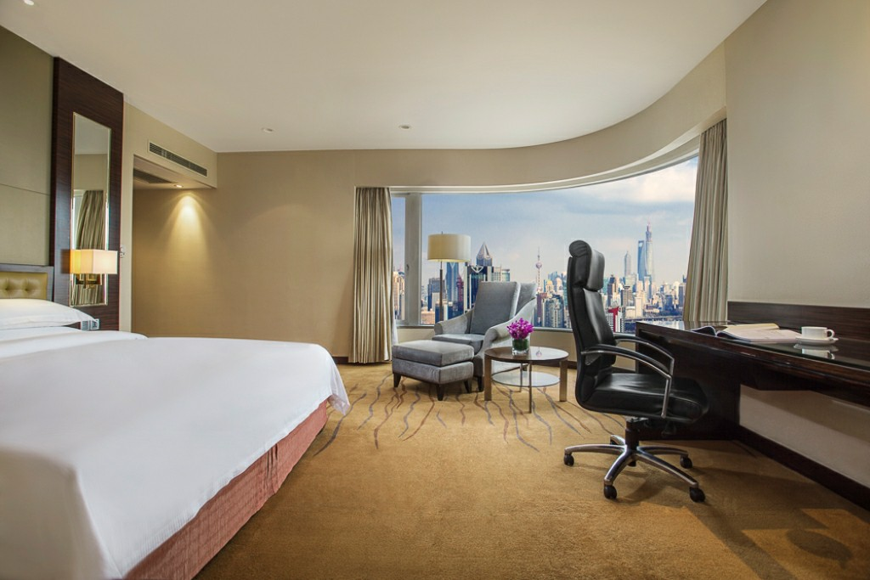
Executive Suite at The Kunlun Jing An

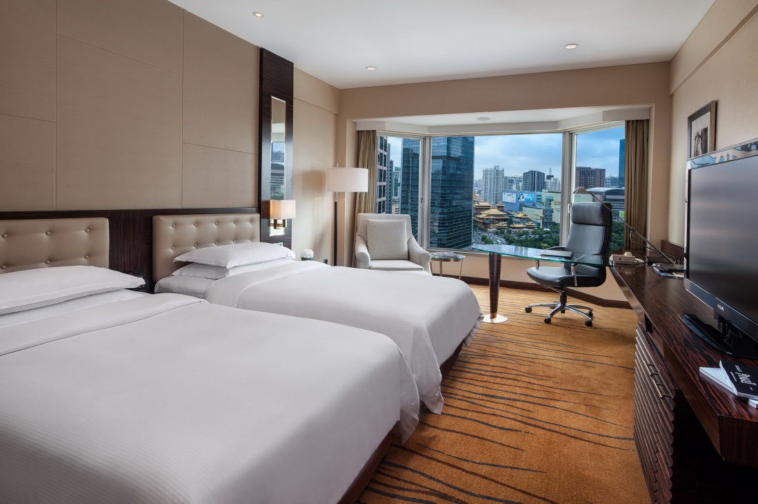
Twin Room at The Kunlun Jing An

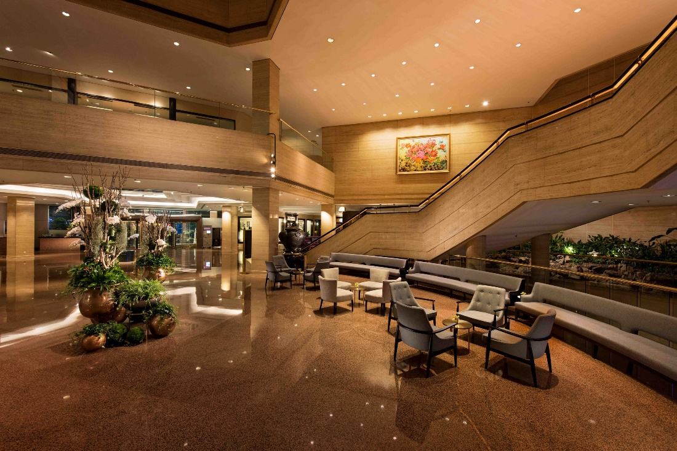
Lobby at The Kunlun Jing An

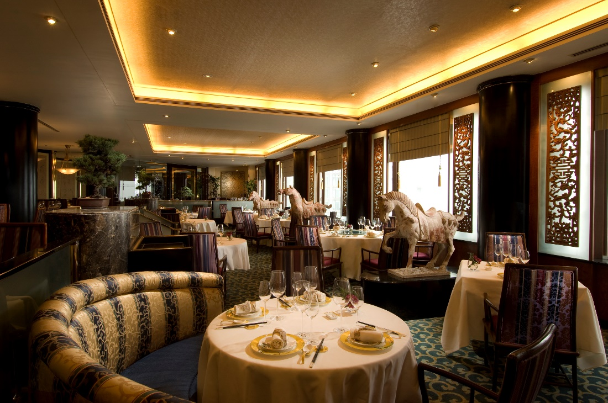
Sichuan Court Restaurant at The Kunlun Jing An

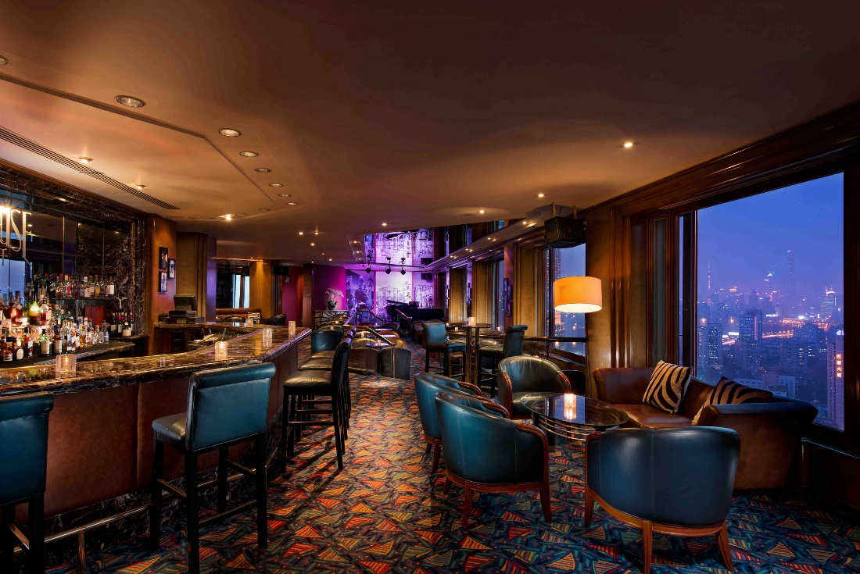
Penthouse Bar at The Kunlun Jing An

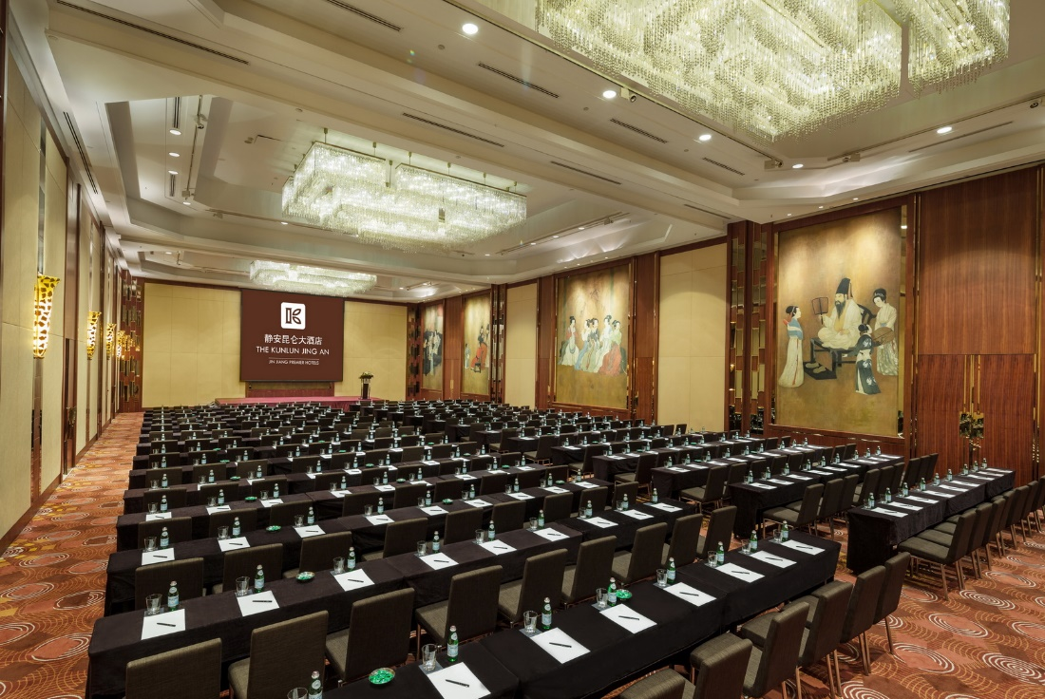
Grand Ballroom at The Kunlun Jing An

