NORWEGIAN CRUISE LINE REVEALS FALL/ WINTER 2019/20 ITINERARIES, FEATURING NEW SHIPS IN NORTH AMERICAN HOMEPORTS

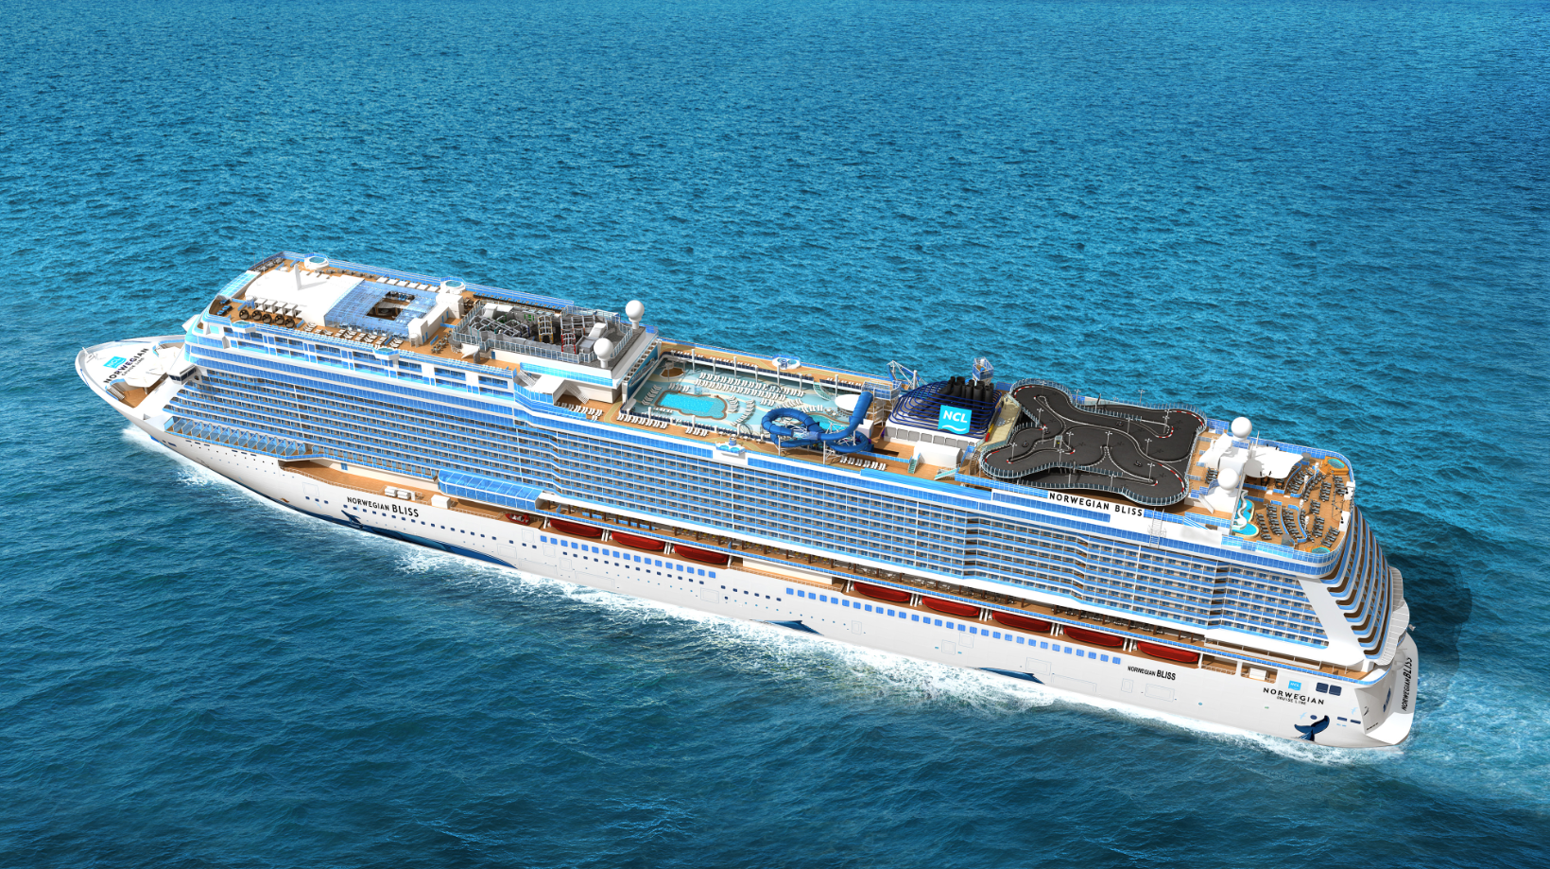
Norwegian Bliss

Guests can enjoy cruising from their favorite homeports on some of the newest ships at sea, with itinerary highlights including Norwegian Bliss sailing to the Bahamas from New York; Norwegian Getaway cruising to the Western Caribbean from New Orleans; Norwegian Breakaway sailing to the Caribbean from Port Canaveral; and the youngest ship to be based in San Juan with Norwegian Epic cruising to the Southern Caribbean

SINGAPORE – January 23, 2018 – Amidst the current winter chill gripping much of the nation, Norwegian Cruise Line today revealed selections from the fleet’s fall/winter 2019/20 deployment, which will feature a plethora of warm weather escapes to tropical paradises in the Caribbean, Bahamas & Florida and South America, as well as fall foliage sailings in Canada & New England. Most of the brand’s largest and newest vessels will each call a new city home in 2019. Norwegian’s unique and varied new itineraries, all of which feature the line’s signature cruising experience that allows guests the freedom and flexibility to design their ideal vacation, will open for sale tomorrow, January 17 for returning guests and will be available to the general public on Thursday, January 18.

“We are delighted to unveil this curated rich mix of our guests’ favorite itineraries with new deployment to exotic destinations that will bring new ships and new experiences to almost all of our homeports,” said Andy Stuart, president and chief executive officer for Norwegian Cruise Line. “Whether a guest has sailed with us many times in the past or they are a first-time cruiser, there is something new for everyone to experience in 2019 and 2020 aboard a Norwegian cruise.”

Bahamas & Florida
The all-new Norwegian Bliss, launching summer 2018, will lead the youngest fleet sailing to the Bahamas from the Big Apple for the winter 2019/20 season. Custom built for the ultimate cruising experience, Norwegian Bliss will boast an array of delectable dining with 27 different options, exhilarating activities like a two-story electric racetrack, and show stopping performances from Broadway’s best including Jersey Boys. The newest and largest ship sailing from New York, Norwegian Bliss’ winter 2019/20 itineraries will offer guests the most cruise options and widest range of itineraries, with 18 different cruises including seven and eight-day Bahamas & Florida sailings, along with longer 12 and 14-day cruises to the Southern and Western Caribbean during the heart of winter, providing a warm weather respite during the coldest months of the year.

Norwegian Bliss will homeport in the heart of Manhattan beginning on November 24, 2019 and set sail each Sunday to the warm turquoise waters of Bahamas & Florida, bringing guests the best of beaches, theme parks and sunshine on seven and eight-day cruises, with calls in Orlando and the Beaches (Port Canaveral); Norwegian’s private island Great Stirrup Cay, which is currently undergoing enhancements that will include a luxury lagoon area for Haven guests, a new zip line and more; and a call to the popular tropical island of Nassau, Bahamas.

Norwegian Gem, fresh from a bow-to-stern enhancement in late 2015 that brought new décor and new venues like the popular Sugarcane Mojito Bar and O’Sheehans Neighborhood Bar & Grill, will kick off the 2019 holiday season with an eight-day Bahamas & Florida cruise from New York on December 13, 2019. This popular family-friendly itinerary includes an overnight stay and two days in Orlando and the Beaches (Port Canaveral), a day at Norwegian’s private island Great Stirrup Cay, and a call in Nassau, Bahamas.

Those looking for a quick winter getaway to ease into the New Year over a long holiday weekend can sail away on Norwegian Dawn from Tampa for a five-day Bahamas & Florida cruise departing January 16, 2020. This one-of-a-kind itinerary features sun drenched ports and white sand beaches, with calls in Key West, Nassau, Bahamas and Norwegian’s private island, Great Stirrup Cay, which recently debuted enhanced facilities, new dining options, premium cabana furnishings and more family-friendly amenities.

Caribbean
On December 1, 2019, Norwegian Bliss will begin a 12-day journey to the Southern Caribbean, calling on the region’s most iconic destinations including San Juan, Puerto Rico; St. Thomas, U.S. Virgin Islands; Basseterre, St. Kitts; Bridgetown, Barbados; Castries, St. Lucia; and St. John’s, Antigua. Norwegian Bliss will also offer a 14-day Southern Caribbean cruise on January 19, 2020, that will additionally call in Tortola, British Virgin Islands and Philipsburg, St. Maarten.

Guests looking to cruise to the tropical rainforests and stunning dive sites of the Western Caribbean on an extended 14-day vacation at sea aboard Norwegian Bliss have two departure dates to choose from: January 5 and February 2, 2020. This spectacular itinerary includes it all, from theme parks to Mayan ruins, with calls in Orlando & the Beaches (Port Canaveral); Great Stirrup Cay, Bahamas; Ocho Rios, Jamaica; George Town, Grand Cayman; Roatán, Bay Islands, Honduras; Harvest Caye, Belize; and Costa Maya and Cozumel, Mexico.

Guests cruising from New Orleans will have the opportunity to experience some sisterly love with Norwegian Breakaway in 2018 and Norwegian Getaway in 2019. For the first time ever, Norwegian Getaway will sail a mix of seven, nine and 12-day cruises to the Western Caribbean from New Orleans beginning November 8, 2019. After fun in the French Quarter, guests can hop aboard the youngest and largest ship sailing from New Orleans for a journey to sun and sand with calls on Costa Maya, Mexico; Harvest Caye, Belize; Roatán, Bay Islands, Honduras; George Town, Grand Cayman; and Ocho Rios, Jamaica on her nine-day voyages. With her mermaid hull guiding the way, Norwegian Getaway’s seven-day Western Caribbean cruises will visit Cozumel and Costa Maya, Mexico; Roatán, Bay Islands, Honduras; and Harvest Caye, Belize. Those looking to explore deeper into the wonders of the Western Caribbean can opt for Norwegian Getaway’s 12-day cruise, which will feature calls on Cozumel and Costa Maya, Mexico; George Town, Grand Cayman; and Ocho Rios, Jamaica; Puerto Limon, Costa Rica; Roatán, Bay Islands, Honduras; and Harvest Caye, Belize.

For the first time ever, guests will have the opportunity to experience a cruise from San Juan aboard the popular Norwegian Epic. From December 8 through March 15, Norwegian Epic will be the youngest contemporary ship and largest ship homeporting in San Juan. The incredible ship will sail the Southern Caribbean on seven-day voyages with calls featuring sapphire blue waters and warm winter sun in Oranjestad, Aruba; Willemstad, Curacao; Kralendijk, Bonaire; Castries, St. Lucia; and Basseterre, St. Kitts, as well as Bridgetown, Barbados; St. John's, Antigua; Philipsburg, St. Maarten and St. Thomas, U.S. Virgin Islands on 10 and 11-day cruises. With 22 dining options and 20 bars and lounges, Norwegian Epic will offer guests more options than any other ship cruising from San Juan.

Following a year and half stay in New York, Norwegian Escape will return to the city of her christening, Miami, on November 23, 2019 and sail seven-day Western Caribbean cruises through April 18, 2020. The 4,200 guest Norwegian Escape features 27 dining options, 21 bars and lounges, as well as the largest Aqua Park and Ropes Course at sea. The ship’s seven-day Western Caribbean cruises will visit Cozumel and Costa Maya, Mexico; Roatán, Bay Islands, Honduras; and the incredibly popular Harvest Caye, Belize. Harvest Caye is a new Belizean port-of-call that features the only cruise ship pier in Belize, a two-story Flighthouse with zip lines and suspension bridges, a street-style local artisan market and opportunities for guests to visit mainland Belize on excursions to the Mayan Ruins, rafting and more.

Norwegian Breakaway will extend her stay in the Sunshine State by repositioning from Miami to Port Canaveral, arriving on November 23, 2019. As one of the largest ships to homeport in Port Canaveral, Norwegian Breakaway will spend her winter 2019/20 season sailing seven-day Eastern and Western Caribbean itineraries every Saturday. The perfect vacation for the young and young at heart, guests can experience the bustling theme parks and excitement of Orlando then head to the coast for a relaxing cruise vacation aboard the beautiful Norwegian Breakaway, which features 27 dining options, more dining options than any other ship departing from Port Canaveral. The ship’s Western Caribbean cruises will offer guests an array of beautiful, tropical destinations including Falmouth, Jamaica; George Town, Grand Cayman; and Cozumel, Mexico. During Norwegian Breakaway’s Eastern Caribbean sailings, guests will cruise to some of the most popular ports of call in the region including St. Thomas, USVI; Tortola, BVI and Norwegian’s very own exclusive, private island, Great Stirrup Cay in the Bahamas.

Norwegian Dawn will round-out the line’s deployment in the Sunshine State with her return to Tampa, with cruises departing from the west coast of the peninsula from November 24, 2019 through March 22, 2020. The recently renovated Norwegian Dawn will sail primarily seven-day Western Caribbean cruises where guests will be able to explore a variety of ports-of-call including Roatán, Bay Islands, Honduras; Cozumel and Costa Maya, Mexico; and the beautiful Harvest Caye, Belize.

Norwegian Gem will return to the Big Apple for her winter 2019 season from November 22, 2019 to March 16, 2020. Norwegian Gem will sail a variety of 10 and 11-day Southern Caribbean itineraries and one 14-day cruise from New York with ports-of-call that will include some the Caribbean’s most sun-kissed destinations including Basseterre, St. Kitts; St. John’s, Antigua; St. Thomas, USVI; and Castries, St. Lucia.

Canada & New England
Norwegian Escape’s year and a half stay in the Big Apple would not be complete without her venturing through the fall foliage and the quintessential colonial sites in Canada & New England. Throughout the month of September 2019, Norwegian Escape will offer four roundtrip seven-day cruises from Manhattan to the picturesque Canadian coastline, with calls in Portland and Bar Harbor, Maine; Saint John, Bay of Fundy, New Brunswick; and Halifax, Nova Scotia.

Panama Canal
Norwegian Dawn and Norwegian Gem, two ships which underwent extensive bow to stern renovations as a part of the Norwegian Edge® program, will both offer a selection of bucket-list cruises through the Panama Canal. Norwegian Gem will cruise from New York to San Francisco on a 20-day journey departing on January 4, 2020, and then back from the Bay City on a 21-day cruise to the Big Apple departing on January 24. Along these incredible coast-to-coast voyages, guests will experience: the sun and fun of the Caribbean with stops in Curacao and Aruba; the vibrant culture and cuisine of South America in Colombia; the adventure and eco-wonders of Central America with calls in Costa Rica, Nicaragua and Guatemala; the warm hospitality of Mexico; and the fun and fare of Southern California.

Norwegian Dawn will sail a one-of-a-kind 15-day cruise from New York to Tampa to the Panama Canal, departing on November 9, 2019. The unique open jaw sailing aboard Norwegian Dawn will feature calls on Willemstad, Curacao; Oranjestad, Aruba; Santa Marta and Cartagena, Colombia; a daytime transit of the Panama Canal, followed by calls in Puerto Limon, Costa Rica; Roatán, Bay Island, Honduras; Harvest Caye, Belize; and Costa Maya, Mexico. Norwegian Dawn will also sail a 14-day roundtrip Panama Canal cruise from Tampa departing on December 1, 2019, with stops in some of the most popular destinations in the Caribbean and Central America including George Town, Grand Cayman; Ocho Rios, Jamaica; Cartagena, Colombia; and Puerto Limon, Costa Rica, among others.

South America
Guests looking to explore the stunning beauty, vibrant culture and adventure of South America can do so on the newer and larger Norwegian Star, which replaces Norwegian Sun, beginning December 2019. Norwegian Star will sail South America for the winter season in 2019 and 2020, offering 14-day sailings from Santiago (San Antonio), Chile and Buenos Aires, Argentina. The Eastbound itineraries depart from Santiago on December 21, January 18 and February 15, while the Westbound depart from Buenos Aires, Argentina on January 4, February 1 and February 29, 2020. These spectacular journeys offer guests jaw-dropping scenery, from volcanos to alpine lakes, waterfalls and glaciers to wildlife viewing, ancient cave paintings and more, with calls in Puerto Montt, Puerto Chacabuco, and Punta Arenas, Chile; Stanley, Falkland Islands; Montevideo, Uruguay; and Puerto Madryn and Ushuaia, Argentina. During these bucket list cruises, guests will also sail the Patagonic Channels, majestic Chilean Fjords, the famous Strait of Magellan; Beagle Channel, Canal Moraleda and a bucket list sail around Cape Horn.

To book an award-winning cruise with Norwegian Cruise Line, call +852 2165 6000 (English, Cantonese and Mandarin assistance) contact your preferred travel professional or visit ncl.com.

Click here for high-resolution images of Norwegian Bliss

# # #

About Norwegian Cruise Line
Norwegian Cruise Line is the innovator in cruise travel with a 51-year history of breaking the boundaries of traditional cruising. Most notably, Norwegian revolutionized the cruise industry by offering guests the freedom and flexibility to design their ideal cruise vacation on their schedule with no set dining times, a variety of entertainment options and no formal dress codes. Today, Norwegian invites guests to enjoy a relaxed, resort-style cruise vacation on some of the newest and most contemporary ships at sea with a wide variety of accommodations options, including The Haven by Norwegian®, a luxury enclave with suites, private pool and dining, concierge service and personal butlers. Norwegian Cruise Line sails around the globe, offering guests the freedom and flexibility to explore the world on their own time and experience up to 27 dining options, award-winning entertainment, superior guest service and more across all of the brand’s 15 ships.

Recently, the line was named “Europe’s Leading Cruise Line” for the tenth consecutive year, “World’s Leading Large Ship Cruise Line” for the sixth consecutive year, the “Caribbean’s Leading Cruise Line” for the fifth consecutive year, as well as “World’s Leading Cruise Line” and “North America’s Leading Cruise Line” both for the second straight year by the World Travel Awards. Norwegian’s next new build, the highly anticipated Norwegian Bliss, will be delivered in April 2018 featuring many firsts-at-sea for the global market including the largest race track at sea, award-winning Broadway entertainment, two observation lounges for guests to enjoy stunning ocean and glacier views and more. Norwegian will introduce an additional new “Breakaway Plus” Class cruise ship in 2019 and has four additional ships on order for delivery beginning in 2022, with an option to introduce two more ships in 2026 and 2027.

For more information please contact:

Alisa Chen / Annette Wong | Lynn Koh
GHC Asia Hong Kong | GHC Asia Singapore
Phone: +852 2810 0532 | +65 6723 8161
Email:  alisa.chen@ghcasia.com  annette.wong@ghcasia.com | lynn.koh@ghcasia.com

