Press Release

Worldhotels Welcomes Three New Dorsett Properties and Extends its Footprint in the APAC Region

Dorsett Grand Chengdu, Dorsett Grand Subang, and Dorsett Kuala Lumpur joins the
growing WorldHotels family

(Singapore, 06 February 2018) – Worldhotels continues its regional expansion and proudly adds three new properties under Dorsett Hospitality International’s portfolio, comprising of Dorsett Grand Chengdu, Dorsett Grand Subang, and Dorsett Kuala Lumpur. This strategic alliance between WorldHotels and the three above Dorsett hotels, brings the total number of WorldHotels properties in Malaysia and China to seven and 27 respectively, further strengthening WorldHotels presence in these two countries.

Dorsett Grand Chengdu

Offering 556 spacious guest rooms and suites, all tastefully furnished with Asian elements and contemporary furnishings, Dorsett Grand Chengdu promises a good night’s rest in the capital of the Sichuan province in China. Each guest room features a bay window that provides panoramic views of the city, spacious and furnished with modern day amenities, a traditional Chinese Tea Board, supremely comfortable bedding and ensuite bathroom as well as WiFi to cater to the needs of today’s travellers.

Guests can delight their palates at Fu Xue Xuan Chinese Restaurant, which features a mesmerising selection of Cantonese and Sichuan delicacies, or indulge in the local and international cuisine offered at Yue Rong Café. The Lobby Lounge at Lobby level beckons every afternoon with its delightful British inspired hi-tea alongside a host of beverages and cocktails. For recreational activities, guests can opt to utilise the fully functioning 24-hour gymnasium.

Catering to the needs of business travellers and meeting planners, Dorsett Grand Chengdu is home to a 700 sqm pillarless ballroom and host of convention facilities and a business centre. It is the ideal hotel for leisure guests wanting to explore the rich cultural city of Chengdu and perfect for business travellers on the move as the property is centrally located within the CBD, with Metro Line 1 and 4 directly in front of its premises.

Dorsett Grand Chengdu Introductory Offer:
All bookings come with breakfast for up to two persons at Yue Rong Café, 24-hour guaranteed check-in, late check-out till 4 pm, welcome drink and 20% off F&B and laundry services. Offers are valid from now till 31st March 2018.

Dorsett Grand Subang
Nestled within the heart of Subang Jaya, Dorsett Grand Subang offers 478 well-appointed rooms and suites, with verdant greenery and lush landscaping surrounding the hotel’s grounds. Complimentary daily shuttle services are available in the mornings and evenings to bring guests to nearby shopping districts and industrial parks as well. On weekends, the shuttle service takes guests to exciting destinations such as KLCC, MidValley Megamall and i-City.

As the preferred venue for large conferences and elite social events, Dorsett Grand Subang is home to one of the largest pillarless ballrooms with a theatre-style seating capacity of up to 1800 people and various other versatile function rooms. The hotel also boasts of four different restaurants and bars that offer international and local Malaysian cuisines, so guests will truly be spoilt for choice when it comes to wining and dining.

Recreation facilities include a spa and outdoor swimming pool with a park adjacent to the hotel, that’s just ideal for morning jogs. Guests can also make full use of the Handy Phones, which offers complimentary Internet access, and unlimited local and international calls to Australia, Hong Kong, Indonesia, Japan, Singapore and Thailand.

Dorsett Grand Subang Introductory Offer:
20% off Best Available Rate for travel period from 1st February to 24th June 2018. Reservations are subject to rooms availability with prevailing Terms & Conditions.

Dorsett Kuala Lumpur

Perfectly situated within Kuala Lumpur’s golden triangle district, Dorsett Kuala Lumpur is mere minutes away on foot to some of the Malaysian capital’s best tourist attractions, and finest shopping malls such as KLCC, Bukit Bintang Walk, Berjaya Times Square, Starhill, and Pavilion KL. The hotel is 45-minute drive away from the Kuala Lumpur International Airport, and truly is the ideal place to stay for both leisure and business travellers alike.

The newly renovated 322 spacious rooms and suites of the hotel are elegantly decorated, equipped with 40-inch HD TV that comes with satellite channels, and are WiFi enabled. New parents and/or families with young children will also feel right at home here as baby cots and baby-sitting services are available upon request.

For the health conscious not wanting to disrupt their regular workout routines, the hotel offers a well-equipped gymnasium with 24-hour access and a free form swimming pool, all located on the same level. Food & Beverage comes in the form of the all-day dining restaurant, Checkers Café, and the Window Lounge at lobby level is the perfect spot to chill out after a day out in the city or for an evening sojourn.

Come March, Dorsett Kuala Lumpur will be celebrating its 20th Anniversary and guests can look forward to a host of exclusive monthly promotions and value offers. Diners of Checkers Café can enjoy a 4-course Value Set Dinner for just RM20 nett with every Value Set Dinner ordered at the normal price of RM55 nett. This offer is valid throughout the month of March 2018. Throughout the month of April, book a suite for just RM20 nett for the 2nd night stay with 1st night booked at Best Available Rate and 3rd night at 20% off Best Available Rate. This room offer is not valid with other offers and discounted rate. Governing terms and conditions apply.

Dorsett Kuala Lumpur Introductory Offer:
10% off Best Available Rate inclusive of buffet breakfast for up to two persons; valid from 1st February to 30th June 2018.

"We are incredibly honoured to add three more properties from one of the APAC region’s most recognised hotel chains into our growing portfolio of 350 unique, independent hotels,” says Christina Spykerman, Executive Vice President of WorldHotels Asia Pacific. “The arrival of these three extraordinary affiliates reinforces WorldHotels commitment to offer guests spectacular experiences in different destinations, and we cannot wait to further establish this burgeoning partnership with Dorsett Hospitality International.”

About WorldHotels:

• WorldHotels is dedicated to empowering the true independence of hotels all around the world. The global brand brings together 350 of the world's most unique independent hotels. With 45 years of excellence in the industry, the company's mission is to provide sales & distribution solution and consultancy to upscale hotels of character and distinction. By reaching over 50 countries and six continents, the group targets savvy business and leisure travellers that seek an authentic and local experience when choosing a hotel.

• WorldHotels solutions allow hotels to keep their independency through providing the power of a global brand with a comprehensive range of products and services that include global marketing, sales, training services, quality experience measurements, hotel business consultancy, operational support, e-commerce services and state-of-the-art distribution and technology. WorldHotels loyalty programme Peakpoints, 19 frequent flyer programmes as well the high number of preferred partnerships provide competitive advantage to the independent hotel industry

• WorldHotels is part of Associated Luxury Hotels. As the owner and operator of WorldHotels and Associated Luxury Hotels International (ALHI), Associated Luxury Hotels is a significant, full-service “soft brand” solution which provides an array of Global Sales Organisation services with broad-reaching reservations connectivity solutions and a powerful sales and marketing infrastructure.

About Dorsett Hospitality International
Headquartered in Hong Kong, Dorsett Hospitality International has three brands under its umbrella/ The upscale and midscale Dorsett Hotels & Resorts and d.Collection comprising a range of charismatic boutique hotels; and the value-led Silka Hotels. The group currently owns and manages 33 hotels in China, Hong Kong, Singapore, Malaysia and the United Kingdom; including 8 more openings in Malaysia, Australia and United Kingdom. For more information on Dorsett Hospitality International, visit: www.dorsett.com .

For reservations or information, visit WorldHotels.com. Images are available from alow@WorldHotels.com.

For most recent news, follow WorldHotels on Facebook and Twitter.
www.WorldHotels.com/facebook
www.WorldHotels.com/twitter

Issued on behalf of WorldHotels by Grebstad Hicks Communications.

For further information or hi-res images, please contact:

GHC Asia (Singapore) WorldHotels
Ms. Lynn Koh Mr. Ash Low
Tel: 65 6438 4024 Tel: 65 6227 5535
E-mail: lynn.koh@ghcasia.com E-mail: alow@WorldHotels.com

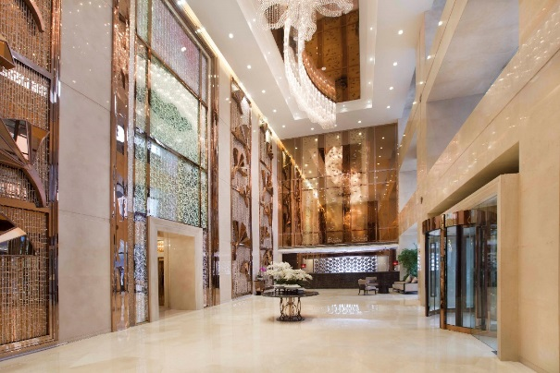
Dorsett Grand Chengdu - Lobby

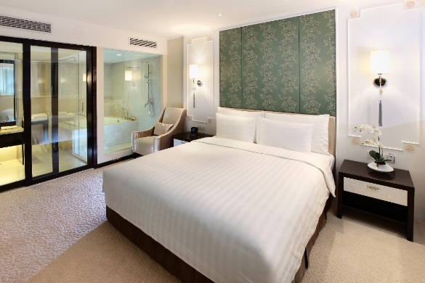
Dorsett Grand Chengdu – Dorsett Suite

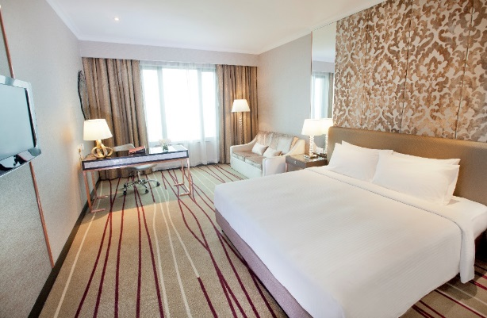
Dorsett Kuala Lumpur – Dorsett King

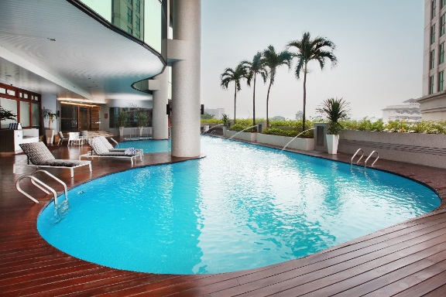
Dorsett Kuala Lumpur – Swimming Pool

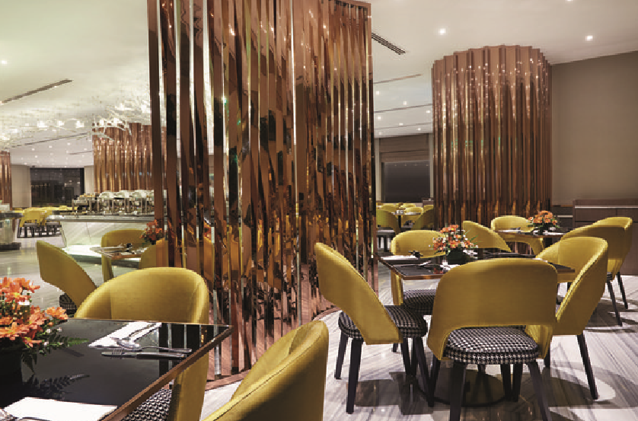
Dorsett Kuala Lumpur – Checkers Cafe

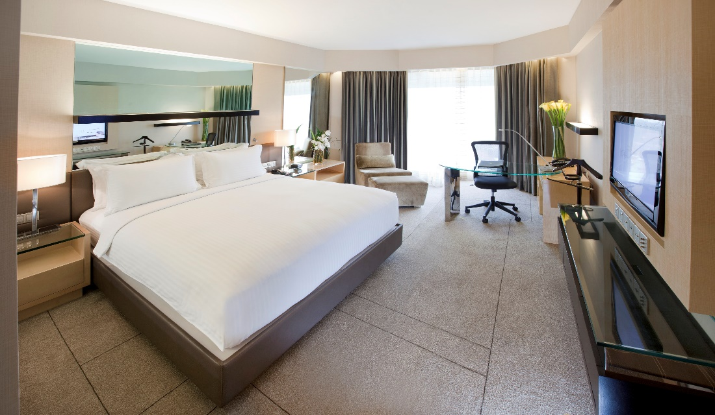
Dorsett Grand Subang – Deluxe King Room

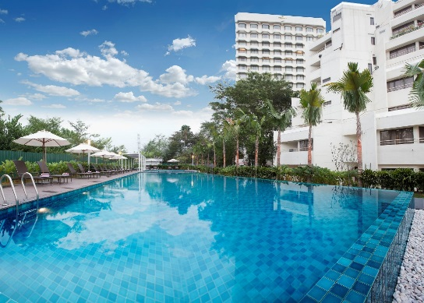
Dorsett Grand Subang – Swimming Pool

