REGENT SEVEN SEAS CRUISES CUTS STEEL AT ANCONA FOR SEVEN SEAS SPLENDOR
Construction begins for ship that will perfect luxury

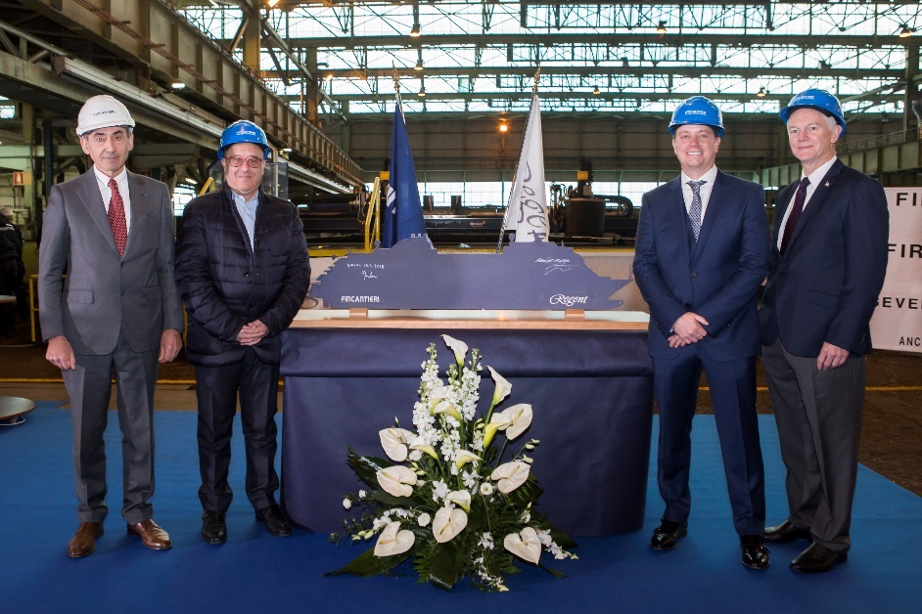

(Regent Seven Seas Cruises and Fincantieri executives together triggered the steel-cutting torch to commence the construction of Seven Seas Splendor at Fincantieri’s Ancona shipyard in Italy. Pictured from left to right are: Giovanni Stecconi, shipyard director for Fincantieri; Franco Semeraro, senior vice president of hotel operations for Regent Seven Seas Cruises and Oceania Cruises; Jason Montague, president and chief executive officer of Regent Seven Seas Cruises; and Robin Lindsay, executive vice president of Vessel Operations, Norwegian Cruise Line Holdings Ltd.

Singapore, March 26, 2018 – Construction of the ship that will elevate the standard for all-inclusive luxury has begun. Regent Seven Seas Cruises’ President and Chief Executive Officer Jason Montague, Norwegian Cruise Line Holdings’ Executive Vice President of Vessel Operations Robin Lindsay, Regent’s Senior Vice President of Hotel Operations Franco Semeraro and Fincantieri’s Shipyard Director Giovanni Stecconi today pressed the button to ignite the cutting torch at Fincantieri Ancona to shape the first plate of steel for Seven Seas Splendor. The new 750-guest ship will join the Regent fleet in early 2020, in pursuit of the ultimate achievement – perfection.

“This is truly an exciting moment for us and we are delighted to work with the skillful engineers of Fincantieri Shipyard to build our new ship that will again raise the standards of luxury for the industry,” said Mr. Montague. “Regent has been committed to delivering the most beautiful destinations with impeccable personalized service aboard elegant and intimately spacious ships for more than 25 years. With the first steel cut for Seven Seas Splendor in Ancona, we are now underway to realizing our plans for the new ship that will perfect luxury.”

The inaugural season for the all-suite, all-balcony ship will go on sale this spring. Seven Seas Splendor will join Regent’s most luxurious fleet in the world comprising Seven Seas Explorer, Seven Seas Voyager, Seven Seas Mariner, and Seven Seas Navigator.

About Regent Seven Seas Cruises
Regent Seven Seas Cruises is the world's most inclusive luxury experience with a four-ship fleet that visits more than 450 destinations around the world. Seven Seas Mariner’s upcoming 2018 drydock refurbishment will conclude Regent Seven Seas Cruises’ $125 million refurbishment program to elevate the elegance of the whole fleet to the standard set by Seven Seas Explorer. In early 2020, Regent will perfect luxury with the launch of Seven Seas Splendor. The cruise line’s fares include all-suite accommodations, round-trip business-class air on intercontinental flights from U.S. and Canada, the largest collection of free, unlimited shore excursions, unlimited internet access, highly personalized service, exquisite cuisine, fine wines and spirits, prepaid gratuities, ground transfers and one-night, pre-cruise hotel package for guests staying in Concierge-level suites and higher. For more information about the world’s most inclusive luxury experience, or to make a reservation, please contact a professional travel agent, visit www.RSSC.com, or call 1-844-4REGENT (1-844-473-4368). For the latest news, please visit www.RSSC.com/news; like the line’s Facebook page; and follow @RegentCruises on Twitter. Regent Seven Seas Cruises is a brand of Norwegian Cruise Line Holdings Ltd. (NYSE: NCLH)

About Fincantieri
Fincantieri is one of the world’s largest shipbuilding groups and number one by diversification and innovation. It is leader in cruise ship design and construction and a reference player in all high-tech shipbuilding industry’s sectors, from naval to offshore vessels, from high-complexity special vessels and ferries to mega-yachts, ship repairs and conversions, systems and components production and after-sales services.

Headquartered in Trieste (Italy), the Group has built more than 7,000 vessels in over 230 years of maritime history. With more than 19,400 employees, of whom more than 8,200 in Italy, 20 shipyards in 4 continents, today Fincantieri is the leading Western shipbuilder. It has among its clients the major cruise operators, the Italian and the U.S. Navy, in addition to several foreign navies, and it is partner of some of the main European defense companies within supranational programmes.

*High Resolution images can be downloaded here.

# # #

For more information please contact:

Sarah Arts/ Lynn Koh
GHC Asia Singapore
+65 67238123
sarah.arts@ghcasia.com
lynn.koh@ghcasia.com

