Press Release
WorldHotels Appoints Two New Senior Executives in Asia Pacific and Strengthens Sales Force in the US

Singapore, 10 April 2018 – WorldHotels, a global sales, marketing and distribution company is pleased to announce the appointments of James Koh and Ganessan Suppiah, who now serve as Regional Vice President of Hotel Development, and Regional Vice President of Sales in Asia Pacific respectively.
Based in Singapore, James Koh has been a part of the WorldHotels family for more than 11 years. James started his career in the Corporate Sales environment at Raffles International and Grand Hyatt Singapore, before joining WorldHotels as an Account Manager for the Membership Services team in Asia Pacific. Under the newly restructured Performance & Revenue Optimisation department, he moved to Shanghai in 2008 and stayed for over seven years to better manage the group’s growing portfolio in the Greater China region. Upon his return to Singapore in 2014, he took on a new challenge in the Hotel Development department and now serves as Regional Vice President of Hotel Development Asia Pacific, where he oversees the portfolio development efforts for the region.
A veteran of the hospitality industry for over 30 years, Ganessan Suppiah has served WorldHotels for over 11 years and was recently promoted to Regional Vice President of Sales – Asia Pacific. Ganessan has been a driving force of the Sales department when he first started off as the Director of Sales for Australia and New Zealand in 2007, before moving to the United Kingdom for his new role as Regional Director of Sales for the UK, Ireland, Nordic and Russia in 2016. On returning from London, in his current role, Suppiah leads all sales strategies and initiatives in the region, out of his base in Sydney, Australia.
Other recent appointments outside the APAC region include, Tim Burke, who joins the organisation as Global Director, Travel Industry Partnerships. Currently based in Dallas, Burke was employed by Hilton Hotels for 22 years and has held positions such as National Account Executive, Director of Marketing and most recently Director for Worldwide Travel Industry Relations.
Fernando Carranza, a Sales and Marketing professional with more than 15 years’ experience has also recently joined WorldHotels as the Regional Director of Sales. He is currently based in Los Angeles, and was previously the Director of Global Sales for Carlson Rezidor Hotel Group, and Director of Global National Corporate Accounts for Hilton Hotels.
“We are thrilled to have both James and Ganessan take on larger roles and responsibilities, and very excited to welcome Tim and Fernando into our organisation,” says Geoff Andrew, Executive Chief Executive Officer of WorldHotels. “Their expertise, experience, and long-time connections within the hospitality industry will undoubtedly drive further business and expand the WorldHotels footprint on a global scale.”

About WorldHotels:
WorldHotels is dedicated to empowering true independence of hotels all around the world. The global brand brings together 350 of the world's most unique independent hotels. With more than 45 years of excellence in the industry, the company's mission is to provide sales & distribution solutions and consultancy to upscale hotels of character and distinction. By reaching over 50 countries and six continents, the group targets savvy business and leisure travelers that seek an authentic and local experience when choosing a hotel.
WorldHotels solutions allow hotels to keep their independence through providing the power of a global brand with a comprehensive range of products and services that include global marketing, sales, training services, quality experience measurements, hotel business consultancy, operational support, e-commerce services and state-of-the-art distribution and technology. WorldHotels, having more than 20 frequent flyer programs along with the high number of preferred partnerships provide competitive advantage to the independent hotel industry.
WorldHotels is part of Associated Luxury Hotels. As the owner and operator of WorldHotels and Associated Luxury Hotels International (ALHI), Associated Luxury Hotels is a significant, full-service “soft brand” solution which provides an array of Global Sales Organization services with broad-reaching reservations connectivity solutions and a powerful sales and marketing infrastructure.

For reservations or information, visit WorldHotels.com. Images are available from slim@worldhotels.com..
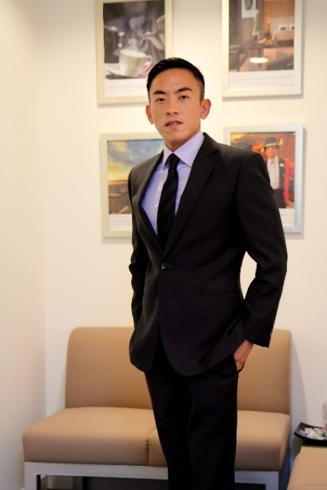
James Koh, Regional Vice President of Hotel Development, Asia Pacific
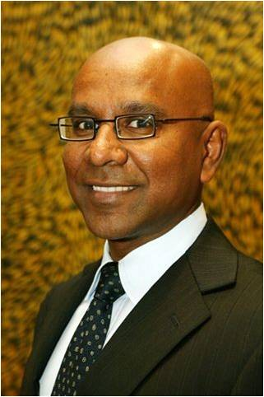
Ganessan Suppiah, Regional Vice President of Sales, Asia Pacific
Tim Burke, Global Director, Travel Industry Partnerships
Fernando Carranza, Regional Director of Sales, West Coast USA

