Press Release

The Blushing Lady — An Elegant Valentine’s Day Cocktail by Morton’s of Chicago
In an ode to Valentine’s Day Morton’s introduces a brand new cocktail
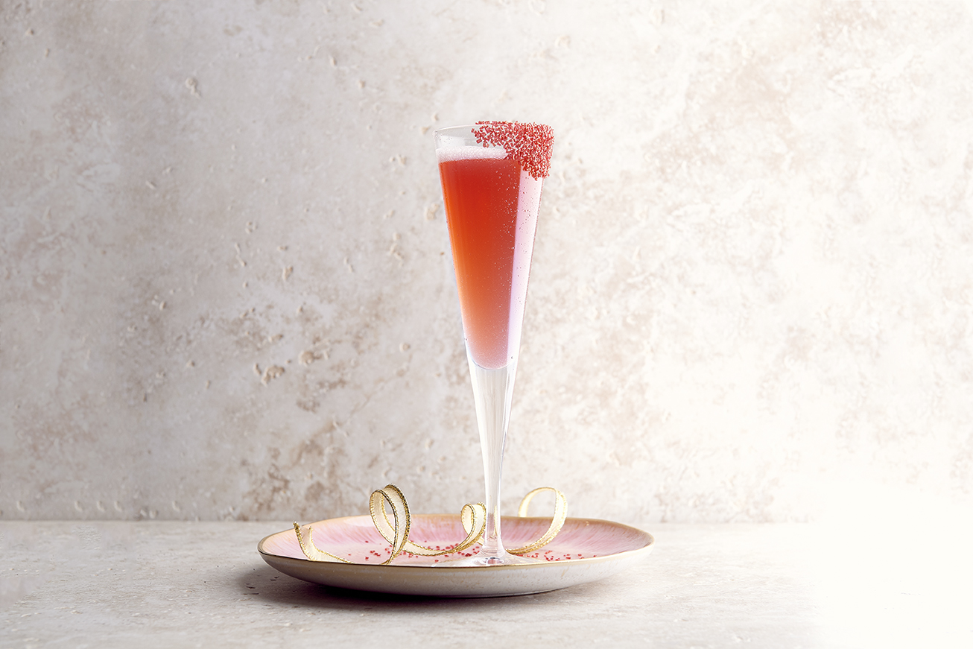

(Singapore, 23 January 2018) – Let us not forgot that Valentine’s Day is a day that commemorates unrequited love and lonely hearts. So whilst couples will be happily carving into their favourite steak at Morton’s of Chicago, The Bar will be debuting its latest cocktail – The Blushing Lady, in an ode to Valentine’s Day. With it, hopefully serving-up some courage for those single that are ready to mingle at the bar.

The elegant prosecco-based creation pays homage to Morton’s all-American character with a cheerful splash of bourbon, and is finished off with cranberry juice, fresh lime, pomegranate liqueur and a cinnamon sugar rim. Served in an elegant champagne flute, the rose-colored creation sets the tone for a romantic evening ahead. The Blushing Lady is available at both the bar and the restaurant, from 10-16 February 2018.
Dark, masculine and brooding, in a Marlon Brando sense, The Bar at Morton’s oozes sophisticated American style, making it the ideal spot for singles to brush shoulders this Valentine’s Day. They’ll be able to order The Blushing Lady cocktail or any tipple to their taste, from the catalogue of spirits and wines available. As well as indulge on Morton’s famed steak sandwiches doing the rounds.

For those happily hitched, why not treat your significant other to a mouth-watering dinner. From the succulent steaks and seafood and vast wine selections to the seamless service, Morton’s has all the elements to make for a memorable night. Renowned for its hallmark steaks, meat-lovers will be spoiled for choice when they have to choose amongst the substantial 14oz Bone-in Filet Mignons, Porterhouse Steaks, Centre-Cut Prime Ribeye’s, Five Peppercorn Rubbed Prime Strip Steaks just to name a few.

Morton’s of Chicago is located at The Mandarin Oriental Hotel Singapore, 4th Storey, 5 Raffles Avenue, Singapore. Reservations can be made at tel. (65) 6339-3740 or via www.mortons.com
- Ends -

Issued by GHC Asia on behalf of Morton’s of Chicago, The Steakhouse

For media enquiries, please contact:
Sarah Arts
GHC Asia – Singapore
Tel: (65) 6723 8123
Email: sarah.arts@ghcasia.com

About Landry’s, Inc./ Morton’s The Steakhouse
Landry’s, Inc., wholly owned by Tilman J. Fertitta, is a multinational, diversified restaurant, hospitality, gaming and entertainment company based in Houston, Texas. The company operates more than 500 high-end and casual dining establishments around the world, including well-known concepts such as Landry’s Seafood, Bubba Gump Shrimp Co., Rainforest Cafe, Mitchell’s Fish Market Restaurants, Morton’s The Steakhouse, The Oceanaire, McCormick & Schmick’s Seafood, Chart House, Saltgrass Steak House, Claim Jumper and Mastro’s Restaurants.

Landry’s also operates a group of signature restaurants, including Vic & Anthony's, Grotto, Willie G's and others. Landry’s gaming division includes the renowned Golden Nugget Hotel and Casino concept, with locations in Las Vegas and Laughlin, Nev.; Atlantic City, N.J.; Biloxi, Miss.; and Lake Charles, La. Landry’s entertainment and hospitality divisions encompass popular destinations including the Galveston Island Historic Pleasure Pier, Kemah Boardwalk, Aquarium Restaurants and other exciting attractions, coupled with deluxe accommodations throughout the Houston and Galveston area, including the luxurious San Luis Resort, Spa & Conference Centre on Galveston Island.

