NORWEGIAN CRUISE LINE PARTNERS WITH JUST GOODS, INC.
TO ELIMINATE SINGLE-USE PLASTIC BOTTLES ACROSS FLEET

-Norwegian will be the First Major Global Cruise Company to Become
Plastic Bottle Free by January 1, 2020

-Over Six Million Plastic Bottles to Be Eliminated Each Year

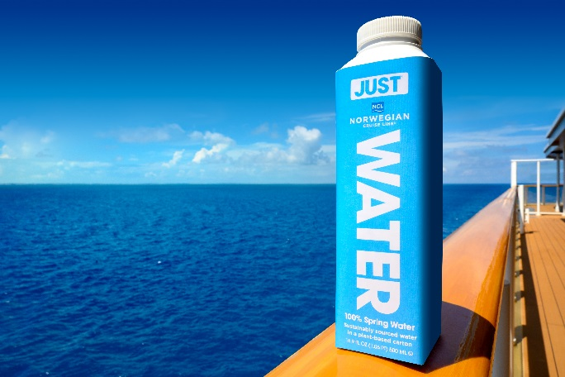
HONG KONG (Oct 9 , 2019) – Norwegian Cruise Line, the innovator in global cruise travel with a 52-year history of breaking boundaries, today announced another first as a result of its partnership with JUST® Goods, Inc., which will enable the Cruise Line to replace all single-use plastic bottles across its fleet by January 1, 2020, beginning with its newest innovative ship, Norwegian Encore.
Norwegian Cruise Line partners with JUST® Goods, Inc. to eliminate plastic bottles from its fleet by Jan. 1, 2020.
The decision is the latest sustainable step forward for Norwegian Cruise Line. In 2018, the Company eliminated single-use plastic straws across its 16-ship fleet and private destinations, and as a result of this most recent initiative, it will replace over six million single-use plastic bottles every year. These efforts are driven by the Company’s Sail & Sustain Environmental Program which is its commitment to minimize waste to landfills, reduce its CO² emissions rate, increase sustainable sourcing and invest in emerging technologies.
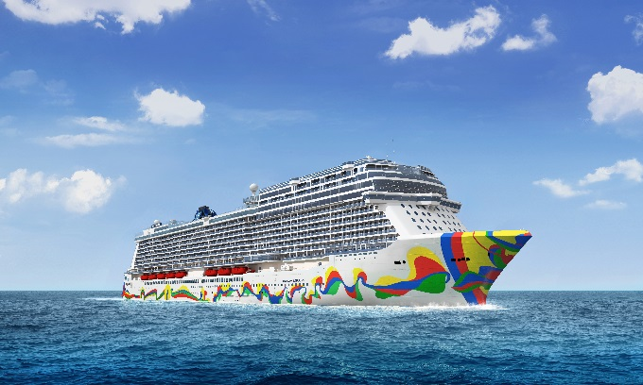
“We are a leading Company – one that is in the business of creating memorable experiences for our guests,” said Andy Stuart, president and chief executive officer of Norwegian Cruise Line. “It is imperative that we take meaningful steps to preserve our oceans and the destinations we visit. Partnering with JUST is one of my proudest moments as the head of our pioneering brand. This latest effort – the elimination of single-use plastic bottles across our fleet – is just the latest environmentally responsible action we are taking to reduce our footprint and encourage others to protect our natural resources. While we are aware that this is just the beginning of what we and others need to do to be good stewards of our environment, we are committed to our Sail & Sustain initiatives and will continue to innovate for the overall benefit of the planet and its future.”
Norwegian Encore to debut in Miami November 2019.
Envisioned and founded by American rapper, songwriter, actor and activist Jaden Smith and family, JUST takes an innovative approach to sourcing and packaging the world’s most valued resource - water. The revolutionary company focuses on an impact model, taking into consideration both how the water is sourced and packaged. JUST is 100% spring water in a plant-based carton. The carton is made of 82% renewable materials – the paper carton is made from trees grown in responsibly-managed forests and the cap and shoulder are made from a sugarcane-based plastic. It is refillable and recyclable. JUST has a global presence with bottling facilities in Glenn Falls, NY; Ballymena, Northern Ireland; and Ballarat, Australia, thus allowing the company to meet demand around the world without shipping water from a single production source. JUST takes care to use the most efficient shipping options available.
“It’s critical that businesses take a leading role in efforts to lighten the impact we have on our planet,” said JUST Goods, Inc. CEO Ira Laufer. “We created JUST to do just that – to be a better option in a category that has created a lot of the damage and continues to do so. The JUST team couldn’t be happier to now share this goal with our partner, Norwegian Cruise Line. We’re deeply appreciative of Norwegian’s commitment that’s so similar to ours – the Company is pushing the boundaries of what’s always been done because it knows we all need to do better. We’re thrilled to be taking steps in the right direction alongside NCL.”
For more information about Norwegian Cruise Line ships and their itineraries, or to book a cruise, please contact a travel professional, call 888-NCL-CRUISE (625-2784) or visit www.ncl.com.
For Norwegian Encore’s press kit and assets, click here.

###
About JUST Goods, Inc.

JUST Goods, Inc. is a global consumer goods company dedicated to producing responsibly sourced products, contained in sustainable packaging. The company's first product, JUST Water, is 100% spring water ethically sourced from Upstate New York, packaged in a bottle made of 82% renewable resources. A Certified B-Corp, the company's mission to create environmental and social value along the supply chain extends to partnerships with environmental non-profits, key members of the science and innovation community, as well as university collaborations, hospitality partnerships, event alliances and community projects. JUST Water is now being produced in three countries - the US, the United Kingdom and Australia. JUST products can be found in a growing number of grocery retail locations, hotels, schools, cultural locations and entertainment venues worldwide. For more information please visit www.justwater.com.
About Norwegian Encore
Taking the brand’s exclusive, stand-out attractions to the next level, Norwegian Encore will feature the world’s longest race track at sea at 1,100 feet with four high-speed curves extending up to 13 feet over the side of the ship; the largest outdoor laser tag arena at nearly 10,000 square feet with the addition of augmented reality elements; and new immersive escape room and interactive theatre experiences in the 10,000-square-foot Galaxy Pavilion.
In addition to featuring many of the highly rated restaurants and lounges that have made the Breakaway Plus class one of the most innovative and successful in the company’s history, Norwegian Encore will debut a new elevated Italian dining experience, Onda by Scarpetta, in collaboration with LDV Hospitality. The Tony Award®-winning musical, “Kinky Boots” will headline the world-class entertainment on board, with returning guest favorites “The Choir of Man,” “Happy Hour Prohibition: The Musical” and the rocking Beatles cover band of The Cavern Club.
Launching this fall, Norwegian Encore will offer seven-day voyages to the Eastern Caribbean from Miami beginning Nov. 24, 2019; Bermuda, and Canada and New England itineraries from New York City beginning Apr. 22, 2020; voyages to the Western Caribbean from Miami beginning Dec. 12, 2020; and in the spring of 2021 will make her West Coast debut and sail to Alaska from Seattle.
About Norwegian Cruise Line
As the innovator in global cruise travel, Norwegian Cruise Line has been breaking the boundaries of traditional cruising for over 52 years. Most notably, the cruise line revolutionized the industry by offering guests the freedom and flexibility to design their ideal vacation on their preferred schedule with no assigned dining and entertainment times and no formal dress codes. Today, its fleet of 16 contemporary ships sail to nearly 300 of some of the world’s most desirable destinations, including Great Stirrup Cay, the company’s private island in the Bahamas and its resort destination Harvest Caye in Belize. Norwegian Cruise Line not only provides superior guest service from land to sea, but also offers a wide variety of award-winning entertainment and dining options as well as a range of accommodations across the fleet, including solo-traveler staterooms, mini-suites, spa-suites and The Haven by Norwegian®, the company’s ship-within-a-ship concept. For additional information or to book a cruise, contact a travel professional, call 888-NCL-CRUISE (625-2784) or visit www.ncl.com. For the latest news and exclusive content, visit the media center and follow Norwegian Cruise line on Facebook, Instagram and YouTube @NorwegianCruiseLine; and Twitter and Snapchat @CruiseNorwegian.
For media enquiries, please contact:
Chloe Chan / Nancy Ho | Ng Yuin Yi / Joleena Seah | Renee Jiang / Zeno Tam
GHC Asia Hong Kong | GHC Asia Singapore | GHC Asia Shanghai
Phone: +852 2810 0532 | Phone: +65 6723 8144 | Phone: +86 21 5213 3030
Email:  chloe.chan@ghcasia.com  nancy.ho@ghcasia.com | Email:  yuinyi.ng@ghcasia.com  joleena.seah@ghcasia.com | Email:  renee.Jiang@ghcasia.com  zeno.tam@ghcasia.com

