Regent Seven Seas Cruises® To Debut New Serene Spa & WellnessTM Fleetwide, The Cruise Industry’s Most Luxurious, Globally Inspired Spa

A new experience in travel wellness, Regent guests will enhance their voyage with exclusive, destination-inspired spa treatments, rejuvenating fitness classes, nutritionally balanced cuisine and wellness tours as they journey around the world

~
Serene Spa & Wellness™, originally designed to perfect luxury on board Seven Seas SplendorTM, will launch fleetwide ahead of Seven Seas Splendor’s maiden voyage

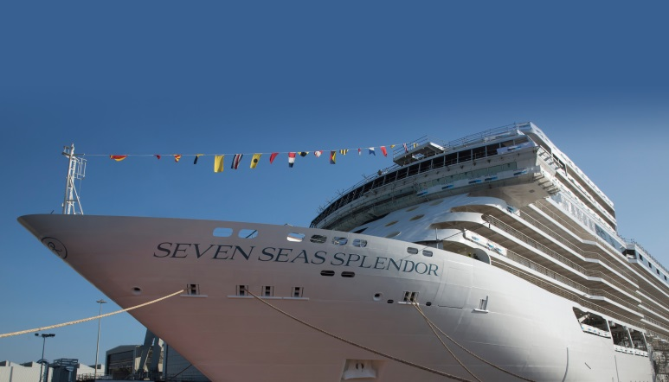

Hong Kong (Oct. 16, 2019) – Regent Seven Seas Cruises®, the world’s leading luxury ocean cruise line, introduced a new globally inspired spa brand that will debut across its five-ship fleet this winter. Serene Spa & WellnessTM will offer exclusive treatments integrating techniques and ingredients from destinations around the world, creating a tranquil haven of health, beauty and wellness that offers restorative treatments and services to soothe both the body and mind.

The groundbreaking menu of services reflects treatments originating from many of the 450 destinations to which the cruise line sails, and includes globally renowned ELEMIS facial therapies, body treatments, massages, manicures, pedicures, luxury Kérastase salon services, fitness classes, and personal training, plus a series of wellness tours and nutritionally mindful cuisine selections served in restaurants on board.

“Regent is deeply inspired by the peace and serenity that can be found in every region of our globe, and we are bringing the beautiful traditions and tried-and-true techniques of the world’s cultures into the exclusive experiences of Serene Spa & Wellness™ through spa treatments, cuisine and captivating shore excursions,” said Jason Montague, president and CEO of Regent Seven Seas Cruises. “We originally developed this innovative experience for Seven Seas SplendorTM in our pursuit to perfect luxury for our newest ship, and then decided to expand Serene Spa & Wellness™ for guests to embark on a global journey of relaxation on all Regent ships. Serene Spa & Wellness™ will set a new benchmark in luxury spas at sea.”

Experience the best of destination-inspired body and beauty treatments
Serene Spa & Wellness™ integrates globally sourced, natural ingredients that promote health and balance for the body, mind and spirit. In addition to traditional spa services, examples of globally inspired techniques and treatments offered exclusively at Serene Spa & Wellness™ on Regent Seven Seas Cruises include:
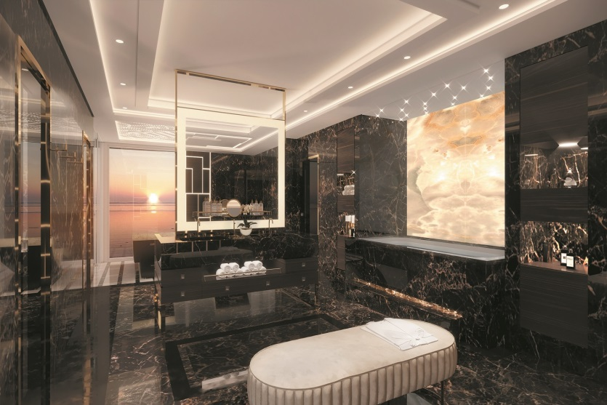

- The Regent Massage. (Destination Inspiration: Sea Buckthorn from the Mediterranean coast)
This bespoke full-body therapy features a synergy of rosemary, sea fennel and sea buckthorn from the Mediterranean coastlines worked into areas of tension to ease and soothe muscles while helping to detoxify. Warm eucalyptus-infused paraffin mitts and boots enhance this signature experience, deeply nourishing and hydrating hands and feet.

- Around The World Massage. (Destination Inspirations: Basalt from China, Coconut Poultice from Caribbean, Bamboo from Asia)
Fusing techniques from the corners of the world, this choreographed therapy is one of optimal wellness: the earthly scents of Indian cardamom, Egyptian coriander and eucalyptus soothe the mind; Swedish massage movements work freely throughout the body to relax; volcanic rocks release muscle tension and stagnant energy in the legs; bamboo stalks glide over muscles to deeply alleviate discomfort; warmed coconut poultices are delicately worked over the face, neck and shoulders; and
argan oil from Morocco conditions the scalp.

- Sea Lavender & Samphire Body Polish. (Destination Inspiration: Samphire from Northern Europe)
Hydrate skin with a nourishing, exfoliation duo. Nutrient-rich extracts from sea lavender and samphire smooth parched, dry skin cells while a moisturizing milk of macadamia nut and sea salt moisturize to allow a thirsty skin to replenish. This lavish body experience includes half or full-body massage.

- Deep Sea Heat Mask & Massage. (Destination Inspiration: Bladderwrack Seaweed from Baltic Coast)
Recharge your body with a detoxifying treatment designed to alleviate deep-seated tension and muscular distress. Rich in minerals and trace elements, an aromatic, warm mask with potent algae from the Baltic Sea is applied on to the back to release tension and ease aches and pains while a back or full-body massage relaxes the body.

- Calming Rose Facial. (Destination Inspiration: Hand-picked Organic English Roses from the United Kingdom)
Comfort sensitive skin with a natural blend of delicate rose absolute to intensely hydrate the dermis. Luxuriously indulgent, precious rose extracts smooth fine lines, strengthening and protecting the skin’s barrier. A warm rose balm is massaged onto the hands and arms to induce relaxation. Skin is left feeling soothed and replenished with a petal softness.

- Kérastase® Elixir Ultime 24-Carat Indulgent Ritual. (Destination Inspiration: Rose from Morocco)
This indulgent hair ritual nourishes, protects and instantly restores hair. Relax with the aromatic scent of rose during a luxurious treatment in which camellia and marula oils and white tea extracts are massaged deep into the scalp. This highly concentrated experience provides a sublime transformation, leaving hair silky, weightless and beautiful.

- Regent Manicure and Pedicure. (Destination Inspiration: Frangipani from the South Pacific)
Hands and feet are soaked in a hydrating milk protein while a vitamin-rich oil strengthens nails and cuticles. Warmed frangipani oil is massaged to further replenish moisture. Includes filing, cuticles and polish.

A full menu of treatments is available on Regent’s website at https://www.rssc.com/experience/onboard-activities/spa-fitness, including a Serene Spa & Wellness™ brochure.

Image download link:： https://www.dropbox.com/sh/tj6fa7v9chad9lt/AAAMYsiLBzSJxt5mrHumNDgma?dl=0

Focusing on holistic wellness, both on ship and on shore
Serene Spa & Wellness™ services extend beyond the physical spa venue:

- Fitness experts at Fitness by Serene Spa & Wellness™ lead popular exercise classes, such as Pilates, yoga and meditation and are available to offer advice and demonstrate the use of fitness equipment. Equipment includes spinning bikes, dumbbells, treadmills, Technogym® strength machines, workout mats and step benches. One-on-one training can be arranged with a fitness instructor.

- Savor the best of world cuisine with Serene Spa & Wellness™ Selections in many restaurants on board. Drawn from a globally inspired approach to healthy living, these culinary dishes are as flavorful as they are nutritious. An extensive array of innovative options is available in restaurants across Regent’s fleet, featuring exquisite dishes influenced by a myriad of global fares including delectable plant-based cuisine.

- Serene Spa & Wellness™ Tours offer curated shore excursions designed to enhance wellness through immersive experiences. Soak in a restorative, mineral-rich thermal spring in Rome or experience a taiji (tai chi) class on a beautiful and serene beach on Palma de Mallorca. Guests can refresh with a Mediterranean breeze as they calm their mind and strengthen their focus through a yoga class overlooking the seaside town of Taormina.

- Experience the healing, detoxifying and tension-releasing power of the European-inspired Serene Spa & Wellness™ Hydrothermal Suite, exclusive to Seven Seas Splendor™ and Seven Seas Explorer®. Relax before or after spa treatments and enjoy Regent’s multisensory aromatherapy steam room, chill room, infrared sauna and experiential showers.

Serene Spa & Wellness™ opening schedule
Serene Spa & Wellness™ will launch on each Regent ship during these voyages:

- Seven Seas Explorer® - Dec. 7, 2019 voyage
- Seven Seas Mariner® - Jan. 6, 2020 voyage
- Seven Seas Voyager® - Jan. 7, 2020 voyage
- Seven Seas Navigator® - Jan. 23, 2020 voyage
- Seven Seas SplendorTM - Feb. 6, 2020 voyage

About Regent Seven Seas Cruises
Regent Seven Seas Cruises offers an unrivaled experience to luxury travelers. The cruise line’s modern four-ship fleet visits more than 450 iconic and immersive destinations around the world, and will add Seven Seas SplendorTM in 2020 as the fleet’s fifth ship and then grow by a sixth ship in 2023. All luxuries are included in Regent Seven Seas Cruises voyages, such as all-suite accommodations, round-trip business-class air on intercontinental flights from U.S. and Canada, the largest collection of unlimited shore excursions, unlimited internet access, highly personalized service, exquisite cuisine, fine wines and spirits, gratuities, ground transfers and one-night, pre-cruise hotel packages for guests staying in Concierge-level suites and higher. In 2018 the cruise line concluded a $125 million refurbishment program of Seven Seas Mariner, Seven Seas Voyager and Seven Seas Navigator to elevate the fleet’s elegance to the benchmark set by Seven Seas Explorer. For more information please visit www.RSSC.com, call Singapore 800-616-7097 / India 0008-0004-01055 / Hong Kong and Rest of Asia +852 2165 6020 or contact a professional travel advisor to inquire about specific Regent Seven Seas Cruises voyages, including Seven Seas Splendor sailings.

# # #

For media enquiries, please contact:

Chloe Chan / Nancy Ho | Ng Yuin Yi / Joleena Seah | Renee Jiang / Zeno Tam
GHC Asia Hong Kong | GHC Asia Singapore | GHC Asia Shanghai
Phone: +852 2810 0532 | Phone: +65 6723 8144 | Phone: +86 21 5213 3030
Email:  chloe.chan@ghcasia.com  nancy.ho@ghcasia.com | Email:  yuinyi.ng@ghcasia.com  joleena.seah@ghcasia.com | Email:  renee.Jiang@ghcasia.com  zeno.tam@ghcasia.com

