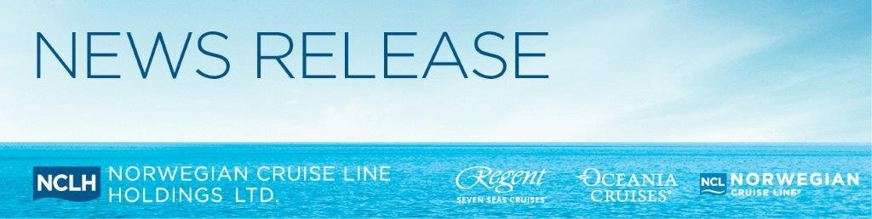

Norwegian Cruise Line Holdings Announces Organisational Enhancements in the Asia Pacific Region to Support Ongoing Growth

Hong Kong – 21 October 2019: Norwegian Cruise Line Holdings Ltd. (NYSE: NCLH), a leading global cruise company which operates Norwegian Cruise Line (NCL), Oceania Cruises (OCI) and Regent Seven Seas Cruises (RSSC), has today announced a number of strategic organisational enhancements in the Asia Pacific region (APAC).

Designed to provide a more distinct focus for each respective brand under the NCLH banner, the new organisational realignment in APAC reflects enhancements at head office level in Miami, including the new appointment of Harry Sommer as President and Chief Executive Officer NCL.

The new direction will see Steve Odell spearhead the company’s upper-premium and luxury brands as Senior Vice President and Managing Director OCI and RSSC APAC and Ben Angell leading the contemporary brand as Vice President and Managing Director NCL APAC.

Ben Angell’s new appointment as Vice President and Managing Director NCL APAC will see him oversee the sales, marketing and passenger services functions for NCL across the APAC region. Reporting to Ben will be Felix Chan, Vice President and General Manager NCL Asia, who will continue his successful leadership of NCL brand in the region.

“I am incredibly excited to be part of NCL’s strategic expansion in the fast-growing APAC market, further growing NCL’s share of the upper-contemporary cruising space for which the brand is renowned,” said Mr Angell, Vice President and Managing Director Asia Pacific at NCL. “I am also delighted that Felix Chan will continue his role for NCL in the region and build on the impressive growth he and his team have already achieved in our key Asia markets.”

“The growth NCL has experienced over the past four years has been phenomenal, with so much more potential to be realised following the launch of Norwegian Encore this November, as well as six new Leonardo Class ships – one every year from 2022 until 2027,” added Mr Angell.

Leveraging his comprehensive specialist experience in upper premium and luxury cruise line operations and promotion, Steve Odell, Senior Vice President and Managing Director OCI and RSSC APAC will oversee the sales, marketing and passenger services functions for OCI and RSSC across APAC.

Mr Odell has over 20 years of experience working with luxury brands across the Asia region. He was instrumental in establishing the luxury cruise business in Asia from his first tenure in the region in 2001 and has worked with travel partners in all the key regional markets. He was a founding board member of the Asia Cruise Association, prior to the establishment of CLIA in the region.

Reporting to Steve in Asia will be Constance Seck, Director of Sales OCI & RSSC Southeast Asia and India; Chisato Morita, General Manager OCI & RSSC Japan; and Holly Kong, Director of Sales OCI & RSSC Northeast Asia.

“I am delighted to be an integral part of this new era for NCLH in APAC, where we are laying long-term foundations to ensure forecasted future growth can be accommodated and maximised,” said Mr Odell.

“With the cruise industry continuing to experience double-digit growth across the APAC region - coupled with NCLH having eleven new ships on order for delivery through 2027, and the local deployment of eleven NCLH vessels in the APAC region alone in 2020 - we are investing more in the local market than ever before. As such, putting in place now the appropriate levels of commercial leadership required to support and nurture this growth is imperative,” said Mr Odell, Senior Vice President and Managing Director OCI and RSSC APAC.

About Norwegian Cruise Line Holdings Ltd.

Norwegian Cruise Line Holdings Ltd. (NYSE:NCLH) is a leading global cruise company which operates the Norwegian Cruise Line, Oceania Cruises and Regent Seven Seas Cruises brands. With a combined fleet of 26 ships with approximately 54,400 berths, these brands offer itineraries to more than 450 destinations worldwide. The Company will introduce eleven additional ships through 2027.
As the innovator in global cruise travel, Norwegian Cruise Line has been breaking the boundaries of traditional cruising for over 52 years. Most notably, the cruise line revolutionised the industry by offering guests the freedom and flexibility to design their ideal holiday on their preferred schedule with no assigned dining and entertainment times and no formal dress codes. Today, its fleet of 16 contemporary ships sail to nearly 300 of some of the world’s most desirable destinations, including Great Stirrup Cay, the company’s private island in the Bahamas and its resort destination Harvest Caye in Belize. Norwegian Cruise Line not only provides superior guest service from land to sea, but also offers a wide variety of award-winning entertainment and dining options as well as a range of accommodation options across the fleet, including solo-traveller staterooms, mini-suites, spa-suites and The Haven by Norwegian®, the company’s ship-within-a-ship concept.
Oceania Cruises is the world’s leading culinary- and destination-focused cruise line. The line’s six intimate and luxurious ships which carry only 684 or 1,250 guests offer an unrivalled holiday experience featuring the finest cuisine at sea and destination-rich itineraries that span the globe. Expertly crafted voyages aboard designer-inspired, intimate ships call on more than 450 ports across Europe, Alaska, Asia, Africa, Australia, New Zealand, New England-Canada, Bermuda, the Caribbean, Panama Canal, Tahiti and the South Pacific and epic 180-day Around the World Voyages.

Regent Seven Seas Cruises offers an unrivalled experience to luxury travellers. The cruise line’s modern four-ship fleet visits more than 450 iconic and immersive destinations around the world, and will add Seven Seas Splendor in 2020 as the fleet’s fifth ship and then grow by a sixth ship in 2023. All luxuries are included in Regent Seven Seas Cruises voyages, such as all-suite accommodation, the largest collection of unlimited shore excursions, unlimited internet access, highly personalised service, exquisite cuisine, fine wines and spirits, gratuities, ground transfers and one-night, pre-cruise hotel packages for guests staying in Concierge-level suites and higher. In 2018 the cruise line concluded a US$125 million refurbishment program of Seven Seas Mariner, Seven Seas Voyager and Seven Seas Navigator to elevate the fleet’s elegance to the benchmark set by Seven Seas Explorer.

-Ends-

For media enquiries, please contact:

Chloe Chan / Nancy Ho | Ng Yuin Yi / Joleena Seah | Renee Jiang / Zeno Tam
GHC Asia Hong Kong | GHC Asia Singapore | GHC Asia Shanghai
Phone: +852 2810 0532 | Phone: +65 6723 8144 | Phone: +86 21 5213 3030
Email:  chloe.chan@ghcasia.com  nancy.ho@ghcasia.com | Email:  yuinyi.ng@ghcasia.com  joleena.seah@ghcasia.com | Email:  renee.Jiang@ghcasia.com  zeno.tam@ghcasia.com

