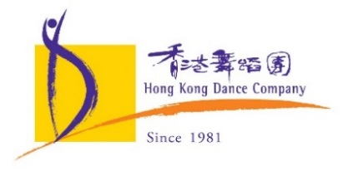
Download high resolution photos:
https://bit.ly/2XxIgng
Press Release
28 September 2021 [9 pages]
Hong Kong Dance Company Dance Season X West Kowloon Cultural District Performing Arts Season
Contemporary Dance Theatre Classic Nine Songs
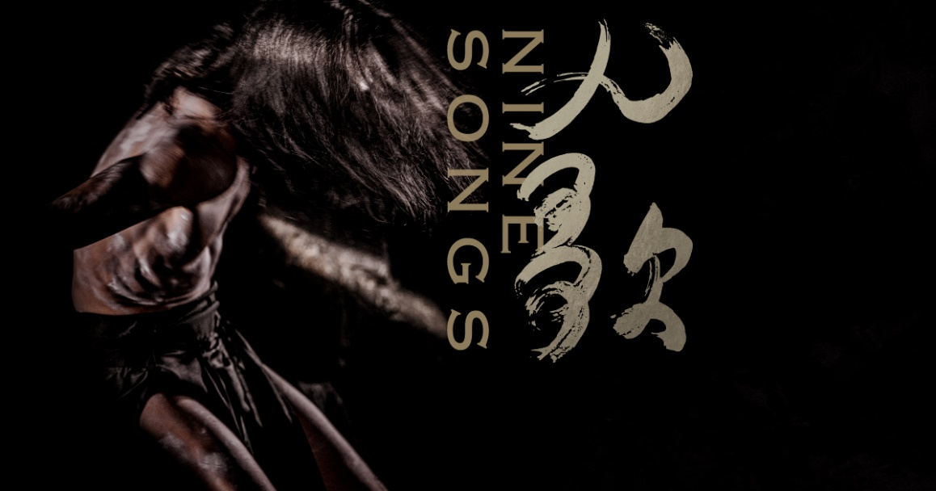
A poetic and dynamic dance ritual
Internationally renowned choreographer Helen Lai is staging an exquisite performance that blends poetry, dance, drama, music and rituals, with an award winning team of masters: Tan Dun – Composer, Grammy and Oscar winner; Tim Yip – Set and Costume Designer, Oscar and British Academy of Film and Television Arts award winner; Leo Cheung – International Lighting Designer, nine times recipient of the Best Lighting Design of the Hong Kong Drama Awards; Anthony Yeung – Sound Designer, winner of prestigious Sound Design Awards; Sunny Chan – seven times recipient of the Best Makeup Design of the Hong Kong Drama Awards; with the dancers from Hong Kong Dance Company. Nine Songs has been inspired by the works of the great Chinese poet Qu Yuan and composer Tan Dun. It presents ancient legend in contemporary context, fusing the specially composed score and movements with emotion and imagery of nature, telling the stories of human and nature, life and death, and reality and dreams.

For the last three decades, Nine Songs has been staged in Hong Kong and toured around the world numerous times. Hong Kong Dance Company and Freespace are co-presenting 3 performances of Nine Songs from 26th to 28th November 2021, bringing remarkable inspiration and eminence to the stage at the Grand Theatre, Xiqu Center, West Kowloon Cultural District!
Excerpt (around 100 words)
Internationally renowned choreographer Helen Lai teams up with Oscar winners Tan Dun and Tim Yip in an exciting blend of breathtaking spectacle and powerful ritual. Inspired by the works of the great Chinese poet Qu Yuan and composer Tan Dun, Nine Songs evokes the ancient legend in contemporary context, fusing the specially composed score and movements with emotion and imagery of nature, telling the stories of human and nature, life and death, and reality and dreams. Since its premiere in 1991, Nine Songs has been re-run and toured numerous times to critical acclaim. This 30th anniversary celebration is not to be missed!

Co-presented By Hong Kong Dance Company and Freespace
Contemporary Dance Theatre Classic: Nine Songs | HKDC in Residence 2021
26th – 27th November, 2021 (Friday–Saturday) 7:45pm
28th November, 2021 (Sunday) 3:00pm
Grand Theatre, Xiqu Centre, West Kowloon Cultural District
Tickets available at West Kowloon Cultural District (online, by phone or in person)
Programme Enquiries: 3103 1889 / www.hkdance.com
Ticketing Enquiries: 2200 0022 / www.westkowloon.hk/en/ticketing

Programme information
Venue | Grand Theatre, Xiqu Centre, West Kowloon Cultural District  [88 Austin Road West, Tsim Sha Tsui, Kowloon (near China Hong Kong City)]
Date, time and ticket prices | 26-*27.11.2021 (Fri-Sat) 7:45pm  28.11.2020 (Sun) 3:00pm  $550, $420, $300, $180 (Evenings)  $450, $320, $220, $160 (Matinee)  *With post-performance Meet-the-Artist session
Duration | Approximately 1 hour and 15 minutes without intermission
Remarks | Please arrive at the venue 30 minutes before the performance begins.  Latecomers will not be admitted.  Audience members who leave the venue during the performance will not be re-admitted.
Ticketing | Tickets available from 24th September, 2021 (Friday) at 10:00am https://www.westkowloon.hk/en/ninesongs#overview
Discount scheme | 50% off | Half price for senior citizens aged 60 or above, people with disabilities and a companion, wheelchair users and a companion, Comprehensive Social Security Assistance (CSSA) recipients and full-time students. Ticket holders must present proof of eligibility on admission. Concessions are available on a first come, first served basis.
Age Range | Children under the age of 6 will not be admitted
Programme Enquiries | 3103 1889 / www.hkdance.com
Ticketing Enquiries | 2200 0022 / https://www.westkowloon.hk/en/ticketing

About the Artistic Team
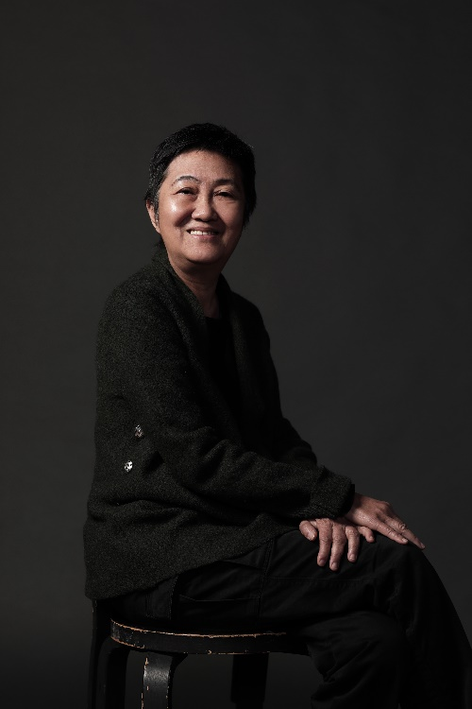  ©Jefu Ha Studio | Helen Lai | Choreographer  Helen Lai is one of Hong Kong’s foremost choreographers; her work was featured at Hong Kong City Hall in 1977 and 1978. She joined CCDC in 1979, holding the posts of Artistic Director from 1985 to 1989 and Resident Choreographer from 1991 to 2011. Helen has choreographed for nearly all of Hong Kong’s performing arts companies including Hong Kong Dance Company, the Hong Kong Repertory Theatre, Hong Kong Ballet and DanceArt, as well as for several other stage and television productions. She frequently collaborates with overseas companies, including Cloud Gate Dance Theatre and Crossover Dance Company in Taipei; Contempodanza and Ballet Estudio in Mexico City; Guangdong Modern Dance Company; and Singapore Dance Theatre.  Lai’s major works include Nine Songs, The Rite of Spring, Invisible Cities, Loose Pages from a Woman’s Diary, Revolutionary Pekinese Opera (Millennium Mix), In the Beginning, Plaza X, The Tragedy of Mr O, The Comedy of K, Testimony, HerStory and Tales of Two Cities - Hong Kong‧Shanghai‧Eileen Chang. Her recent works include Soledad, the chamber opera Heart of Coral (as Director), The Island Whispers and While the Dream Unfolds.  Lai has been the recipient of numerous awards including Choreographer of the Year from the Hong Kong Artists’ Guild (1990) and the Hong Kong Dance Alliance’s Dance Awards for her choreography work (1999, 2000, 2001 and 2008), Outstanding Achievement in Choreography (2011) and Outstanding Choreographer (2016 and 2017). In 2002, the Alliance presented Lai with a Distinguished Achievement Award. She received the Award for Arts Achievement (Dance) from the Hong Kong Arts Development Council in 2003; an Honorary Fellowship from The Hong Kong Academy for Performing Arts in July 2004; and an Outstanding Contribution in Arts award in 2015, also from the Council.
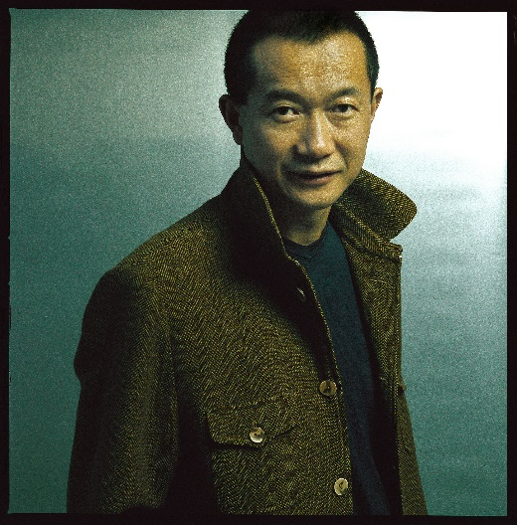 | Tan Dun | Composer  The world-renowned artist and UNESCO Goodwill Ambassador Tan Dun, has made an indelible mark on the world's music scene with a creative repertoire that spans the boundaries of classical music, multimedia performance, and Eastern and Western traditions. A winner of today's most prestigious honors including the Grammy Award, Oscar/Academy Award, most recently Italy’s Golden Lion Award for Lifetime Achievement, Tan Dun's music has been played throughout the world by leading orchestras, opera houses, international festivals, and on radio and television.  Tan Dun’s individual voice has been heard widely by international audiences. Paper Concerto was premiered with the Los Angeles Philharmonic at the opening of the Walt Disney Hall. His multimedia work, The Map, premiered by Yo-Yo Ma and the Boston Symphony Orchestra, has toured more than 30 countries worldwide. Other important premieres include Four Secret Roads of Marco Polo for the Berlin Philharmonic, Piano Concerto The Fire for Lang Lang and the New York Philharmonic.  Tan Dun records for Sony Classical, Deutsche Grammophon, EMI, Opus Arte and Naxos. Tan Dun’s music is published by G. Schirmer, Inc and represented worldwide by the Music Sales Group of Classical Companies.
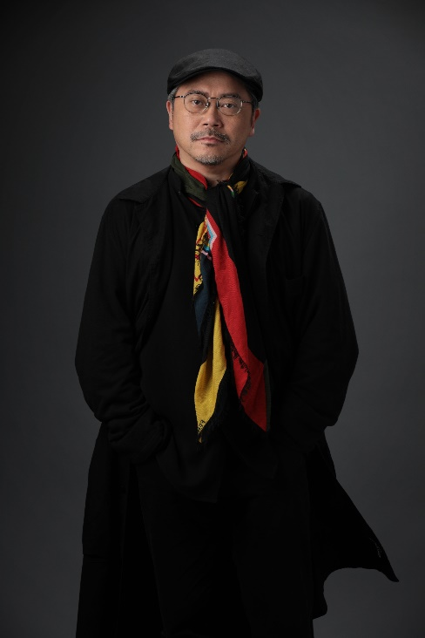 | Tim Yip | Set and Costume Designer  As a world-renowned art director for stage and film, costume designer and visual artist Tim Yip continues to explore and communicate his aesthetic concept "New Orientalism", which is his interpretation of ancient culture as a means to inspire the future. He works widely in contemporary film, theatre, art, literature and other creative fields. For Crouching Tiger, Hidden Dragon, Yip won the Oscar for "Best Art Direction", becoming the first Chinese to be awarded by the Academy, and the British Film and Television Academy award for "Best Costume Design", in 2001.  In the field of theatre, Tim Yip has collaborated with many world-renowned practitioners and groups, including Robert Wilson, Franco Dragone, Akram Khan, Zhang Yimou, Stan Lai, Yang Liping, Cloud Gate Dance Theatre, Contemporary Legend Theater, Legend Lin Dance Theater, Han Tang Yue Fu, Tai-Gu Tales Dance Theatre, U Theatre and more. His works have been staged in China, Austria, France, the United States, the United Kingdom, Spain, Japan and Israel.
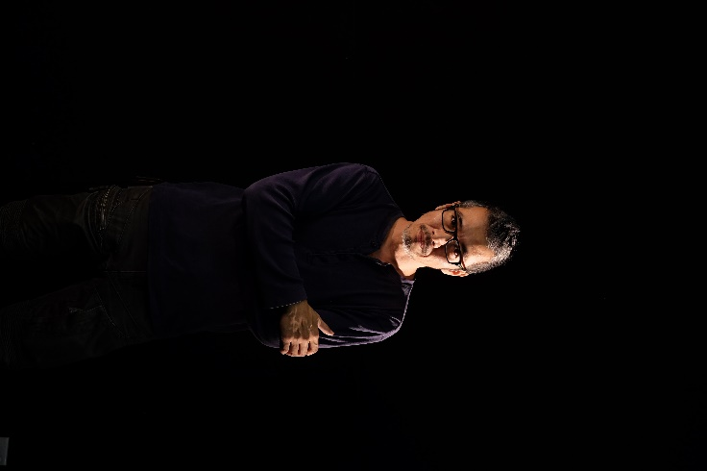 | Leo Cheung | Lighting Designer  Leo Cheung started his theatre career at the City Contemporary Dance Company in 1982. He graduated with High Distinction from The Hong Kong Academy for Performing Arts in 1989, majoring in Theatre Lighting Design. Leo has created numerous outstanding lighting designs every year for different types of productions, such as drama, opera, ballet, modern dance, Chinese traditional theatre and musicals. His designs can be found both in Hong Kong and abroad, including Mainland China, Taiwan, Singapore, Korea, Japan, England, Prague, Israel, Germany and Sweden, which have won him an international acclaim.  One of the most distinguished artists and masters of lighting in Hong Kong theatre, Leo has won a wealth of prestigious awards throughout his career. These include receiving the Outstanding Achievement of the Decade Award in 1994, and The Best Lighting Design Award nine times (1995, 1996, 1998, 2001, 2009, 2010, 2011, 2014, and 2017) from the Hong Kong Federation of Drama Societies. Leo has also received The Annual Dance Award four times (1999, 2007, 2010, 2013) from the Hong Kong Dance Alliance for his sets and lighting designs. In 2014, in recognition of his outstanding contributions to the development of arts and culture in Hong Kong, Leo was conferred the Certificate of Commendation by the Home Affairs Bureau of the HKSAR government.  Leo has not only lit over 300 productions Leo, he has also designed set for dance productions including Revolutionary Pekinese Opera, Thirty Something, Sexing Three Millennium, Testimony, Post-Perception/Transcendence, and Mr Blank for City Contemporary Dance Company; Invisible City and Loose Pages from a Woman’s Diary for the Cloud Gate Dance Theatre, Taipei; Maze for Passover Dance Company; and As It Were for GoteborgsOperans Dance Company.  Leo continues to integrate and explore the potentials of light, shadows, spaces, and visual media elements in live performance, connecting different art forms and reflecting social and cultural issues.
Anthony Yeung | Sound Designer
A graduate of the Hong Kong Academy for Performing Arts, Anthony Yeung is a sound designer for theatre, studio sound engineer and sound art creation. In 2004, he taught at the Hong Kong Academy for Performing Arts. He has been an advisor for a sound art organization “Soundpocket” since 2008. In 2010, Yeung was appointed Sound Consultant for “Dolby Laboratories”.

He has recently participated in numerous theatrical productions such as the Hong Kong Dance Company’s Waiting Heart and Dance of Strings, City Contemporary Dance Company’s Re-Mark and Winterreise. The Rite of Spring, West Kowloon Cultural District’s experimental Cantonese Opera Wenguang Explores the Valley, and Chung Ying Theatre Company’s Pride and Prejudice, All My Life I Shall Remember, and Calming the Chaotic Seas, etc

In 2003, he received the award for Best Sound Design at the 12th Hong Kong Drama Awards. He also won the Outstanding Sound Design in the 2017 Hong Kong Dance Awards with the work Reveries of the Red Chamber of Hong Kong Dance Company.

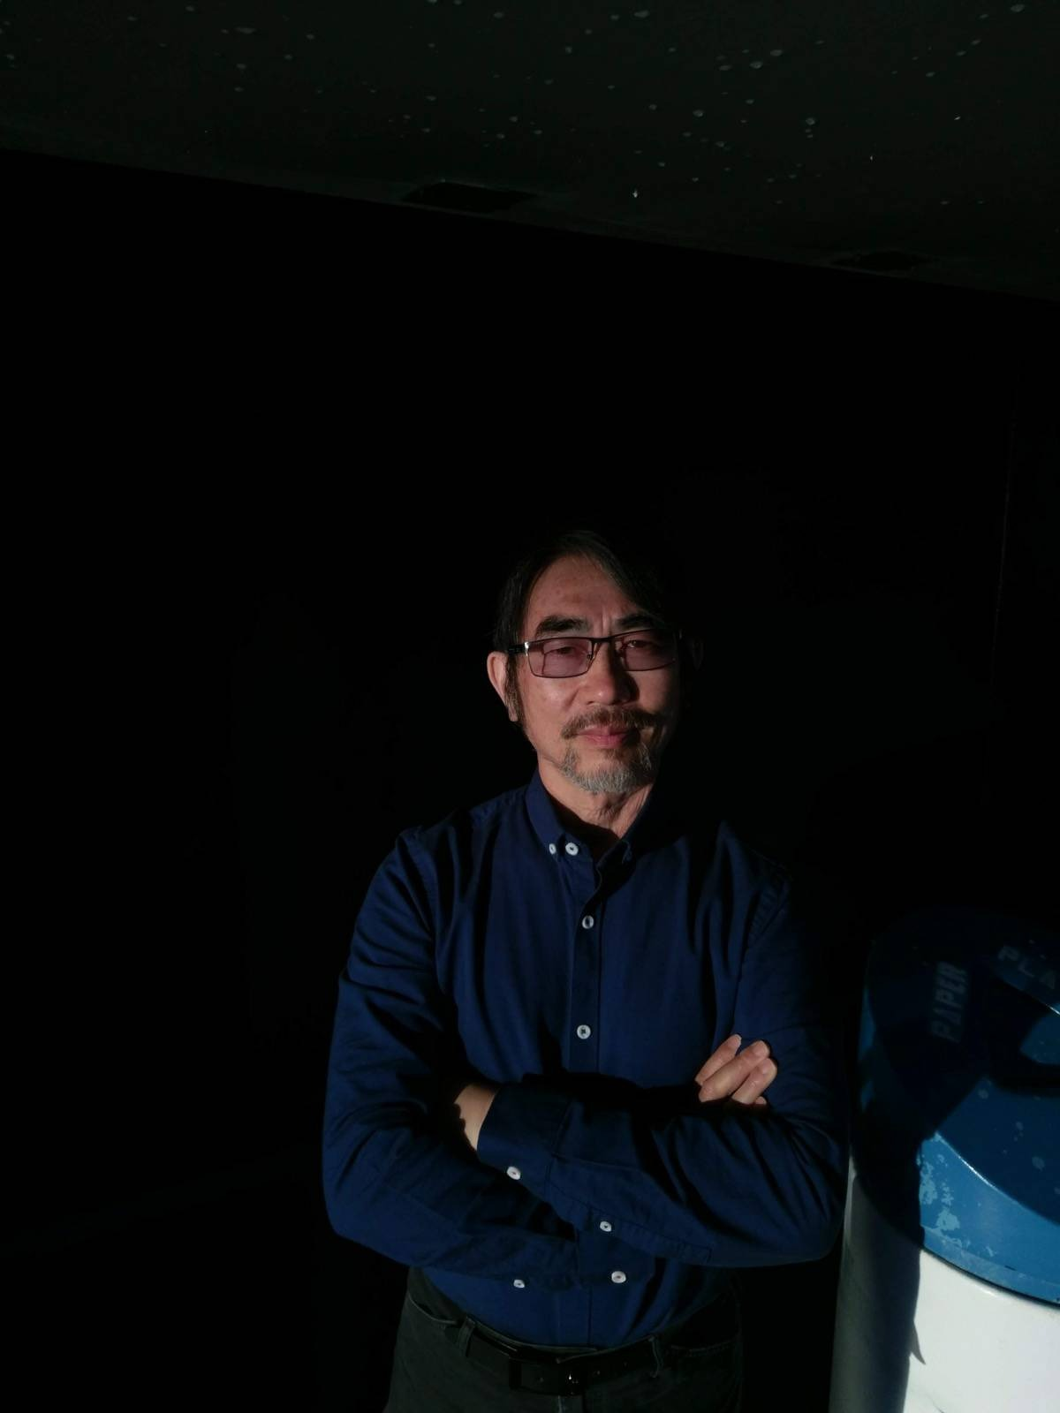 | Sunny Chan | Make-up and Hairstyle Designer  Sunny Chan completed a diploma in fine art in 1981 at the Hong Kong Ling Hai Art School, and began his career with an apprenticeship in theatrical make-up under Wong Suen Kee at Hong Kong Repertory Theatre. Since then Chan has been active in the theatre both in Hong Kong and overseas, and has also been involved in film and television production. He has been the recipient of several Best Makeup Design awards from the Hong Kong Drama Association.  In 1994, Chan received a scholarship from the Asian Cultural Council for research and cultural exchange at The Metropolitan Opera and La MaMa Experimental Theatre Club in New York, San Francisco Opera House, and Sony/Paramount Studios in Hollywood. In 1995, he became a guest lecturer in theatrical make-up at The Hong Kong Academy for Performing Arts. Chan established Splash Make-up Workshop in 2007 to explore and promote the teaching of make-up art. Between 2011 and 2017, he planned and taught a two-year stage course in make-up for the Macau Conservatory for Performing Arts. He was a lecturer in wigs and make-up at The Hong Kong Academy for Performing Arts from 2017 to 2021. He published The Aesthetic Coding of Asian Faces in 2020.  Chan’s stage performances have included Red Soil; My Baby, My Treasure; The Poets Li and Du; The Days of the Commune; My Dear Wu Suet Ngam; Behold the Spring Wind; Miss Julie Doesn’t Live Here Any More; Mother; Heading West; The Seventh Drawer; Heading West 2: The Curious Case of Sanzang; and O you Heavenly Creatures! He also played accordion on the production Bertolt Brecht and Zhou Enlai: Two Lives, One Sky.

Programme Plus Events
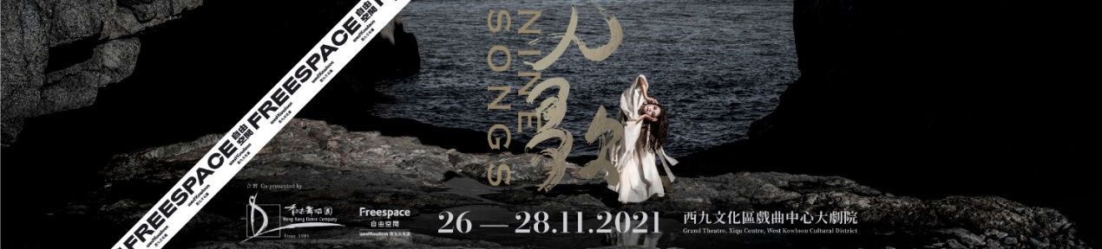
Programme Exhibition: Nine Songs
Exhibition Period | 18-31.10.2021
Venue | Foyer, Hong Kong Cultural Centre
Address | 10 Salisbury Road, Tsim Sha Tsui, Kowloon, Hong Kong

Guided Screenings of Nine Songs
Theme | The World of Tan Dun’s Nine Songs | Helen’s Nine Songs in Three Decades
Moderator | Dr Joyce Tang  Lecturer, School of Music,  The Hong Kong Academy for Performing Arts | Dr Lo Wai-luk  Honorary Resident Writer,  Academy of Film,  Hong Kong Baptist University
Date | 17.11.2021 (Wed) | 23.11.2021 (Tue)
Time | 7:30pm-9:00pm
Venue | Seminar Hall, Xiqu Centre, West Kowloon Cultural District
Address | 88 Austin Road West, Tsim Sha Tsui, Kowloon (near China Hong Kong City)
Programme Summary | World-renowned choreographer Helen Lai is well-known for her creative works inspired by classical music and literature. Thirty years ago, she transformed Nine Songs, an avant-garde and dramatic musical written by Tan Dun, into a dance drama. Over the last 30 years, with frequent re-runs and numerous world tours, dance drama Nine Songs continues to accumulate and emanate energy and wisdom. In addition to screening recordings of past performances of Nine Songs, we have also invited Dr Joyce Tang and Dr Lo Wai-luk to share on the music and movie of Nine Songs. Performers of Nine Songs would also be present to share their stories in the journey of taking Nine Songs to the stage.
Remarks | 1. This activity will be conducted in Cantonese  2. Participation in the activity is free-of-charge. Seats are limited and available on a first-come-first-served basis.  3. Online registration is required for participation. Details will be released by end October, 2021.

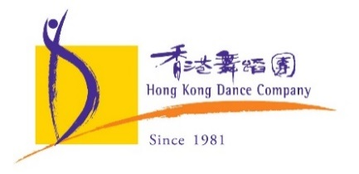

Hong Kong Dance Company
“Dancing across East and West, Moving to the Tempo of Hong Kong”

Mission Statement

We are nurtured in the cultural tradition of China, combining with the creativity of contemporary art, to impress the world with Chinese dance of Hong Kong character.

Established in 1981, the Hong Kong Dance Company (HKDC) was incorporated in 2001 as a charitable and non-profit-making institution, and is financially supported by the Government of the Hong Kong Special Administrative Region. As one of the nine flagship performing arts companies in Hong Kong, our mission is to promote Chinese dance with contemporary artistic visions and Hong Kong character. Celebrating its 40th anniversary this year, HKDC has staged over 200 productions over the decades, many of which were highly popular with critical acclaim. Recent productions include The Legend of Mulan, Red Poppies, Spring Ritual·Eulogy, The Butterfly Lovers, Storm Clouds, L’Amour Immortel, Dream of the Past: Ancient Chinese Court Dances, Reveries of the Red Chamber, Chinese Hero: A Lone Exile, Vipassana, Lady White of West Lake, Tale of Three Cities, Waiting Heart, Liu Sanjie, Ode to the Silk Road, Dance of Strings, A Tale of the Southern Sky, Mazu the Sea Goddess, The Moon Opera, Shan Shui: An Ode To Nature, as well as Convergence, a culminating work created through a three-year interdisciplinary research study on Chinese dance and Chinese martial arts traditions.

As a cultural ambassador of Hong Kong, HKDC constantly brings the city’s unique artistic style to the world by touring to different cities across the globe, engaging local audiences and encouraging cultural exchange. In recent years, it has brought its award-winning productions to the Lincoln Center in New York, the Kennedy Center in Washington, D.C., the Sony Centre in Toronto, the Concourse Theatre in Sydney and the Southbank Centre in London, among others.

About Freespace
Freespace is Hong Kong’s new centre for contemporary performance. Located in the heart of the Art Park, Freespace presents multi-genre performances and events, produces boundary-pushing collaborations, and promotes new ways of seeing and experiencing performance. Freespace houses The Box, a flexible space for cutting-edge performances and one of the largest black box theatres in Hong Kong, two multi-purpose spaces, The Room and The Studio, designed for creative exchange and artistic collaborations, and Lau Bak Livehouse, an intimate bar cafe presenting live music from Hong Kong and around the world.

About the West Kowloon Cultural District
The West Kowloon Cultural District is one of the largest and most ambitious cultural projects in the world. Its vision is to create a vibrant new cultural quarter for Hong Kong on forty hectares of reclaimed land located alongside Victoria Harbour. With a varied mix of theatres, performance spaces, and museums, the West Kowloon Cultural District will produce and host world-class exhibitions, performances and cultural events, providing twenty-three hectares of public open space, including a two-kilometre waterfront promenade.
Media Enquiries:
Candy Cheung – Head of Programme and Education
Tel: (852) 3103 1878 Email: candycheung@hkdance.com

Cheng Yu-ching – Senior Officer (Marketing and Programme)
Tel: (852) 3103 1810 Email: yuching@hkdance.com

