Download HKDC 2022/23 Dance Season
Press Photos
http://gofile.me/5eMFL/TaURAPFig

Press Release https://bit.ly/3RrGbR8

Immediate release [6 pages in total]

Hong Kong Dance Company 2022/23 Dance Season
Here and Now
Dance Season Subscription Packages available until 7 August 2022

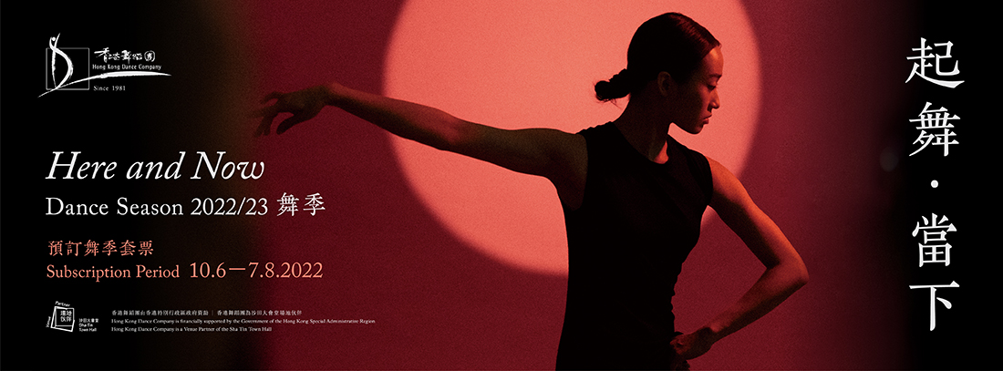

Hong Kong Dance Company (HKDC) is thrilled to launch the 2022/23 Dance Season. Be ready to indulge yourself with our many enticing dance programmes!

For more than two years, we have had to contend with the many challenges under the impact of the COVID-19 pandemic. Despite all the uncertainties we have faced, our dancers have persisted in their training during the lockdowns. They are longing to return to the theatre and to the stage. They are ready physically and mentally – to dance “Here and Now”!

The new dance season opens with Myth of the Dancing Durumi, an anthology of Korean folk dance. This eagerly anticipated show has been in the works for over two years. Undaunted by the restrictions in place during the pandemic, our dancers forged ahead in rehearsal and were able to receive personal instruction from masters in Seoul and Yanbian online. Next is the re-run of the thought-provoking dance poem Shan Shui: An Ode to Nature. It premiered to great acclaim last year and scored three nominations at the 23rd Hong Kong Dance Awards. After spending another year in contemplation, our dancers have delved deeper into their martial arts training and gained greater insight into their body movements. They look forward to the opportunity to repaint this picturesque scene.

Hong Kong Dance Company’s many iconic moments were remembered and cherished in last year’s 40th anniversary celebrations. What makes a classic in and of itself a classic? Emotion. Twirl of the Heartstrings is a production that marries dance with live music performance, coupled with high-tech visual creations. These re-imagined classic dance excerpts will give audiences an occasion to revisit many beautiful memories of our shows. Womanhood explores the theme of change of identities over time from the female perspective that tell stories embedded in our day-to-day lives.

Besides mainstage productions, HKDC’s “8/F Platform” series serves as an artistic arena to nurture young dancers and will remain a staple for audiences to enjoy innovative new works.

Hong Kong Dance Company is also dedicated to art education. Interactive performance All About The Three Kingdoms shares the beauty of traditional dance with audiences in a simple-to-understand manner. They will enjoy the lively atmosphere of the many interactive activities that await them, and gain a deeper understanding of dance. Our Children’s and Youth Troupes will present The Kids in Rainbow Jerseys. This Olympic-themed dance drama is a fine example of the indomitable spirit of perseverance that drives both dancer and athlete.

Our Outreach and Education Department has also prepared a diverse offerings of educational courses, masterclasses, performances, and more, to introduce dance in schools. As the venue partner of the Sha Tin Town Hall, HKDC also organises various thematic dance workshops to bring the joy of art further into the community. “Through thick and thin, the Company is firmly committed to bringing you quality dance works and programmes that demonstrate the harmony between traditional culture and contemporary artistic ideas. We look forward to seeing you all at the theatre!” Mr Tsang Kee-kung, MH, Board Chairman of the Hong Kong Dance Company, said.

“Dance is an art form related to both mind and body. Only by cultivating the mind and achieving a state of tranquillity can we gain strength and remain undaunted by the raging storm outside. Let’s dance — right here, right now! Hong Kong Dance Company has been your companion on the road for four decades. We look forward to sharing the journey with you for many years to come,” Mr Yang Yuntao, Artistic Director of the Hong Kong Dance Company, remarked.

Special Season Subscription Packages
- Enjoy premium discounts and secure the best seats for Shan Shui: An Ode to Nature, Twirl of the Heartstrings, Womanhood and The Kids in Rainbow Jerseys by purchasing two standard tickets of two or more programmes, on or before 7 August 2022.

- Subscribers of the 2022/23 Dance Season (during 10 June to 7 August 2022) will receive a complimentary “Friends of HKDC” Classic Membership to enjoy exclusive benefits and 10% off tickets of HKDC productions.

Hong Kong Dance Company 2022/23 Dance Season Programme Lineup

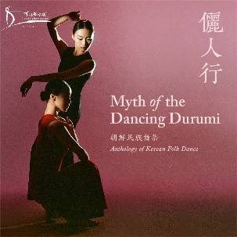 | Anthology of Korean Folk Dance - Myth of the Dancing Durumi  The Elegant Beauty of the Dancing Crane  Korean folk dances have a refined elegance that evokes images of a durumi (Korean crane) in flight. Breathing out, the dancers effortlessly glide. Breathing in, they pause with a subtle grace. Their colourful traditional Korean costumes move in harmony with the distinctive rhythms of their folk tunes.  Hong Kong Dance Company is bringing works of Seoul and Yanbian artists together in Hong Kong for the first time, to showcase the traditional charm and contemporary elegance inherent in Korean dance.  9 - 10.9.2022（Fri - Sat）7:45pm  10 - 11.9.2022（Sat - Sun）3:00pm  Auditorium, Sha Tin Town Hall  16 - 17.9.2022（Fri - Sat）7:45pm  18.9.2022（Sun）3:00pm  Auditorium, Yuen Long Theatre
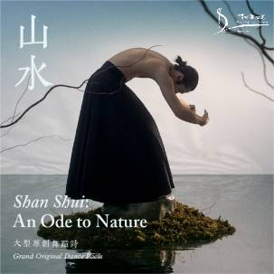 | Grand Dance Poem - Shan Shui: An Ode to Nature  A Waltz of Nature’s Timeless Charm  Hong Kong Dance Company draws on the imagery of nature under the brush, painting an inner world beyond the confines of time or space through dance. The dancers’ bodies become the dots, dashes, and vigorous strokes of the brush; they are the artist’s eye for rhyme, rhythm, and internal beauty.  Shan Shui: An Ode to Nature received three nominations in the Hong Kong Dance Awards 2022.  14 - 15.10.2022（Fri - Sat）7:45pm  15 - 16.10.2022（Sat - Sun）3:00pm  Lyric Theatre, The Hong Kong Academy for Performing Arts  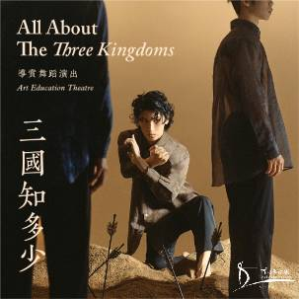  Art Education Theatre - All About The Three Kingdoms  Dance Transcending Form and Imagination  Gaining mastery of dance through years of practice, dancers convey the beauty in their expressive movements. Come share the joy of artistic creation in this vivid and interactive dance performance.  Art Education Theatre All About The Three Kingdoms is a family-friendly performance for audiences of all ages. It brings alive tales from Romance of the Three Kingdoms, from which audiences can gain deeper insights into arts appreciation.  3 - 4.3.2023（Fri - Sat）7:45pm  4 - 5.3.2023（Sat - Sun）3:00pm  Auditorium, Sha Tin Town Hall  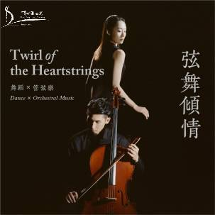  Dance x Orchestral Music - Twirl of the Heartstrings  Music and Dance Entwine: A Revival of the Classics  Romance, heroic adventures, heart-rending stories. There are contemporary reinterpretations of Chinese literary classics and fables, with new artistic and creative dimensions. Memorable characters in pop culture and their fantastical, imaginative world are also brought to life on the stage.  Through the seamless interweaving of dance, music and imagery, Hong Kong Dance Company's collaboration with the local orchestra, In-heritage Philharmonic, will instil new vitality into these larger-than-life stories on stage.  14 - 15.4.2023（Fri - Sat）7:45pm  15 - 16.4.2023（Sat - Sun）3:00pm  Auditorium, Kwai Tsing Theatre  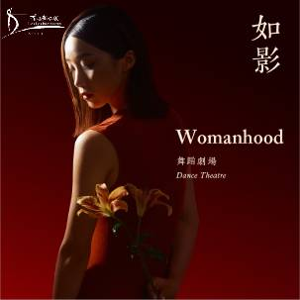  Dance Theatre – Womanhood  And Far Beyond Motherhood  Weaving through the heavy threads of shadows and light, time shuttles between the present and yesteryear.  Memory-filled fragments of fragility, resilience, conflict, and struggle… now all reflect and refract within this trance-like chasm. Time stands still as each unique ‘Her’ is, in turn, revealed.  Where will her path lead now?  12 - 13.5.2023（Fri - Sat）7:45pm  13 - 14.5.2023（Sat - Sun）3:00pm  Studio Theatre, Hong Kong Cultural Centre

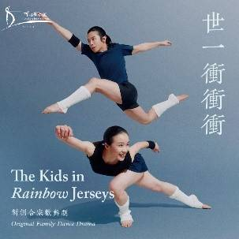 | Family Dance Drama - The Kids in Rainbow Jerseys  Don’t lose your way!  Be determined, but humble, and one day you’ll be a champion!  Look ahead to the future with passion and courage, put your best foot forward, and persevere until you reach your goal! Join Hong Kong Dance Company’s professional dancers and more than 400 young talents from our Children’s and Youth Troupes in a delightful song-filled dance drama telling stories of indomitable athletic endeavour. Together, we will win that gold medal!  11.8.2023（Fri）7:45pm  12 - 13.8.2023（Sat - Sun）3:00pm  Auditorium, Sha Tin Town Hall

Hong Kong Dance Company

Dancing across East and West, Moving to the Tempo of Hong Kong

Mission Statement
We are nurtured in the cultural traditions of China, combined with the creativity of contemporary art, to inspire the world with Chinese dance of Hong Kong character.

Established in 1981, the Hong Kong Dance Company (HKDC) was incorporated in 2001 as a charitable and non-profit-making institution, and is financially supported by the Government of the Hong Kong Special Administrative Region. As one of Hong Kong’s nine flagship performing arts companies, our mission is to promote Chinese dance with contemporary artistic visions and Hong Kong character. Since its inception, the Company has staged over 200 productions over the decades, many of which were highly popular with critical acclaim. Recent productions include The Legend of Mulan, Red Poppies, Spring Ritual·Eulogy, The Butterfly Lovers, Storm Clouds, L’Amour Immortel, Dream of the Past: Ancient Chinese Court Dances, Reveries of the Red Chamber, Chinese Hero: A Lone Exile, Vipassana, Lady White of West Lake, Tale of Three Cities, Waiting Heart, Liu Sanjie, Ode to the Silk Road, Dance of Strings, A Tale of the Southern Sky, Mazu the Sea Goddess, The Moon Opera, Shan Shui: An Ode to Nature, Nine Songs, Nezha: Untold Solitude, as well as Convergence, a culminating work created through a three-year interdisciplinary research study on Chinese dance and Chinese martial arts traditions.

As a cultural ambassador of Hong Kong, HKDC tours to different cities across the globe to share the city’s unique artistic style with the world, engaging local audiences and encouraging cultural exchange. In recent years, we have brought our award-winning productions to the Lincoln Center in New York, Kennedy Center in Washington, D.C., Sony Centre in Toronto, the Concourse Theatre in Chatswood, Sydney, the Southbank Centre in London and The Belarusian State Academic Musical Theatre in Minsk, among others.

https://www.hkdance.com

Media Enquiries
Ms Candy Cheung, Head of Programme and Education
Tel: (852) 3103 1878 Fax：(852) 2851 3607
Email：candycheung@hkdance.com
Ms Chris Lam, Development Manager
Tel：(852) 3103 1828 Fax：(852) 2805 2743
Email：chris@hkdance.com

