Download Press photos:
http://bit.ly/41k8GFi
Press release
10 March 2023 [6 pages in tatol]

Hong Kong Dance Company and In-heritage Philharmonic Proudly Co-present
Dance x Orchestra Music Twirl of the Heartstrings
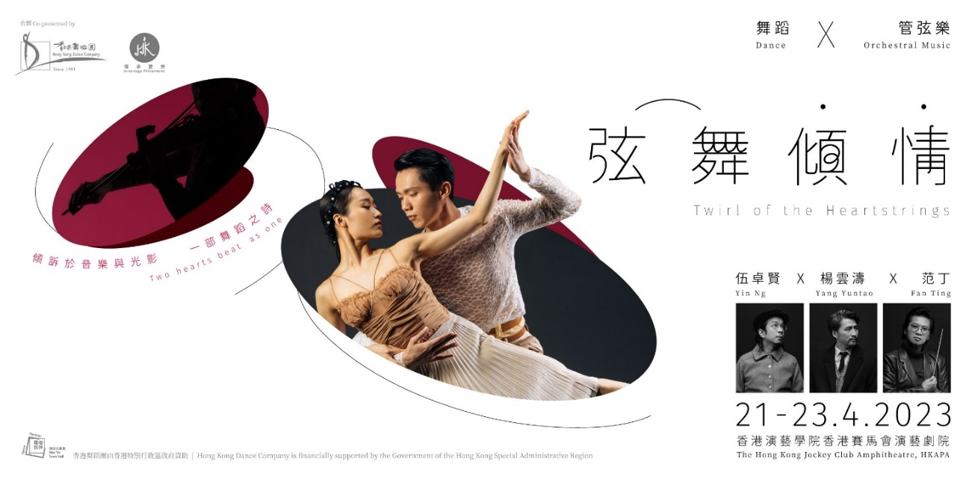

Two hearts beat as one

The theatre lights are dimmed, and in this vast twilight, we fall for what they fell for, the bonds unsevered.

If it’s a stage, dance would only wreathe its periphery;
If it’s music, the fiddle would only twang a wiry string;
If it’s a poem, the words would only weave a faint murmur of ambivalence;
As if two discordances becoming one.

Yin Ng x Yang Yuntao x Fan Ting
Hong Kong Dance Company (HKDC) relives fragments of earlier artistic endeavours: L’Amour Immortel, Storm Clouds, Chinese Hero: A Lone Exile, The Legend of Mulan and Lady White of West Lake, crafting a tuneful poem song in the form of dance. Accompanying the dance with soaring new orchestral works, Hong Kong’s up-and-coming In-heritage Philharmonic spins a sweeping panorama of emotion and entanglement.

Choreographed and directed by Yang Yuntao, Artistic Director of Hong Kong Dance Company, conducted by the maestro Fan Ting, Artistic Director and Conductor of In-heritage Philharmonic, with music arranged and composed by the renowned composer Yin Ng, Twirl of the Heartstrings sets out to steer a course of love.

Co-presented by Hong Kong Dance Company and In-heritage Philharmonic, Twirl of the Heartstrings will be staged from 21 April to 23 April 2023 (Fri-Sun) at The Hong Kong Jockey Club Amphitheatre, HKAPA. To reimagine dance excerpts from HKDC’s grand dance dramas with live orchestra and live dance performance. Tickets are now available at HK Ticketing.

Dance x Orchestral Music Twirl of the Heartstrings
Co-presented by Hong Kong Dance Company and In-heritage Philharmonic

21-22 April 2023 (Fri-Sat) 7:45pm
22-23 April 2023 (Sat-Sun) 3:00pm
The Hong Kong Jockey Club Amphitheatre, HKAPA
[Address: 1 Gloucester Road, Wan Chai]

$380, $280, $140
Tickets NOW available at *HK Ticketing

Internet Booking www.hkticketing.com | Ticket Purchase Hotline 31 288 288
Programme Enquiries 3103 1888｜www.hkdance.com

Discount Schemes
- 50% off for full-time students, senior citizens aged 60 or above, people with disabilities and the minder, CSSA recipients (Limited quota)
- Members of Friends of HKDC enjoy up to 20% discount
- Other details please refer to HK Ticketing website

* HK Ticketing applies a customer service fee to all tickets purchased via its network. This fee is additional to the face value of the ticket and is payable upon purchase of tickets.
Programme duration is about 1 hour and 50 minutes with an intermission
Suitable for ages 6 and above
Hong Kong Dance Company reserves the right to change programme details and substitute artists

Free Pre-show events: Programme Exhibition
Exhibition Period: 10-23 March 2023
Venue: E1, Foyer Exhibition Area, Hong Kong Cultural Centre
Address: 10 Salisbury Road, Tsim Sha Tsui, Kowloon, Hong Kong

Artistic Team
Director / Choreographer | Yang Yuntao
Music Director / Composer / Music Arranger | Yin Ng
Conductor | Fan Ting
Composer / Music Arranger | Lee Che-yi
Digital Image Designer | Oliver Shing
Multi-media Production | DAAIMUNG
Set Designer | Shui Wai-man
Lighting Designer | Yeung Tsz-yan
Sound Designer | Anthony Yeung
Costume Designer | Cindy Ho Pui-shan
Co-presented and performed by | Hong Kong Dance Company  In-heritage Philharmonic

Introduction of key artists
Yang Yuntao | Director / Choreographer
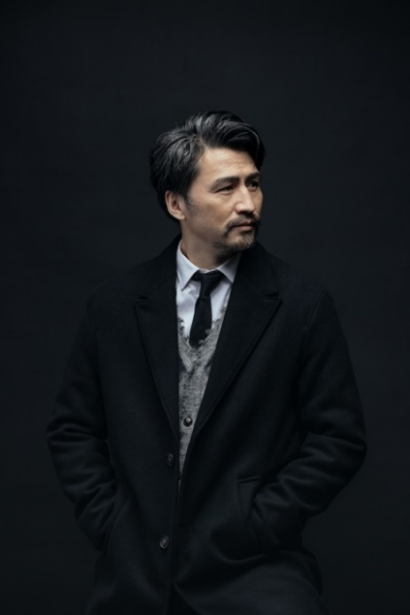
Winner of two Hong Kong Dance Awards (2003, 2006) for his outstanding dance performance, and awarded Best Artist (Dance) at the Hong Kong Arts Development Awards 2009, Yang Yuntao is an accomplished dancer and choreographer. He joined the Hong Kong Dance Company (HKDC) in 2002 as Principal Dancer. He was the company's Assistant Artistic Director from 2007 and has been its Artistic Director since November 2013.

Yang has choreographed for various dance companies. His award-winning choreography for HKDC includes: Spring Ritual·Eulogy, winner of Outstanding Achievement in Production at the Hong Kong Dance Awards 2013 and presented in Beijing and Taipei in 2013; The Legend of Mulan, winner of Outstanding Production and Outstanding Ensemble Performance at the 2014 Hong Kong Dance Awards and presented in New York, Sydney, London and Minsk in 2015, 2017 and 2019 respectively; Storm Clouds, winner of three awards including Outstanding Achievement in Production at the 2015 Hong Kong Dance Awards; L’Amour Immortel, winner of three awards at the 2016 Hong Kong Dance Awards, presented in Beijing and Guangzhou in 2017, in Taipei in 2018 and in Shanghai and Hangzhou in 2019; and Waiting Heart, winner of Outstanding Medium Venue Production at the 2019 Hong Kong Dance Award.

Other works for HKDC include The Butterfly Lovers (presented in Seoul in 2016), Romance of the Three Kingdoms, Voices and Dances of the Distant Land, Blanc in Reveries of the Red Chamber, Chinese Hero: A Lone Exile, In the Beginning in Vipassana, Lady White of West Lake. Dance of Strings and A Tale of the Southern Sky.

Yin Ng | Music Director / Composer / Music Arranger
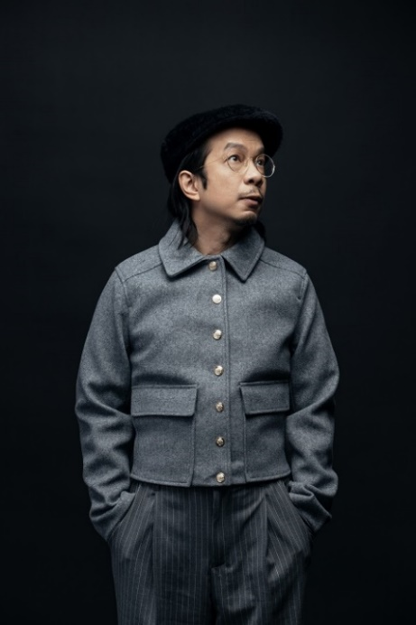
Composer, music producer, sheng performer and a cappella artist Yin Ng was the first Artist Associate of the Hong Kong Sinfonietta, founder of the fusion group SIU2 as well as artistic director of the Yat Po Singers.

Ng was a graduate in composition of the Music Department of the Chinese University of Hong Kong. He went on to study at the International Christian University in Tokyo (Japanese) and Codarts in Holland (jazz).

Yin received Award for Best Artist (Music) from the Hong Kong Arts Development Awards 2011. In 2009, 2013 and 2022, Yin received the Best Serious Composition in CASH Golden Sail Music Awards by the theatrical choral concert Rock Hard, double sheng concerto Before the City Collapses and Chinese orchestral work Ji respectively. And his choral work Singing Voices of the world was awarded twice the CASH Golden Sail Most Performed Works Award (Serious Music).

Ng has composed and arranged music for many arts groups and singers. His major dance music works include Hong Kong Dance Company’s grand dance drama L'Amour Immortel, Lady White of West Lake, Fun Ride with Big Beard and A Sea of Smiling LT Ducks, Hong Kong Dance Drama Company’s Di Zi Gui etc.

Orchestral works include drumset concerto Fly, Chinese orchestral work Tang Resonating and sheng concerto for Chinese orchestra The Seventh Month etc.

Fan Ting | Conductor
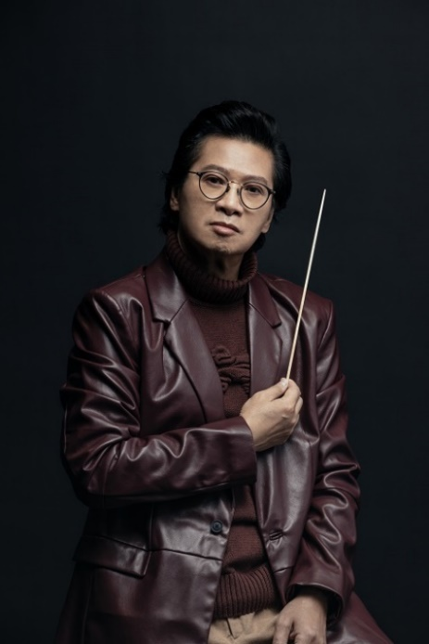
Fan Ting is currently the Artistic Director and Conductor of In-heritage Philharmonic, the Music Director and Chief Conductor of the Saigon Philharmonic Orchestra in Vietnam, and Chief Conductor of the Vietnam National Opera and Ballet. He is the founding faculty of the Orchestral Technique Class at the Hong Kong Academy of Performing Arts and teaches at the Chinese University of Hong Kong and the Hong Kong Baptist University. He has also founded the Metropolitan Youth Orchestra, which has since become one of the most recognized young people’s orchestras in Asia. Fan founded the In-heritage Philharmonic and officially conducted the premiere in 2020.

As a violinist, Fan was a long-standing member of the Hong Kong Philharmonic Orchestra and has acted as the Principal Second Violin, Assistant Concertmaster, and Acting Concertmaster in his 38-years career there. He has also toured Taiwan, Japan, Canada, Chicago, London, Cremona, and New York with different chamber groups he has founded, including the Tononi String Quartet, the New Art Quartet, and the Canzone Trio. With the Tononi String Quartet, he has also premiered music composed by Benjamin Britten and Leoš Janáček in China.

Co-presenters

Hong Kong Dance Company
“Dancing across East and West, Moving to the Tempo of Hong Kong”

Mission Statement
We are nurtured in the cultural tradition of China, combining with the creativity of contemporary art, to impress the world with Chinese dance of Hong Kong character.

Established in 1981, Hong Kong Dance Company (HKDC) was incorporated in 2001 as a charitable and non-profit-making institution, and is financially supported by the Government of the Hong Kong Special Administrative Region. As one of the major flagship performing arts companies in Hong Kong, our mission is to promote Chinese dance with contemporary artistic visions and Hong Kong character. Since its inception, HKDC has staged over 200 productions over the decades, many of which were highly popular and critically acclaimed. Recent productions include The Legend of Mulan, Red Poppies, Spring Ritual·Eulogy, The Butterfly Lovers, Storm Clouds, L’Amour Immortel, Dream of the Past: Ancient Chinese Court Dances, Reveries of the Red Chamber, Chinese Hero: A Lone Exile, Vipassana, Lady White of West Lake, Tale of Three Cities, Waiting Heart, Liu Sanjie, Ode to the Silk Road, Dance of Strings, A Tale of the Southern Sky, Mazu the Sea Goddess, The Moon Opera, Shan Shui: An Ode to Nature, Nine Songs, Nezha: Untold Solitude, Myth of the Dancing Durumi, as well as Convergence, a culminating work created through a three-year interdisciplinary research study on Chinese dance and Chinese martial arts traditions.

As a cultural ambassador of Hong Kong, HKDC constantly brings the city’s unique artistic style to the world by touring to different cities across the globe, engaging local audiences and encouraging cultural exchange. In recent years, we have brought our award-winning productions to Lincoln Center in New York, Kennedy Center in Washington, D.C., Sony Centre in Toronto, Concourse Theatre in Chatswood, Sydney, Southbank Centre in London, the Belarusian State Academic Musical Theatre in Minsk, Arko Arts Theatre in Seoul, National Centre for the Performing Arts in Beijing, Tianqiao Acrobatics Theatre in Beijing, Shanghai Grand Theatre, Shanghai International Dance Cente, Hangzhou Grand Theatre, Guangzhou Opera House, Taipei New Stage and Taiwan Traditional Theatre Center, among others.

In-heritage Philharmonic
In-heritage Philharmonic is a Philharmonic Orchestra founded in Hong Kong in 2020. We are established and managed by renowned and finest musician team in Hong Kong.

Our Artistic Advisory Board consists of formerly core members of the World and Asia’s forefront classical orchestra, who are strongly and actively support us to promote and develop the art of classical music in Hong Kong; including the World leading conductor Maestro Charles Dutoit as our Honorary Artistic Advisor; Mr David Chan, the Concertmaster of Metropolitan Opera Orchestra; and Mr Chiu Tsang-Hei, Hong Kong Renowned Musicmaker and Music Director of Hong Kong Pop Superstars..etc. The Orchestra Advisory Committee is formed by Hong Kong’s prominent leaders with high credibility that includes Dr. Ko Wing-Man , GBS , JP, Mr. Kenneth Fok Kai-Kong, J.P., Mr. Fung Hing-Wang , SBS, and Mr. Leung Siu-tong , MH.

The Orchestra is leading by Maestro Fan Ting, our Artistic Director and Conductor, he is also the Music Director and Chief Conductor of the Saigon Philharmonic Orchestra in Vietnam, and Chief Conductor of the Vietnam National Opera and Ballet. He is the founding faculty of the Orchestral Technique Class at the Hong Kong Academy of Performing Arts and teaches at the Chinese University of Hong Kong and the Hong Kong Baptist University. He has also founded the Metropolitan Youth Orchestra, which has since become one of the most recognized young people’s orchestras in Asia.

With the aim and mission to cultivate the next generation through music, and to share music of the best Hong Kong young professional musicians with the world; In-heritage Philharmonic strives to discover young elite musicians and nurture tomorrow’s rising music and performing talents. Since our establishment, we had successfully organized a numerous performance over the year, such as public concerts, talent show, youth music competitions and master classes, etc. We work closely with major music units in the Greater Bay Area and the Worldwide to showcase the power of Hong Kong music on the global stage.

Media Enquiries:

Jenny Lam｜Head of Marketing and Communications
Tel (852) 3103 1830 / Fax (852) 2851 3607 / email jenny@hkdance.com

Cheng Yu-ching｜Assistant Manager (Marketing)
Tel (852) 3103 1810 / Fax (852) 2851 3607 / email yuching@hkdance.com

