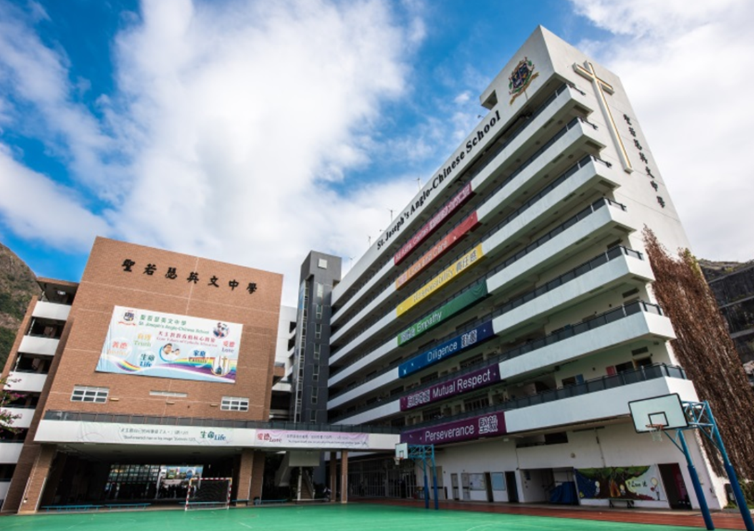

Name of the School: St. Joseph’s Anglo-Chinese School
Name of the proposal: Item Provision Network
Names of students: Ho Ho Hin, Ho Lok Yin, Lee Cheuk Hei Martin,
Mak Siu Sing, Yu Guande

