The University of Law reveals plans for September campus openings

As lockdown restrictions are eased, The University of Law (ULaw) has announced plans to reopen all of its ULaw UK campuses to staff and students in September.

ULaw’s reopening plans include the introduction of a number of measures to ensure the safety and wellbeing of staff and students. Measures will include temperature checks on arrival, hand sanitizer stations, Perspex® social distancing screens, enhanced and increased cleaning schedules, antibacterial wipes and products available at touch points such as printers, one-way walking systems and clear social distancing markers on the floors.

These measures will help protect all staff and students against the virus and ensure they adhere to Government guidelines.

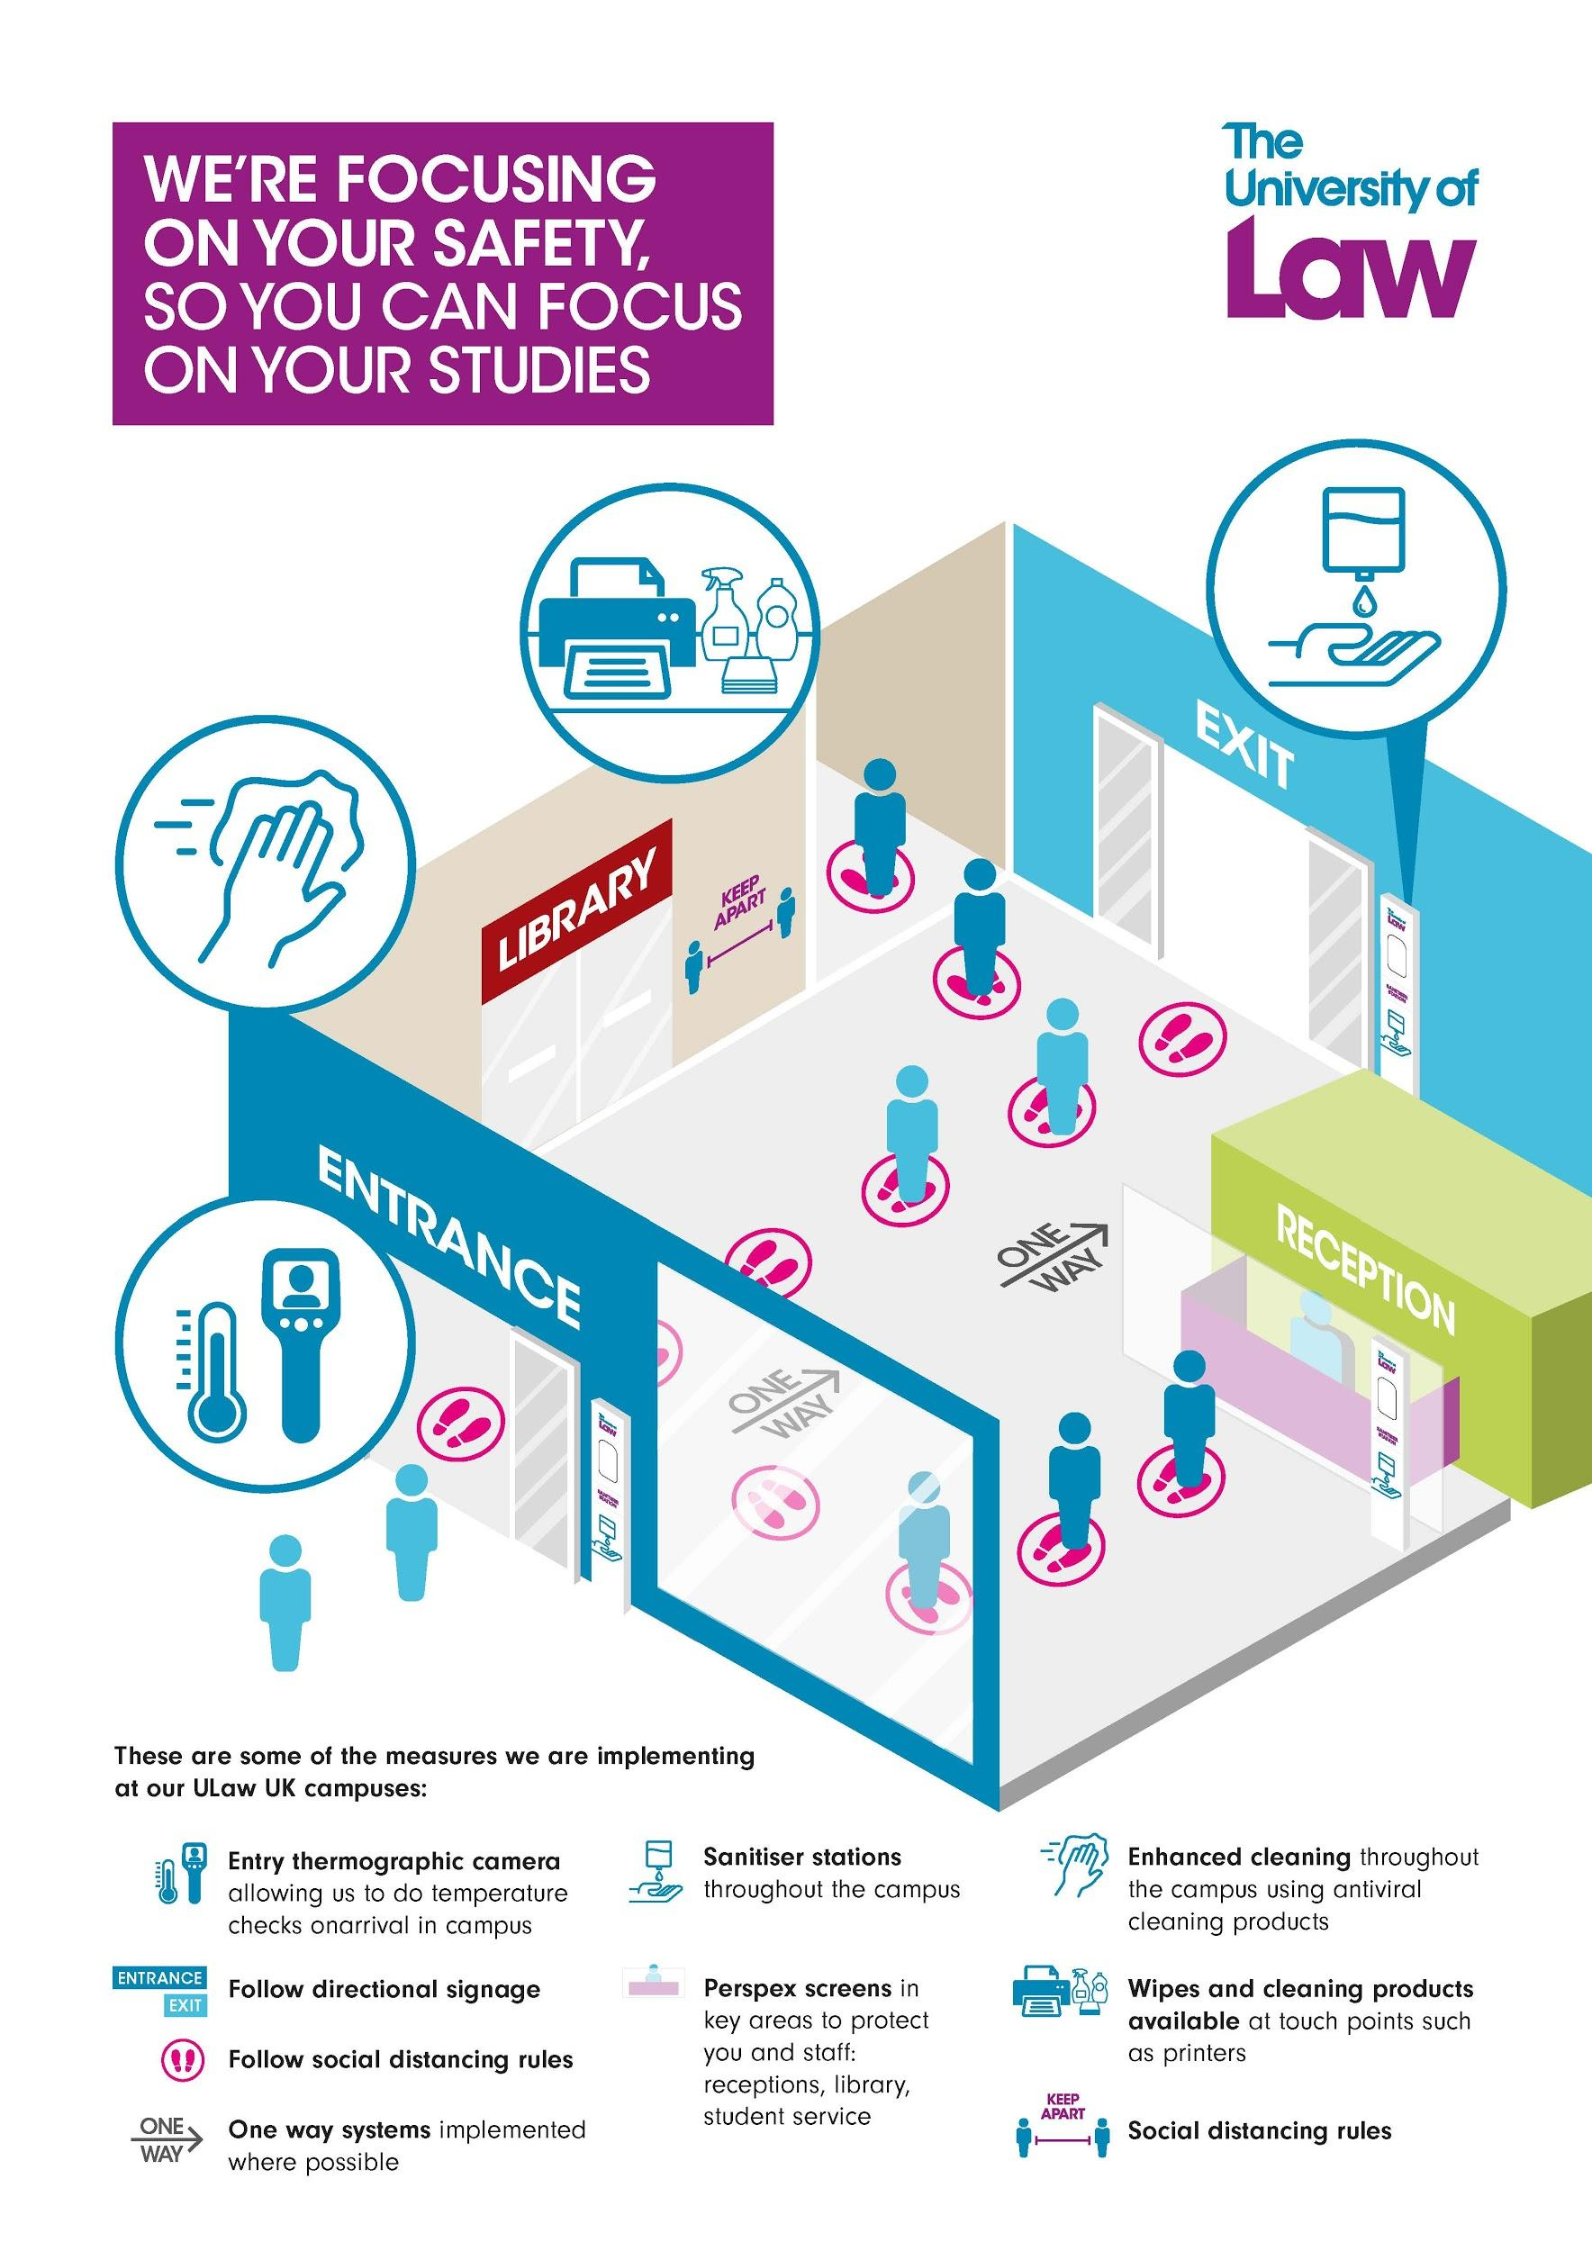

Further alleviating uncertainty among prospective students, the University is also offering flexible study options via its Study Guarantee, including the option to start classes at one campus and switch to another at a later date, in addition to online and hybrid courses. All of these online and hybrid courses will follow the same experience, quality of teaching and material as those provided on-campus, but give students the flexibility to take them wherever and whenever is best for them.

ULaw has produced a video outlining the safety measures and study options for students, available here.

Commenting on the plans, Professor Andrea Nollent, Vice-Chancellor and CEO of ULaw, says: “Although we continue to face uncertain times, we fully expect our campuses to reopen in September and are doing all we can to ensure the health and wellbeing of all our staff and students by introducing several safety measures on campus.”

“It is understandably a worrying time for students who are set to begin their studies at one of our campuses in September. That’s why we introduced our Study Guarantee, which promises students that even if our campuses aren’t able to open, or if students cannot travel there for whatever reason, their studies won’t be affected and they will be able to begin their university life as planned.”

“We know students are keen to continue their journey to fulfilling their career ambitions and we remain committed to supporting them at ULaw.”

To find out more about ULaw’s plans for September: https://www.law.ac.uk/study/guarantee/

ENDS
About The University of Law (ULaw)
The University of Law is one of the longest-established specialist providers of legal education and training in the UK, with campuses in London, Birmingham, Bristol, Chester, Guildford, Leeds, Manchester and Nottingham, as well as international campuses in Berlin and Hong Kong. Our law courses are also provided at the University of East Anglia, The University of Exeter, The University of Reading, The University of Liverpool and The University of Chester Law School. Our full-time and part-time courses are also available online.
Please change first sentence: onarrival in campus-> “upon arrival on campus”
Please change “Sanitiser stations” to “Hand sanitizer stations”

