Press Release
Immediate Release

" Sing Out" - Teenagers Interpreting the Path of Youth Passing on the "Striving Youth" Spirit
Cultivating Positive Growth through Musical Theatre
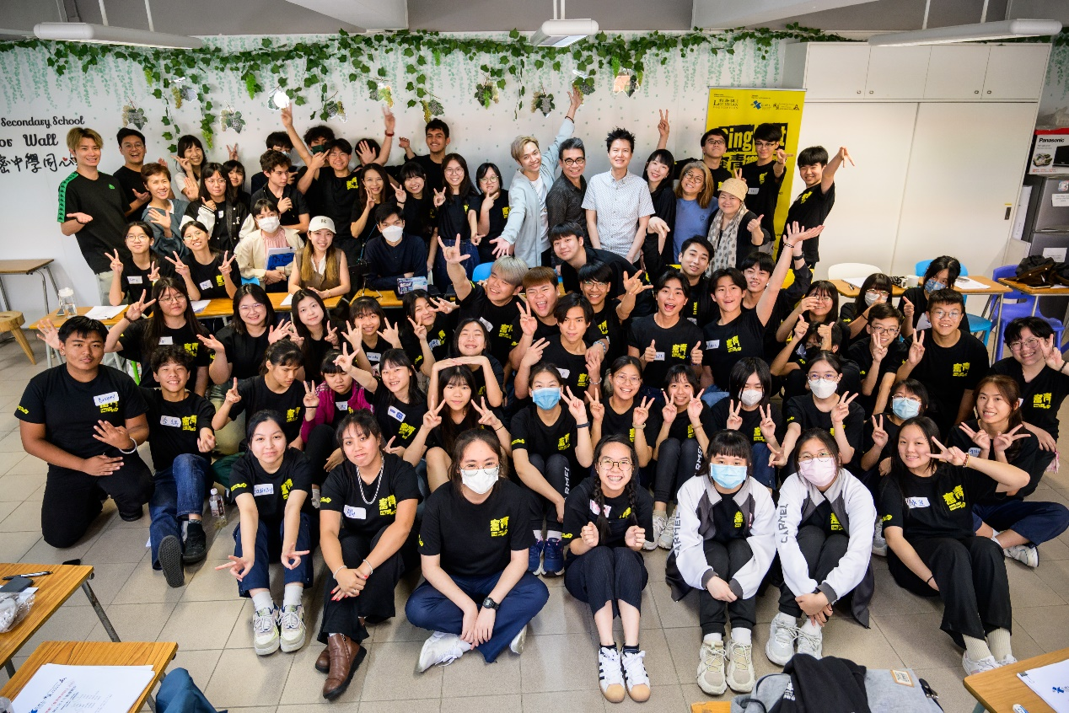
[Hong Kong. May 27, 2024] Musical theatre has always been a popular form of entertainment. To ensure the vibrant growth of musical theatre in Hong Kong, nurturing fresh talent to uphold and pass on the cultural heritage is crucial. Why not let a group of teenagers perform an original musical, allowing them to experience the joy of music firsthand?

The award-winning original musical, "Sing Out – A Musical 2024" is set to begin rehearsals for its new production! The musical is organized and produced by the Extension and Continuing Education for Life (EXCEL) of The Hong Kong Academy for Performing Arts (HKAPA), and is sponsored by the Lee Hysan Foundation.
Approximately 70 teenagers from different schools have joined the cast and crew through an audition and selection process. Their participation is sure to inject new vitality and creativity into the local musical theatre scene.

A Journey of Educative Arts and Diverse Growth Brings About Positive Transformations
"Sing Out" requires participating students to have relevant skills in musical theatre and demands that they follow through with their commitments. Once registered for the musical, students must be fully committed and cannot back out at the last minute; they must also balance their studies during the program. Musical theatre is known as the triple threat because performers must be proficient at acting, dancing, and singing simultaneously. Through this training, students enhance their artistic skills and develop good habits like self-discipline, punctuality, and a sense of responsibility, fostering commendable character traits. After participating in the program, some students have learned time management and proper stress-relief techniques, which benefit their overall learning and life.
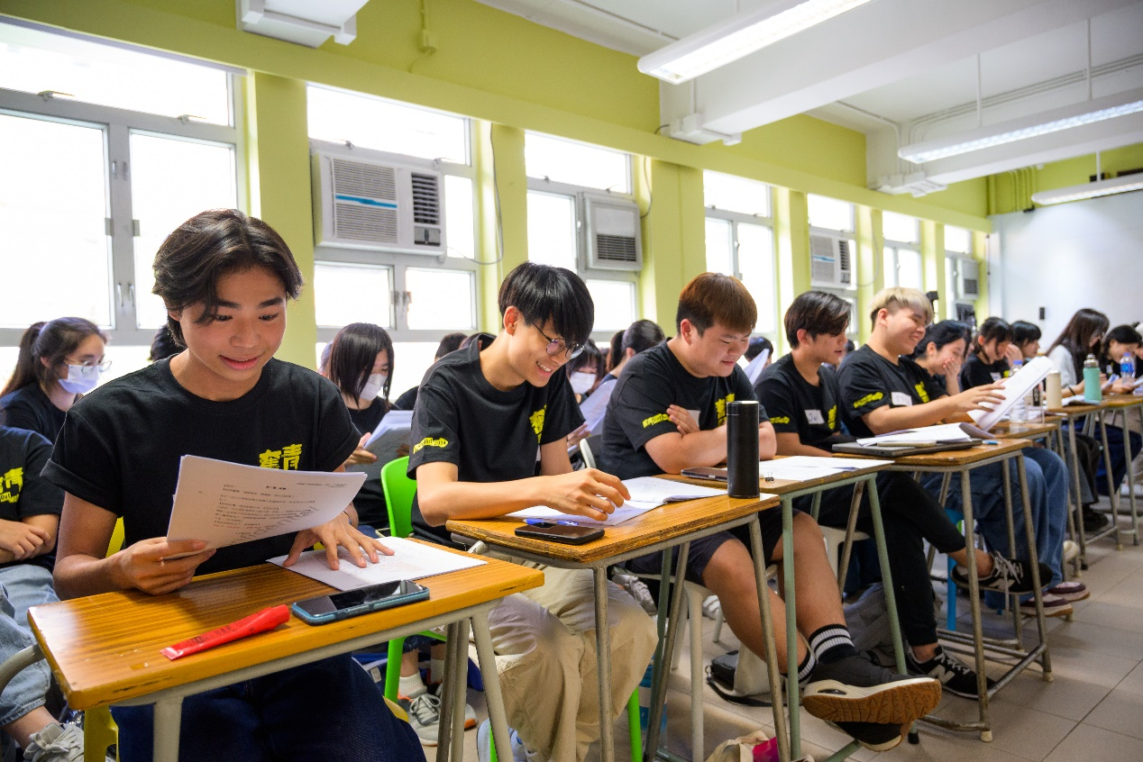
Image: Students gather to read through, attempting to interpret the dialogues within.

Josephine Yim, the General Manager of the EXCEL and the Producer of the 2024 musical, believes that musical theatre helps students grow: "The special thing about 'Sing Out' is that although participants are local students, they come from all walks of life. We have visually impaired students, ethnic minorities, new immigrants, and more. They all share a passion for performing in musicals and have shown complete engagement and dedication during intensive rehearsals over the Easter holiday. They are fearless of making mistakes and understand the importance of helping each other within the team to achieve the best possible performance."

Top-Tier Creative Team of The Theatre Scene
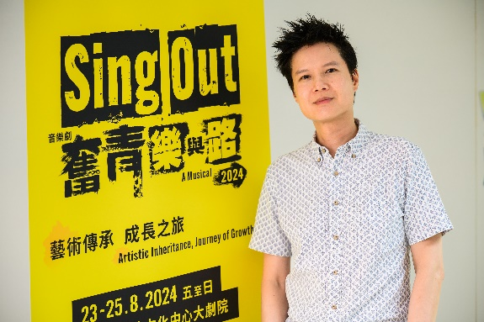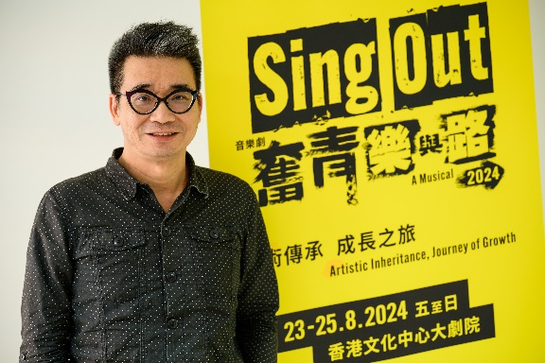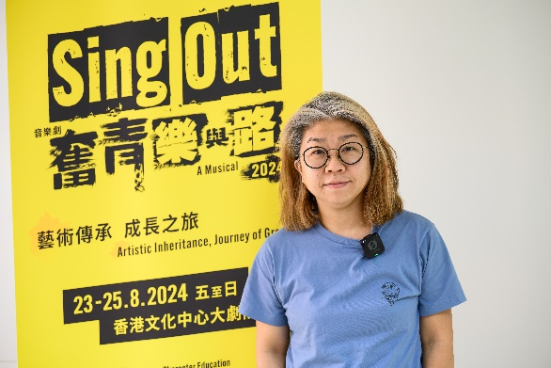
Image: The powerhouse trio behind "Sing Out" consists of composer Leon Ko, lyricist Chris Shum, and playwright Cancer Chong.

"Sing Out" is created by the award-winning theatre “dream team”, composed by the renowned Hong Kong musical and film composer Leon Ko, with lyrics by famous lyricist Chris Shum and a script by playwright Cancer Chong. The drama won six awards at the 27th Hong Kong Drama Awards, including "Best Production", "Best Director", and "Best Original Song Lyrics", and became a sensation by receiving widespread acclaim from audiences. Nonetheless, students must also meet a certain level of ability, as Leon Ko treats them as professional actors: "I did not deliberately create simple songs or lower my expectations because they are secondary school students or newcomers. I want them to do their best."

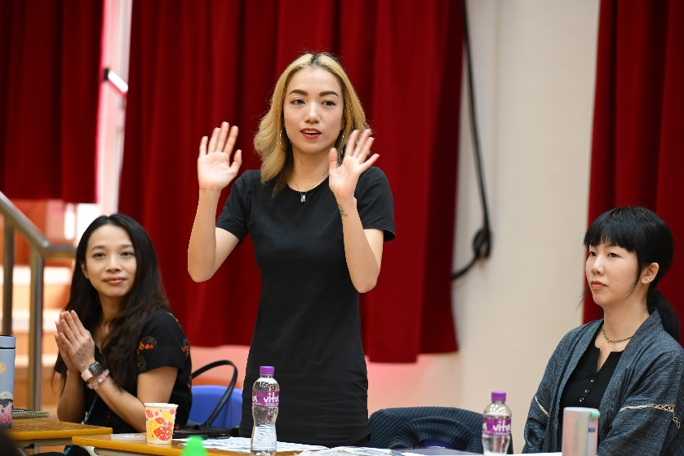
Image: Co-Director Florence Cheong also serves as the Choreographer for the musical.

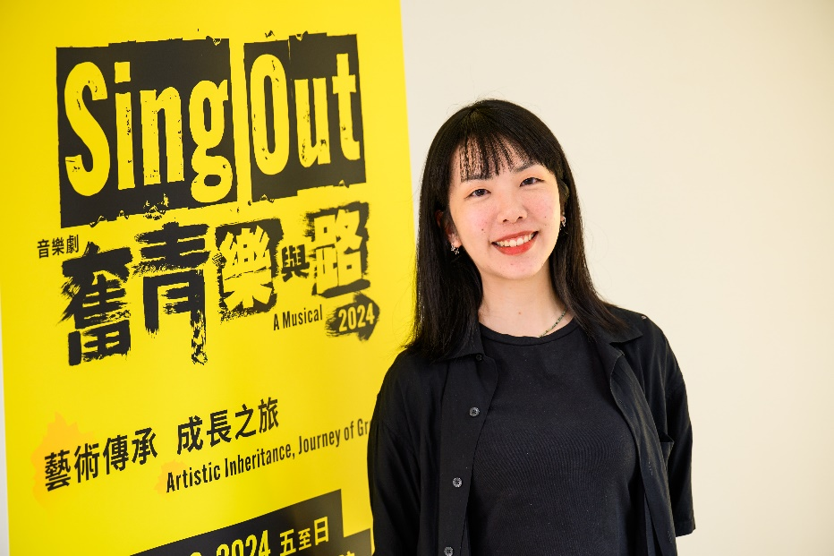
Image: Co-Director Becca Cheung transitions from being an audience to participating in the production of this year's musical.

This year's musical has breakthroughs, co-directed by Becca Cheung and Florence Cheong. Becca Cheung might be a new director, but she has a long-standing connection with "Sing Out": "I once watched the first 'Sing Out' as an audience member while studying at the HKAPA. At that time, I was inspired by the high production level and hoped to participate in such musical production after graduation. It's like a dream comes true to have this opportunity. As the co-director director of this year's 'Sing Out', I hope we can bring out a stronger sense of 'striving' and provide a fresh experience for the audience."

Passing the Torch from One Generation to the Next
In addition to the leading creative team, the musical "Sing Out" is also guided by a group of outstanding mentors. This year's mentor team includes professionals who have mentor-mentee relationships with mentors from previous years. Some of the mentors were students in the first edition of the musical, now taking on the role of "senior peers" to pass on the spirit of "Sing Out." These mentors help carry on the deeper meaning of the musical and provide guidance and inspiration to a new generation of students.

Enhua Yang, a former student from Ebenezer School and Home for the Visually Impaired who participated in the first musical and is affectionately nicknamed "Master," is now a music student at the HKAPA. He has transitioned into a senior peer to assist students in this year's musical: "When I took part in the musical in 2017, I was in the stage of losing sight. Fortunately, I had the help of my companions, who helped me through the low point in my life. Therefore, I want to continue passing on this spirit of mutual support to the students participating in the musical this year."

Countless Rehearsals in the Pursuit of Perfection Preparations
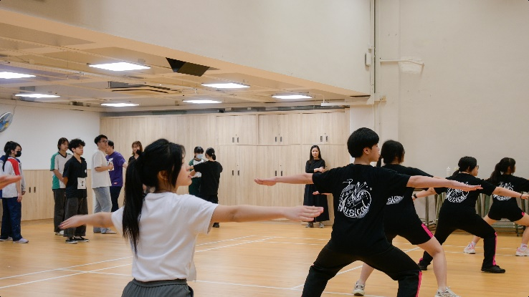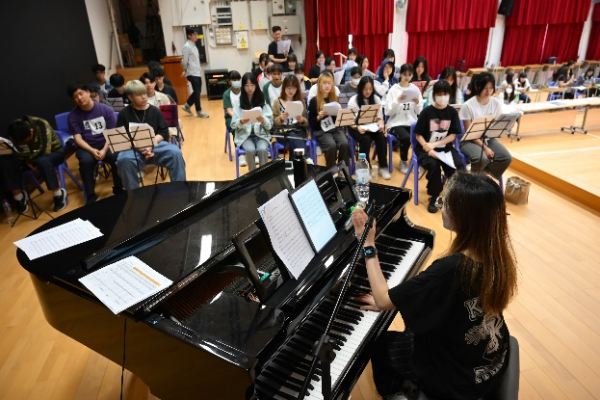
Image: Students participating in the intensive training of singing and dancing earlier.

This year's musical is underway, with auditions from mid-January to early February, followed by more than 300 hours of professional training from March to August. Additionally, intensive training day camps and backstage workshops were held during the Easter holidays to enhance the performers' acting skills and experience the production process behind the scenes. Likewise, intense rehearsals for the performers and the production team will occur from July to August. The musical will be open to the public at the Grand Theatre of the Hong Kong Cultural Centre from August 23 to 25, showcasing the results of everyone's hard work.

Timeline:
January to February | Auditions
March to May | Regular performers training
Early April | Intensive training day camps and backstage experience workshops
July to August | Regular performers training
Mid-July to Mid-August | Intense performers and backstage rehearsals
August 23 to 25 | Public performances

Expanding the Development of Musical Theatre
EXCEL has been offering musical theatre training courses since 2002 and produces a significant summer musical for teenagers yearly. Through professional stage performance, dance, and vocal training, thousands of teenagers have been trained in musical theatre performances. This year, young artists and students from Carmel Secondary School, Gertrude Simon Lutheran College, PAOC Ka Chi Secondary School, Ebenezer School, Home for the Visually Impaired, and the HKAPA Applied Learning Programmes will embark on a journey filled with both artistic and character education.

Tickets for the premiere and subsequent performances of "Sing Out" were completely sold out, with over ten thousand audience members attending, making it a widely discussed topic. This year, the proceeds from ticket sales will be fully utilized to promote the development of youth musical theatre in Hong Kong and encourage positive growth to extend the "Artistic Inheritance, Journey of Growth. "

About HKAPA EXCEL
Established in 2001, EXCEL (Extension and Continuing Education for Life) is a non-profit subsidiary of The Hong Kong Academy for Performing Arts (HKAPA). EXCEL is registered charitable organization (Ref:91/7878). Our aim is to provide innovative, multidisciplinary and globally focused performing arts education through short courses, full-time programmes, customized workshops, and performance-based productions. We strive to create positive social impact in the community and promote artistic excellence, while enhancing arts literacy, interest and appreciation among the general public. For more information, please visit: https://www.excel.hkapa.edu/ .

***
This press release is issued on behalf of Extension and Continuing Education for Life of The Hong Kong Academy for Performing Arts by Square Communications Limited.
For inquiries or to arrange an interview, please contact Ms. Kate Mo (Tel: 6842 9909) or Mr. Tony Chan (Tel: 6891 6883).

