Media Contact:
Christina Tse
Director of Marketing Communications
JW Marriott Hotel Macau
christina.tse@marriott.com
+853 8886 6268

Satisfy Sweet Cravings with Exquisite Desserts
at Urban Kitchen’s New Grab-and-Go Area

MACAU, CHINA – February 17, 2016 – Those with a sweet tooth will be pleased to hear that Urban Kitchen, JW Marriott Hotel Macau’s all-day buffet dining outlet, is now offering afternoon tea buffet each weekend. Guests will be spoilt for choice with up to 30 types of desserts and a variety of sweet treats. Urban Kitchen has also recently set up a Grab-and-Go area at the entrance closest to The Promenade at Galaxy Macau, providing guests access to a whole new à-la-carte menu throughout the day. What’s more? Guests can also enjoy an exclusive sweet surprise – a signature cupcake when they purchase coffee or tea!

The Afternoon Tea Buffet is now available between 3pm and 5pm on Saturdays and Sundays, and is priced at MOP128* for adults and MOP98* for children. Spectacular showstoppers created by Urban Kitchen’s pastry chefs include Croquembouche – a cream-filled profiterole tower, and a 30cm-tall Giant Strawberry Tart made with seasonal Australian and USA strawberries. Guests can even personalize self-serve Soft Ice Cream and made-to-order Belgian Waffles topped with fresh fruits and homemade comfitures. A taste of Macau is also on offer with the myriad of traditional Macanese items such as Almond Cookies, Portuguese-Style Egg Tarts, Egg Rolls and Serradura.

With Urban Kitchen just moments away from The Promenade, Galaxy Macau’s sophisticated shopping precinct, JW Marriott Hotel Macau has now also set up a ‘Grab-and-Go’ area outside the restaurant for hotel guests and shoppers to enjoy a light meal, afternoon tea or relaxing drink. The à-la-carte menu, ranging from salads and sandwiches, to pastas and pizzas, is available from MOP$118* from Monday to Sunday. Guests can add an additional MOP68* to access the afternoon tea buffet at weekend.

For more information, please call +853 8886 6220 or email mhrs.mfmjw.urban.kitchen@marriotthotels.com.

Urban Kitchen Details:
Location | : | 1/F
Offerings | : | International Buffet / A La Carte
Operation Hours | : | 07:00 – 10:30 (Breakfast)  12:00 – 14:30 (Lunch)  15:00 – 17:00 (Afternoon Tea buffet available on Saturdays and Sundays)  18:00 – 22:30 (Dinner)  12:00 – 21:00 (Grab-and-go)
Seating Capacity | : | 220
Private Room  Reservation hotline | :  : | 2  +853 8886 6888

Photo Cutlines
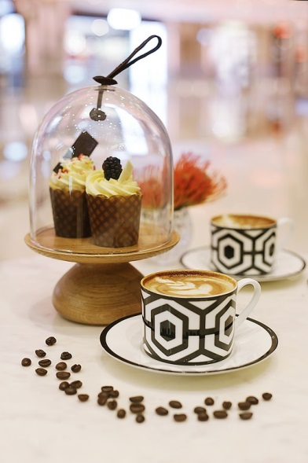
Guests can also enjoy an exclusive sweet surprise – a signature cupcake when they purchase coffee or tea
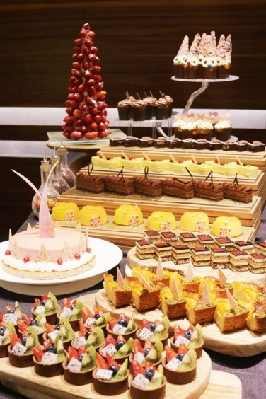  Urban Kitchen, JW Marriott Hotel Macau’s all-day buffet dining outlet, is now offering afternoon tea buffet each weekend | 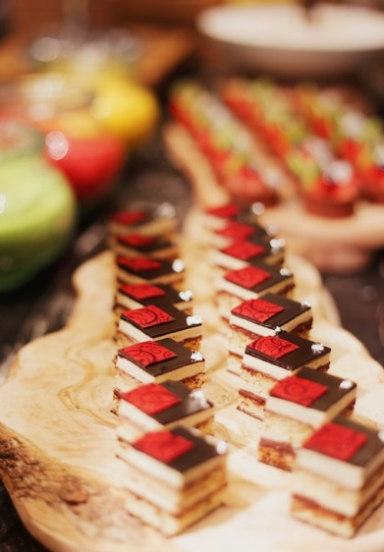  The Afternoon Tea Buffet is now available between 3pm and 5pm on Saturdays and Sundays, and is priced at MOP128* for adults and MOP98* for children
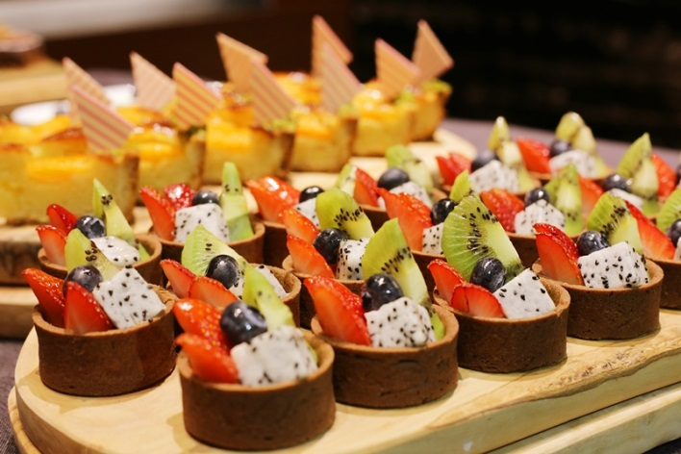  Urban Kitchen, JW Marriott Hotel Macau’s all-day buffet dining outlet, is now offering afternoon tea buffet each weekend | 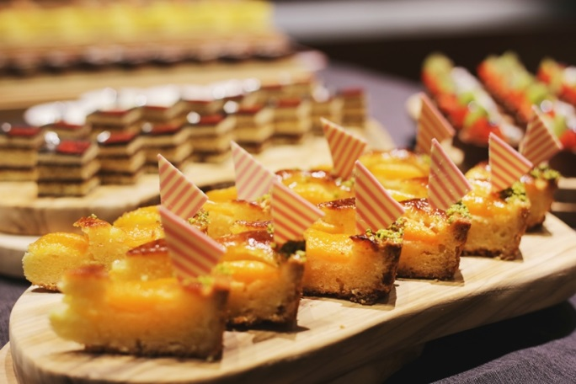  The Afternoon Tea Buffet is now available between 3pm and 5pm on Saturdays and Sundays, and is priced at MOP128* for adults and MOP98* for children
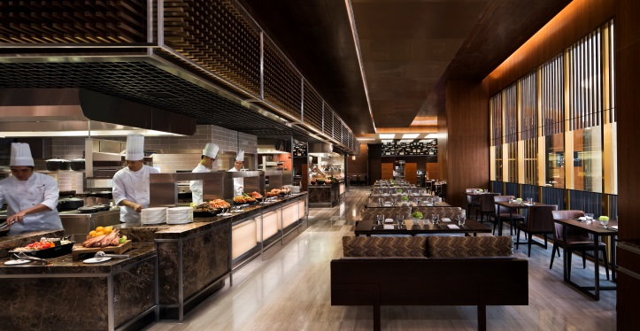
Urban Kitchen, a modern and lively all-day dining outlet, at 1/F of JW Marriott Hotel Macau

Please download more high resolution images via the link below:
https://app.box.com/s/phirisekru8nijs3cxhp0tmcqf17nvy9

About JW Marriott Hotel Macau, China
Situated within one of the world’s most spectacular entertainment and leisure destinations – Galaxy Macau™, the JW Marriott Hotel Macau is located in the heart of Cotai Macau, offering 1,015 rooms and suites styled with elegant and sophisticated decor. For more information, please visit jwmarriottmacau.com.
About JW Marriott Hotels & Resorts
JW Marriott is part of Marriott International’s luxury portfolio and consists of beautiful properties in gateway cities and distinctive resort locations around the world. These elegant hotels cater to today’s sophisticated, self-assured travellers, offering them the quiet luxury they seek in a warmly authentic, relaxed atmosphere lacking in pretence. JW Marriott properties artfully provide highly crafted, anticipatory experiences that are reflective of their locale so that their guests have the time to focus on what is most important to them. Currently, there are 76 JW Marriott hotels in 27 countries; by 2020 the portfolio is expected to encompass more than 100 hotels in over 30 countries. Visit us online, on Instagram, Twitter and Facebook and #experiencejwm.

Marriott International, Inc. (NASDAQ: MAR) is a global leading lodging company based in Bethesda, Maryland, USA, with more than 4,200 properties in 80 countries and territories. Marriott International reported revenues of nearly $14 billion in fiscal year 2014. The company operates and franchises hotels and licenses vacation ownership resorts under 19 brands. For more information or reservations, please visit our website at www.marriott.com, and for the latest company news, visit www.marriottnewscenter.com.

# # #

