For Immediate Release | Media Contact:  Christina Tse  Director of Marketing Communications  JW Marriott Hotel Macau  christina.tse@marriott.com  +853 8886 6268

Experience the Fine Art of Tea Dishes
Through JW Marriot Hotel Macau’s Man Ho Chinese Restaurant

MACAU, CHINA – March 4, 2016 – Guests of JW Marriott Hotel Macau’s Man Ho Chinese Restaurant will be able to experience the art of tea appreciation through the unique tea dishes from 11 March to 30 April, 2016. True to its promise to share luxury experiences through the richness of authenticity, Man Ho Chinese Restaurant is launching 13 tea dishes – prepared with a twist – using fragrance of tea leaves as the main or secondary seasoning ingredient in classic Cantonese fare. Tea sommelier will also provide a tea-pairing journey to our extinguish guests who interested in exploring more about the art of Chinese tea.

Tea drinking and appreciation of this art by connoisseurs is a longstanding hallmark of Chinese tradition dating back almost 5,000 years ago. The consumption of tea has for centuries been considered to be a symbol of high social status for aristocrats. True to JW Marriott Hotel Macau’s focus on the excellence of its culinary offerings, the renowned Man Ho Chinese Restaurant will take guests on a new culinary adventure to explore the depth and finesse of a variety of dishes where tea creates additional depth and tones.

The art of perfecting tea dishes goes far beyond marrying fresh ingredients with the precision and finesse of classic Cantonese cooking techniques. The true challenge lies in how to retain the distinctive color, aroma and flavor of the aromatic tea leaves. During the cooking or smoking process, the delicate tea leaves easily lose their distinctive properties. For example, once green tea leaves are heated within a dish, it may lose its essential qualities. Man Ho’s chefs will demonstrate their exceptional understanding of the characteristics of tea leaves through harmoniously pairings with other ingredients to create this series of exquisite tea dishes.

Signature dishes include:

- Smoked Chicken with Oolong and Coconut: One chicken at a time will be marinated with Oolong Tea leaves in a small claypot to achieve a slow, even and delicate cook. The claypot also helps to bring out the natural sweetness of the food as clay is alkaline and will interact with acidity in the food to neutralise the pH balance. A specialty dark roast Oolong will lend extra tea fragrance to the chicken, which is then smoked with other ingredients like coconut and black sugarcane to further enhance its flavor. The aromatic Oolong Tea is widely regarded as a weight loss aid and a beauty enhancer.
- Sautéed Diced Beef Filet with Wild Mushroom and Dragon Well: Dragon Well Tea offers a multitude of health benefits, including anti-inflammatory and detoxification properties, it also aids in digestion and is an effective thirst quencher. Fungi will be combined with the finest West Lake Dragon Well and Lingzhi, allowing the fungi to soak up the essence of the tea leaves before being stir-fried with beef to become a salutary dish.
- Braised Bean Curd Minced with Shrimp Paste and White Peony: White Peony Tea has a smooth and highly refreshing green taste with the flavor of fresh, raw buds. These subtle and delicate notes pair well with tofu, which also has a mild taste. In this dish, tofu absorbs the essence of White Peony Tea when steamed together, and is then deep-fried just before serving. Here, once again Man Ho’s chefs expert culinary precision and expertise elevates a seemingly humble dish to one that is exceptional.

To further enhance this gastronomic journey, the knowledgeable Man Ho tea sommelier will be on hand to recommend harmonious tea pairings, balancing the aroma and fragrance notes of the tea with the natural goodness of each dish. Guests will also be able to witness first-hand the art of brewing a perfect cup of tea, as expert tea sommelier prepare tea in front of them.

Please see the appendix for details. For dining reservations, please call +853 8886 6222 or email mhrs.mfmjw.man.ho@marriotthotels.com.

Photo Cutlines
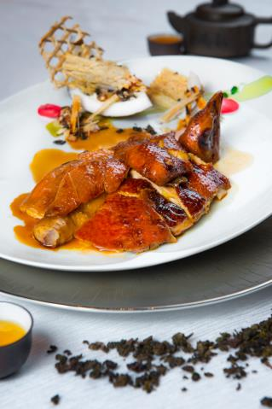  Smoked Chicken with Oolong and Coconut | 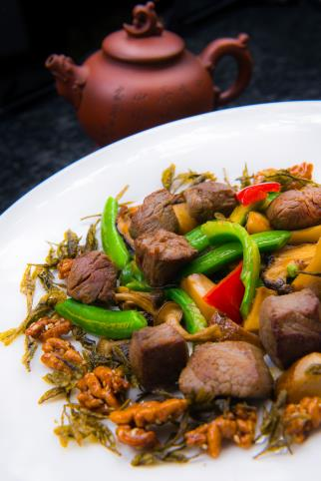  Sautéed Diced Beef Filet with Wild Mushroom and Dragon Well
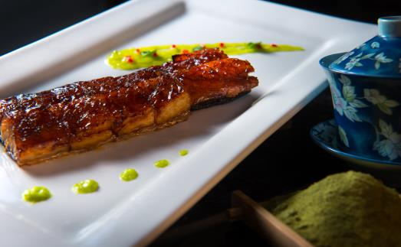  Grilled Eel Favored with Green Tea and Mustard | 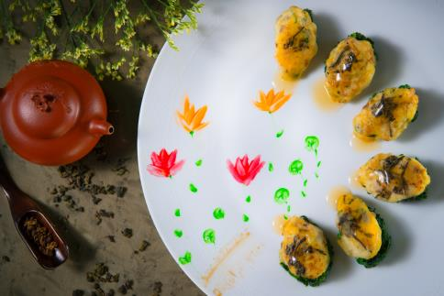  Braised Bean Curd Minced with Shrimp Paste and White Peony
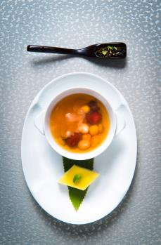
Green Tea and Coconut Juice Pudding Accompanied with Sweetened Oolong Tea with Eight Treasure

Please download more high resolution images via the link below:
https://app.box.com/s/0w97b1s6m5ys4t2vh54gttg4i2xpbt2o

Appendix

Signature Tea Dish Menu

Steamed Shrimp and Dragon Well Dumpling | Mop68*
Steamed Mushroom and Biluochun Dumpling | Mop58*
Double-boiled Matsutake Mushroom and Baby Chrysanthemum | Mop68*/person
Roasted Pigeon Favored with Jasmin Tea (one portion) | Mop138*
Grilled Eel Favored with Green Tea and Mustard | Mop198*
Shrimp Sautéed with Dragon Well | Mop238*
Sautéed Macau Sole with Dragon Well | Mop498*
Braised Bean Curd Minced with Shrimp Paste and White Peony | Mop168*
Sautéed Diced Beef Filet with Wild Mushroom and Dragon Well | Mop238*
Salt and Pepper Shrimp paste and Scallop Favoured with Tiequanyin | Mop268*
Smoked Chicken with Oolong and Coconut (half portion) | Mop238*
Green Tea and Coconut Juice Pudding | Mop58*
Sweetened Oolong Tea with Eight Treasure | Mop48/ person*

* Price is subject to a 10% service charge

About JW Marriott Hotel Macau, China
Situated within one of the world’s most spectacular entertainment and leisure destinations – Galaxy Macau™, the JW Marriott Hotel Macau is located in the heart of Cotai Macau, offering 1,015 rooms and suites styled with elegant and sophisticated decor. The hotel offers innovative culinary experiences including classic Cantonese cuisine in a contemporary Chinese setting at Man Ho; an all-day dining outlet with international and regional cuisine, Urban Kitchen; the relaxing JW Pool Bar; and the sophisticated lobby lounge – The Lounge. The hotel also features an outdoor swimming pool and state-of-the-art fitness centre. JW Marriott Hotel Macau is taking the concept of “Edutainment” to Macau via the world’s largest JW Kids’ Club, which features an abundance of interactive activities for children that are designed to educate as well as to entertain. In addition, guests can take advantage of Galaxy Macau's Grand Resort Deck with tropical gardens and Adventure River. The hotel's pillar-less Grand Ballroom and venue spaces are ideal settings for weddings and social events. For more information, please visit jwmarriottmacau.com.

About JW Marriott Hotels & Resorts
JW Marriott is part of Marriott International’s luxury portfolio and consists of beautiful properties in gateway cities and distinctive resort locations around the world. These elegant hotels cater to today’s sophisticated, self-assured travellers, offering them the quiet luxury they seek in a warmly authentic, relaxed atmosphere lacking in pretence. JW Marriott properties artfully provide highly crafted, anticipatory experiences that are reflective of their locale so that their guests have the time to focus on what is most important to them. Currently, there are 76 JW Marriott hotels in 27 countries; by 2020 the portfolio is expected to encompass more than 100 hotels in over 30 countries. Visit us online, on Instagram, Twitter and Facebook and #experiencejwm.

Marriott International, Inc. (NASDAQ: MAR) is a global leading lodging company based in Bethesda, Maryland, USA, with more than 4,200 properties in 80 countries and territories. Marriott International reported revenues of nearly $14 billion in fiscal year 2014. The company operates and franchises hotels and licenses vacation ownership resorts under 19 brands. For more information or reservations, please visit our website at www.marriott.com, and for the latest company news, visit www.marriottnewscenter.com.

# # #

